INTRODUCTION

Team ID : LTVIP2025TMID29792

Team Size : 4

Team Leader : P Dhana Raj

Mail id : Pdhanaraj348@gmail.com

Team member : Kontham Harita Ganilakshmi

Mail id : harithakontham3@gmail.com

Team member : Kola Durga Gayatri Rama Devi

Mail id : Koladurgagayatriramadevi@gmail.com

Team member : Krupasatya Kotipalli

Mail id : Kotipallikrupasatya65@gmail.com

**Ideation Phase Define the Problem Statements**

|  |  |
| --- | --- |
| Date | 20 June 2025 |
| Team ID | LTVIP2025TMID29792 |
| Project Name | Workforce Administration Solution (Dev) |

**Customer Problem Statement Template:**

Managing workforce operations such as attendance tracking, leave management, shift scheduling, payroll processing, and compliance reporting has become increasingly complex and inefficient due to reliance on manual processes and disconnected systems. HR managers and administrative staff face constant challenges in maintaining accuracy, ensuring timely processing, and delivering a smooth employee experience. Employees often struggle with delayed responses, lack of transparency, and no self-service access to critical information. These pain points not only reduce productivity but also lead to dissatisfaction among both staff and management. The absence of a centralized, automated solution causes communication breakdowns, operational delays, and an increased risk of errors and non-compliance. There is a strong need for an integrated workforce administration system that simplifies HR operations, reduces manual effort, increases accuracy, and improves employee engagement.

**Example:**

|  |  |  |  |  |  |
| --- | --- | --- | --- | --- | --- |
| **Problem**  **Statement (PS)** | **I am**  **(Customer)** | **I’m trying to** | **But** | **Because** | **Which makes me feel** |
| PS-1 | an HR  Manager | manage attendance and leave records accurately | the current process is manual and errorprone | there’s no integrated system to track everything in one place | frustrated, overworked, and anxious about errors |
| PS-2 | an Admin Officer | generate payroll efficiently | the attendanc e data is scattered across different systems | I need to manually collect, cross-check, and calculate the data | stressed and afraid of mistakes |
| PS-3 | an Employee | request leave and access my payslips easily | I need to email HR or wait for  responses | there’s no employee  self-service portal | helpless and unimportant |
| PS-4 | a Team | adjust team | I don’t | everything is | stressed and |

|  |  |  |  |  |  |
| --- | --- | --- | --- | --- | --- |
|  | Leader | shifts in real  time | have access to live  attendanc e data | updated manually after the fact | inefficient |
| PS-5 | a  Compliance  Officer | ensure labor law compliance in workforce management | data tracking is inconsiste nt and scattered | there’s no automated  alert or audit system | worried about legal exposure and audit failure |

**Ideation Phase Empathize & Discover**

|  |  |
| --- | --- |
| Date | 20 June 2025 |
| Team ID | LTVIP2025TMID29792 |
| Project Name | Workforce Administration Solution (Dev) |

**Empathy Map Canvas:**

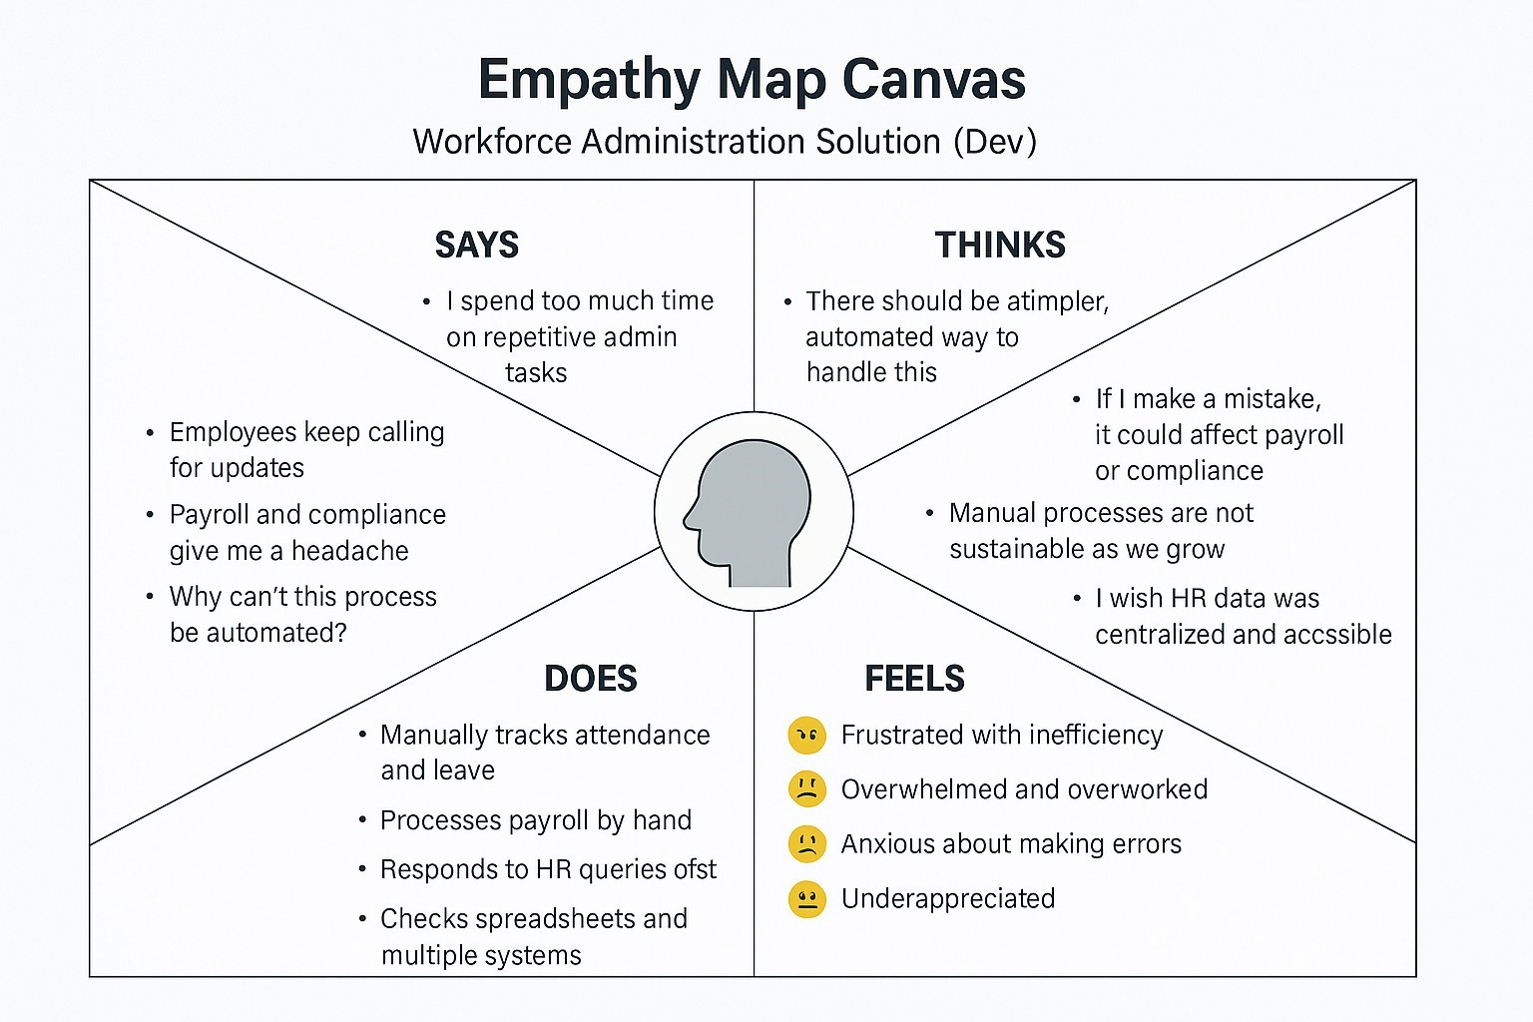The HR manager often **says** they are tired of spending hours managing attendance, leave, and payroll through outdated manual processes. They frequently express frustration when employees ask for updates that should be accessible through a self-service system. Internally, they **think** there must be a better way to streamline workforce administration and often worry about making mistakes that affect payroll accuracy or compliance. They also feel the pressure of scaling operations without a scalable system in place.

In their daily tasks, they **do** everything from maintaining Excel sheets to manually coordinating with other departments to gather data. They **feel** overwhelmed, undervalued, and anxious about the consequences of human error in critical HR functions. The lack of integration across systems adds to their stress. Their **pain points** include fragmented tools, repetitive work, and limited access to real-time data. What they truly need is a centralized, automated workforce administration platform. This would help them feel confident, efficient, and more in control of HR operations.

**Example:**

**Example: Food Ordering & Delivery Application**

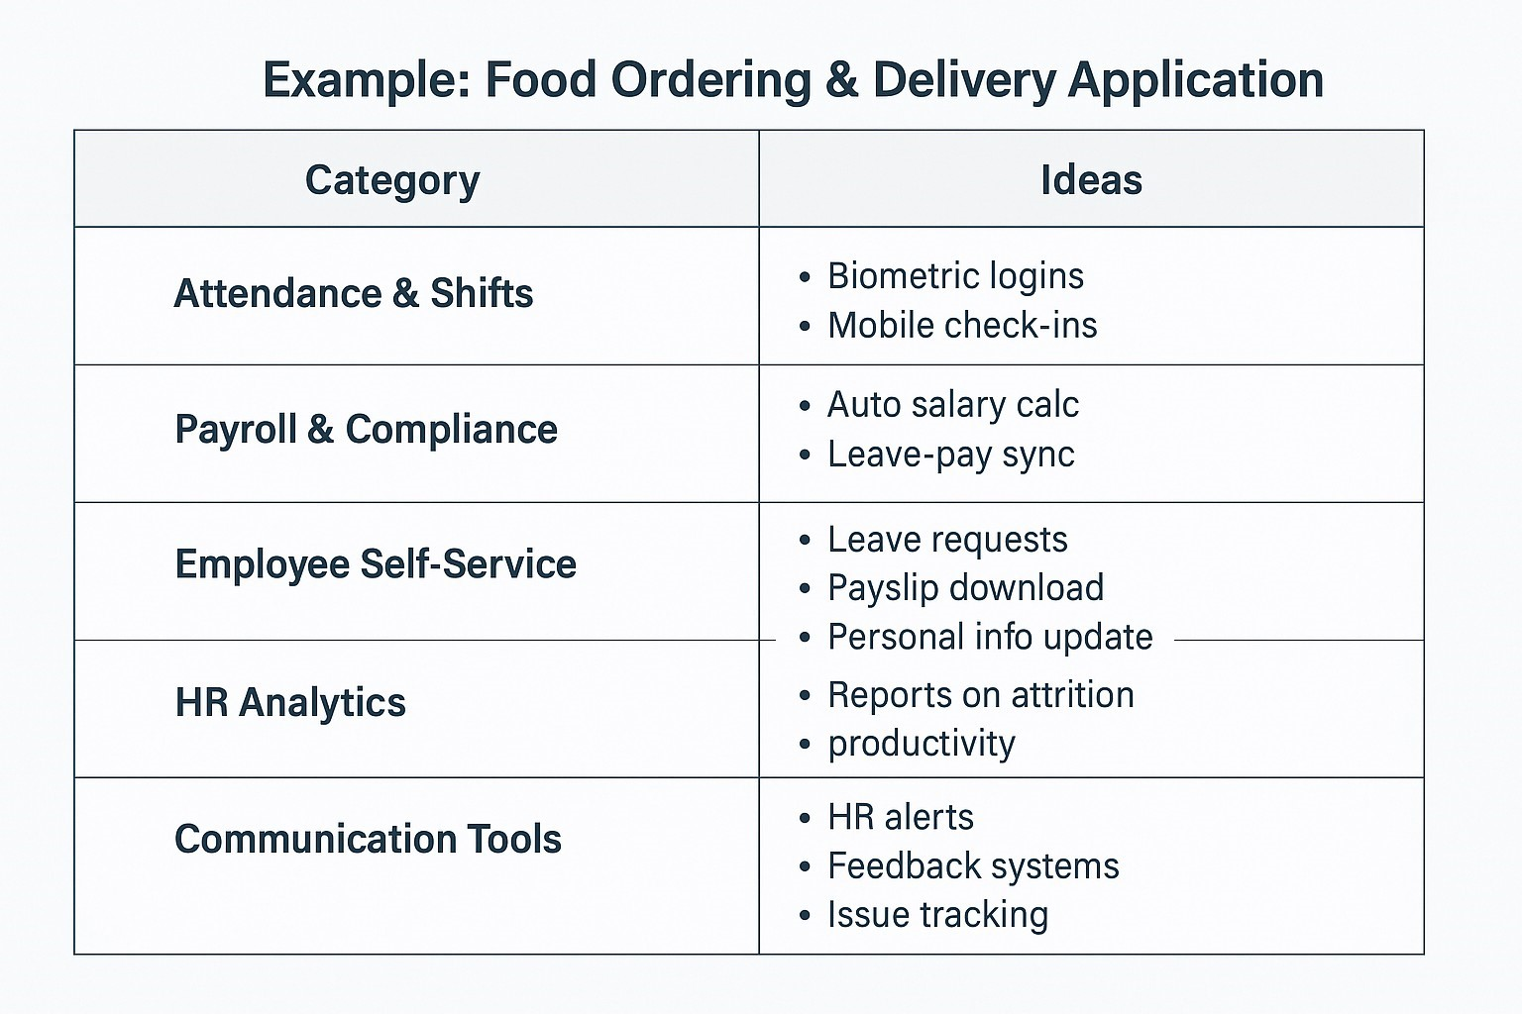

Ideation Phase

Brainstorm & Idea Prioritization

Template

|  |  |
| --- | --- |
| Date | 20/06/2025 |
| Team ID | LTVIP2025TMID29792 |
| Project Name | Workforce Administration Solution (Dev) |

Brainstorm & Idea Prioritization Template:

Brainstorming provides a free and open environment that encourages everyone within a team to participate in the creative thinking process that leads to problem solving. Prioritizing volume over value, out-of-the-box ideas are welcome and built upon, and all participants are encouraged to collaborate, helping each other develop a rich amount of creative solutions.

Use this template in your own brainstorming sessions so your team can unleash their imagination and start shaping concepts even if you're not sitting in the same room.

Reference: https://www.mural.co/templates/brainstorm-and-idea-prioritization

Step-1: Team Gathering, Collaboration and Select the Problem Statement

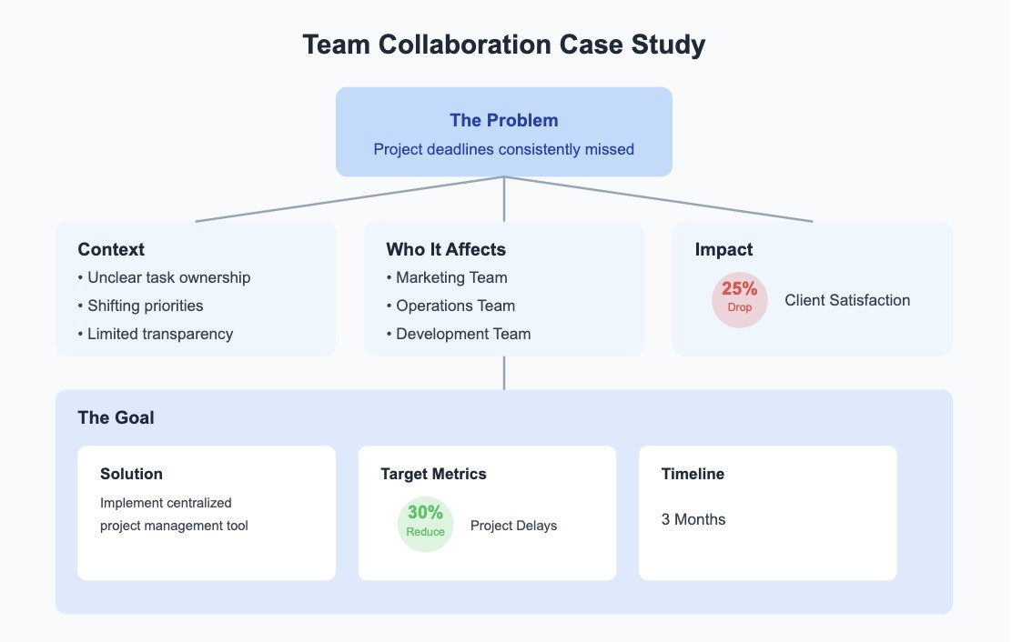

**Step-2: Brainstorm, Idea Listing and Grouping**

**Idea Listing**

**Capture all raw ideas—big or small. Examples:**

Biometric & mobile attendance tracking

Automated payroll integration

Digital onboarding & offboarding

Real-time shift assignment & change requests

Employee self-service portal (ESS)

Compliance tracking & alerts

Analytics dashboard for HR KPIs

Remote work monitoring tools AI chatbot for HR queries

🧩 **Grouping Ideas by Function**

|  |  |
| --- | --- |
| Category | Ideas |
| Attendance & Shifts | Biometric logins, Mobile check-ins, Shift swap system |
| Payroll & Compliance | Auto salary calculation, Leave-pay synchronization, Legal alerts |
| Employee Self-Service | Leave requests, Payslip download, Personal information update |
| HR Analytics | Reports on attrition, productivity, absenteeism |
| Training & Support | Digital onboarding, e-Learning modules, HR chatbot |
| Communication Tools | HR alerts, Feedback systems, Issue tracking |

**Step-3: Idea Prioritization**

|  |  |  |  |  |  |
| --- | --- | --- | --- | --- | --- |
| Idea | Impact | Feasibility | Cost | Urgency | Priority |
| Biometric  Attendance  System | High | High | Medium | High | Top Priority |
| Mobile Checkin for Remote  Employee | High | Medium | Low | High | High |
| Employee  Self-Service  Portal | High | Medium | Medium | Medium | High |
| Shift Swap  Feature | Medium | High |  | Medium | Medium |
| Payroll &  Leave Sync  Automation | High | Medium | Medium | High | Top Priority |
| Real-time HR | Medium | Medium | Medium | Low | Medium |

|  |  |  |  |  |  |
| --- | --- | --- | --- | --- | --- |
| Dashboard  (Analytics) |  |  |  |  |  |
| HR Chatbot for Employee Support | Medium | High | Low | Low | Low |
| Digital  Onboarding | Medium | Medium | Medium | Medium | Medium |
| Legal  Compliance  Alert System | High | Medium | Medium | High | High |

**F A I R P L A N E** Guided city tours

|  |  |  |  |  |  |
| --- | --- | --- | --- | --- | --- |
| **Stage** | User Action | Touchpoints | Experience | Pain Points | Opportunities |
| Awareness | Learns about the workforce system | HR mail, training, onboarding | Curious, Interested | Unfamiliar with features | Provide quick demo & training videos |
| Onboarding | Logs in, sets up profile, configures team data | Web Portal, Mobile  App | Confused initially | UI/UX not intuitive | Simplified dashboard, tooltips |
| Usage | Uses system for attendance, shifts, leave | Biometric device, Mobile, Web | Efficient, Mixed | Manual shift entries, delayed leave approval | Automate shifts, improve approval workflow |
| Reporting | Views analytics on team productivity | Reports Module, Notifications | Informative | Limited filtering | Add advanced report filters & charts |
| Payroll Process | Sends data to finance | Payroll Integration, Export Buttons | Smooth or slow | Integration errors | Add export verification & backup options |
| Support | Needs help with access or data errors | Helpdesk, Chatbot, Email | Frustrated or satisfied | Delayed support responses | Add live support, FAQs, chat support |

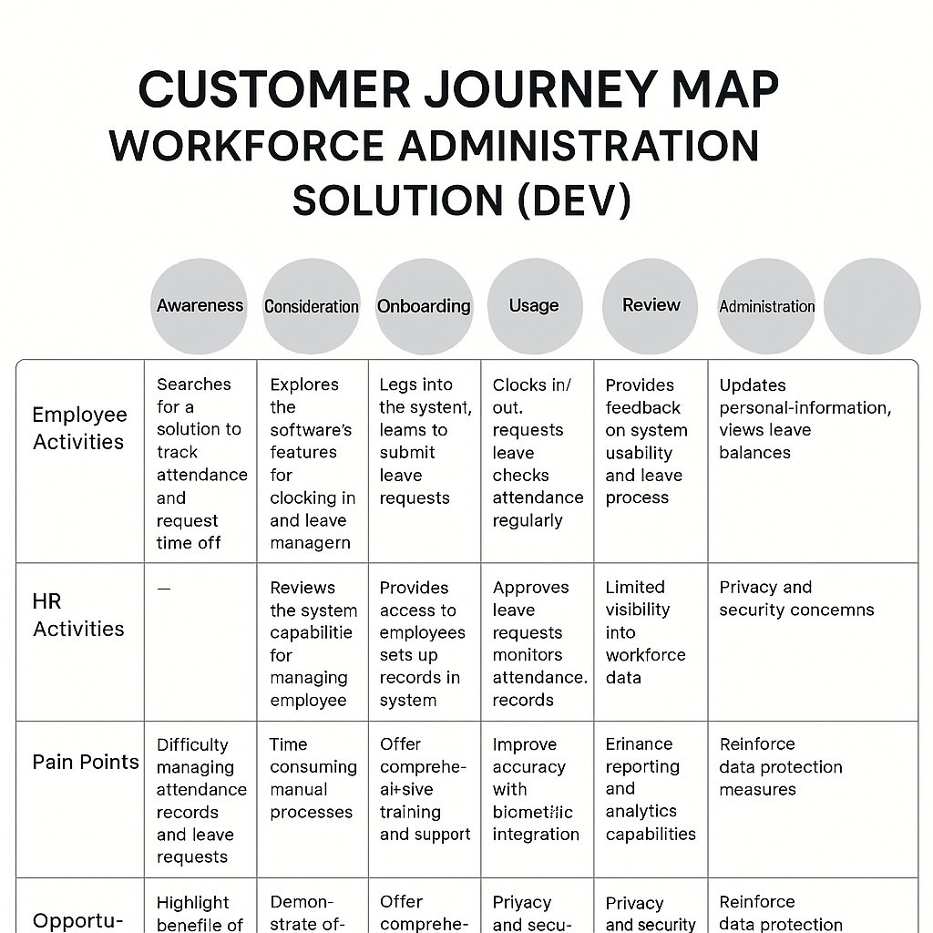

i s

o v e r

?

# Project Design Phase-II

**Solution Requirements (Functional & Non-functional)**

|  |  |
| --- | --- |
| Date | 20 June 2025 |
| Team ID | LTVIP2025TMID29792 |
| Project Name | Workforce Administration Solution (Dev) |

**Functional Requirements:**

Following are the functional requirements

|  |  |  |
| --- | --- | --- |
| **ID** | **Requirement** | **Description** |
| FR1 | Employee Login &  Authentication | Secure login for employees, HR, admin, and payroll roles. |
| FR2 | Attendance Tracking | Automatic attendance logging via biometric or mobile check-in. |
| FR3 | Leave Management | Employees can request, cancel, or track leave. |
| FR4 | Shift Scheduling | Shift assignment, editing, and swap features for supervisors. |
| FR5 | Payroll Export | Generate payroll-ready reports based on attendance and leave data. |
| FR6 | Employee Self-Service Portal | Employees can view their attendance, leave balance, and profile. |
| FR7 | Admin Panel | Full control to manage roles, access rights, and data consistency. |
| FR8 | Notifications | Email/SMS alerts for leave approvals, shift changes, and pay cycles. |

**Non-functional Requirements:**

Following are the non-functional requirements

|  |  |  |
| --- | --- | --- |
| **ID** | **Requirement** | **Description** |

|  |  |  |
| --- | --- | --- |
| NFR-1 | Security | Role-based access control, encrypted data storage. |
| NFR-2 | Usability | Clean UI, mobile-friendly interface. |
| NFR-3 | Performance | Quick response times under load, especially during payroll processing. |
| NFR-4 | Scalability | Should support small to large organizations without performance drops. |
| NFR-5 | Availability | System should be available 99.9% of the time. |
| NFR-6 | Backup & Recovery | Automatic data backups and fast disaster recovery system. |
| NFR7 | Maintainability | Easy to update features, fix bugs, and manage deployments. |

# Project Design Phase-II Data Flow Diagram & User Stories

|  |  |
| --- | --- |
| Date | 20 June 2025 |
| Team ID | LTVIP2025TMID29792 |
| Project Name | Workforce Administration Solution (Dev) |

**Data Flow Diagrams:**

This level shows the system as a single process and how it interacts with external entities.

**External Entities:**

**HR Manager** – Manages workforce data, approves leave, views reports.

**Employees** – Apply leave, view attendance, update profile.

**Payroll System** – Receives salary data for processing.

**Biometric Device** – Sends attendance data.

**Main Process:**

Workforce Admin System (central process) **Data Stores:**

**Employee Database** – Stores personal, attendance, shift, leave data.

**Example: (Simplified)**

|  |  |  |  |
| --- | --- | --- | --- |
| **User Role** | **User Story** | **DFD Component** | **Data Interaction** |
| HR Manager | Manage employee records | External Entity | Updates to Employee Da |
| HR Manager | Approve leave requests | External Entity | Sends approval to Workf |
| HR Manager | View reports for analysis | External Entity | Receives processed data |
| Employee | Apply for leave | External Entity | Sends leave request to A |
| Employee | View attendance record | External Entity | Reads from Attendance |
| Shift Supervisor | Assign or swap shifts | External Entity | Sends updates to Shift S |
| Payroll Officer | Access attendance and leave data | External Entity | Reads data for salary pro |

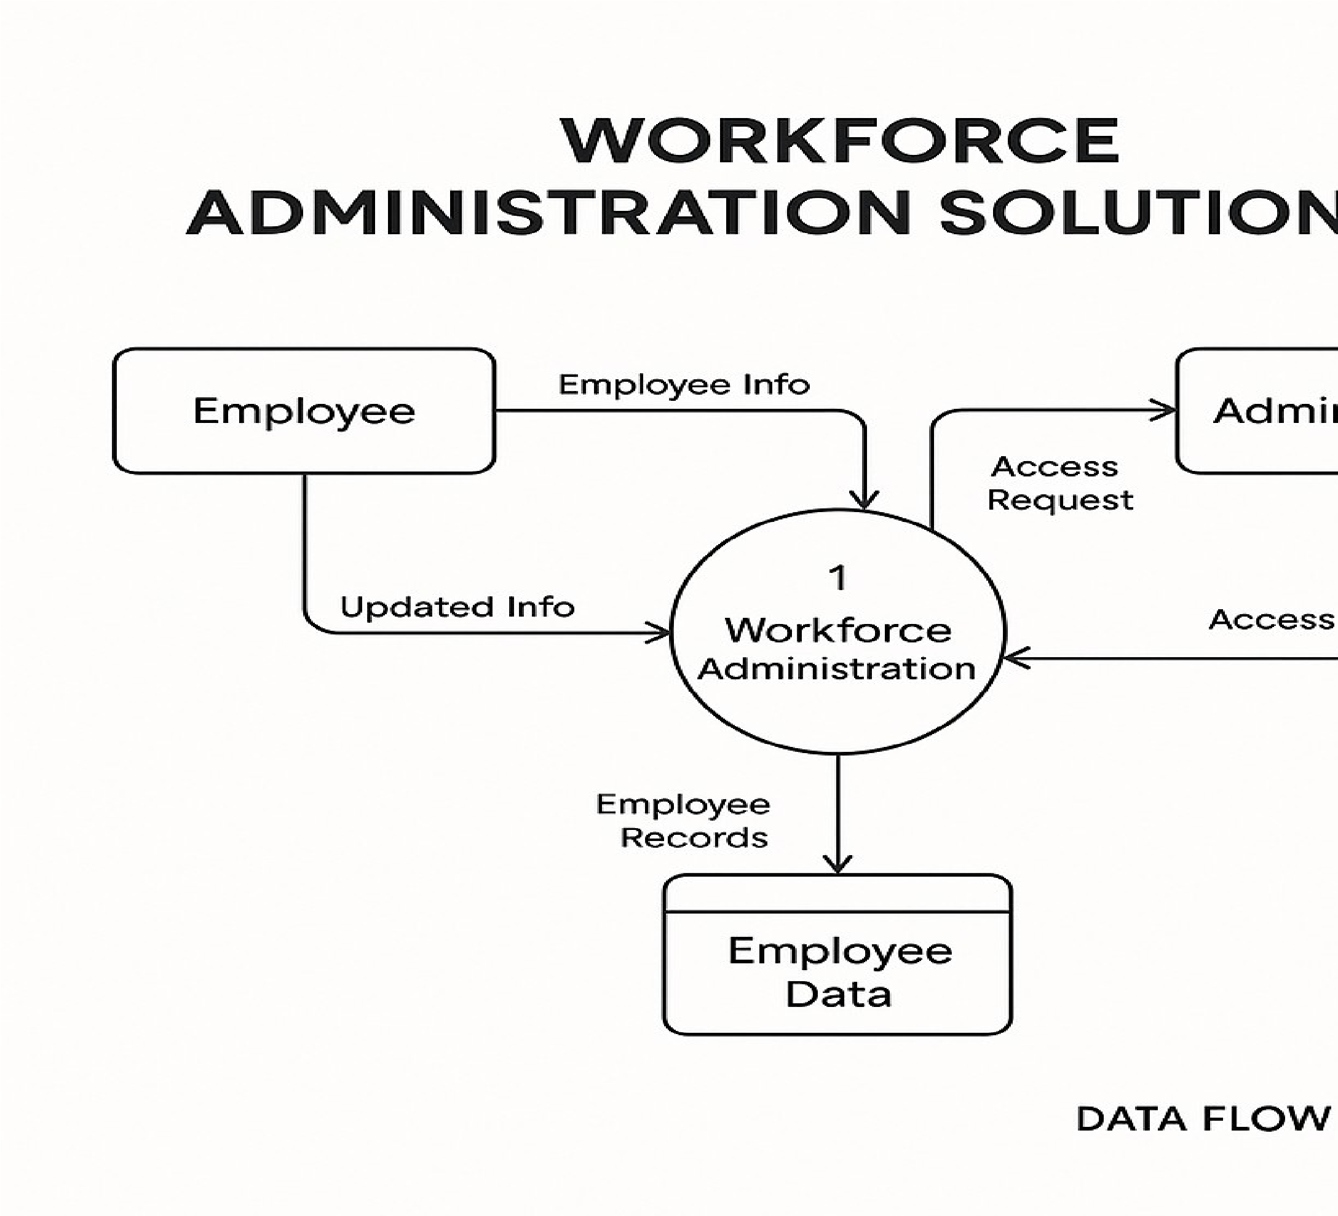**User Stories:**

|  |  |  |  |
| --- | --- | --- | --- |
| **User Role** | **User Story** | **DFD Component** | **Data Interaction** |
| Admin | Manage system users and permissions | External Entity | Updates to User Access |
| Biometric Device | Automatically log attendance | External System (Device) | Sends raw data to Admin |
| Payroll System | Generate payroll using attendance and leave info | External System | Receives structured data |

# Project Design Phase-II Technology Stack (Architecture & Stack)

|  |  |
| --- | --- |
| Date | 20 June 2025 |
| Team ID | Workforce Administration Solution (Dev) |
| Project Name | LTVIP2025TMID29792 |

**Technical Architecture:**

The Workforce Administration Solution (Dev) is built on a modular, scalable three-tier architecture comprising**:**

1. **Frontend (Presentation Layer):**

React.js / HTML / CSS / Tailwind CSS – For building responsive, user-friendly web interfaces. Flutter / React Native – For cross-platform mobile access to attendance and leave modules.

1. **Backend (Application Layer):**

Node.js with Express.js – Handles core business logic and APIs.

JWT / OAuth 2.0 – Provides secure authentication and role-based access control.

Socket.IO / Firebase – Enables real-time updates and notifications (e.g., attendance status).

1. **Database & Storage (Data Layer):**

PostgreSQL – For structured employee, shift, and leave data.

MongoDB – Optional NoSQL layer for flexible document-based storage (e.g., logs, feedback).

Cloud Storage (AWS S3 / Firebase Storage) – Stores documents, exports, and backups.

1. **DevOps & Hosting:**

Docker & GitHub Actions – For containerization and CI/CD automation.

AWS / Azure / Google Cloud – Reliable cloud hosting and scalable infrastructure.

1. **Analytics & Reporting:**

Power BI / Metabase – For workforce insights, dashboards, and exportable report

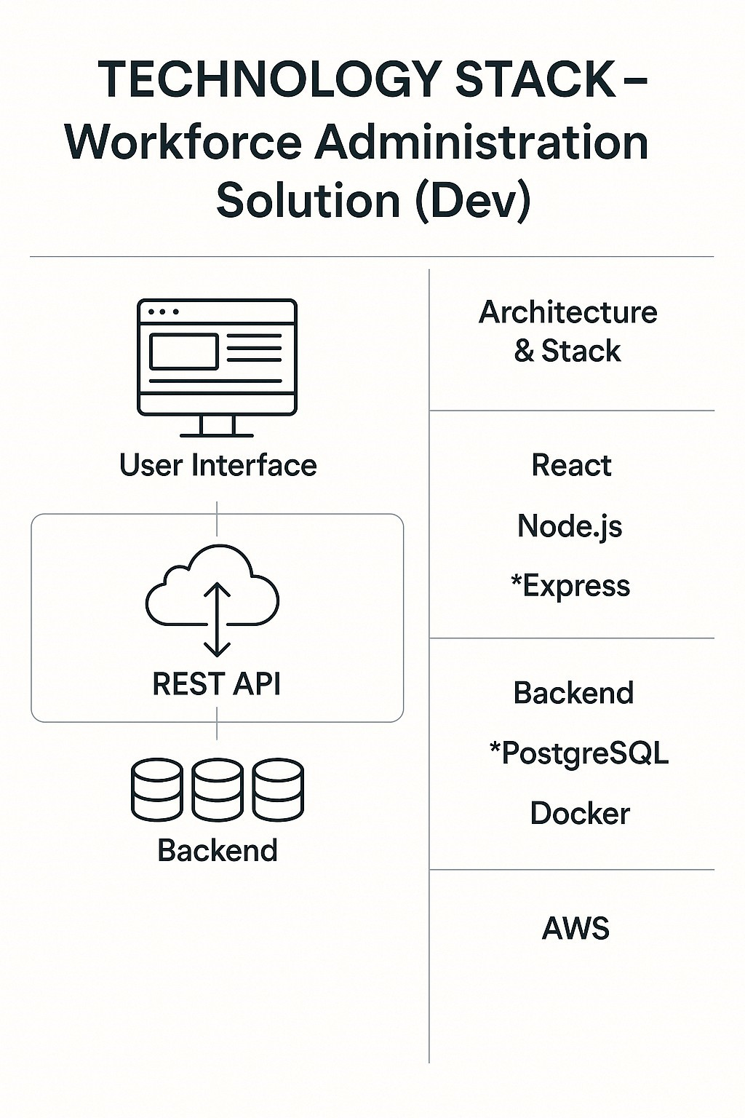

**Table-1 : Components & Technologies:**

**Pur**

|  |  |  |  |
| --- | --- | --- | --- |
| **S.NO** | **Layer** | **Technology** |  |
|  | Frontend (UI) | React.js / HTML5 / Tailwind CSS |  |
|  | Mobile Access | Flutter or React Native | Mo  shif |
|  | Backend (API & Logic) | Node.js / Express.js | pro |

Use adm Han Sec

Rea t

|  |  |  |  |
| --- | --- | --- | --- |
| **S.No** | **Characteristics** | **Description** |  |
|  | Secure user login and access control | Individual components like attendance, leave, and payroll can operate independently. | Tech |
|  | Scalability | Supports growing teams from small startups to large enterprises. | e.g.  Con |
|  | Real-Time Processing | Instant updates for attendance, notifications, and shift changes. | Tech |
|  | Role-Based Access | Secure login and permissions for employees, HR, and admin. | Tech |
|  | Cross-Platform Access | Available on both web browsers and mobile devices. | Tech |
|  | Integration-Friendly | Can integrate with biometric devices, payroll systems, and analytics tools. |  |
|  | User-Friendly Interface | Simple and intuitive UI for all user roles. |  |
|  | Data Security | Encrypted data storage and secure authentication mechanisms. |  |

|  |  |  |  |
| --- | --- | --- | --- |
|  | Authentication | JWT / OAuth 2.0 |  |
|  | Database | PostgreSQL / MongoDB | Sto log |
|  | Real-time Sync | Firebase / Socket.IO | no |
|  | Cloud Hosting | AWS / Azure / GCP |  |
|  | DevOps / CI-CD | GitHub Actions / Docker / Jenkins | Aut ver |
|  | Analytics | Metabase / Power BI | Vis |
|  | Security Tools | SSL, Firewalls, Role-based Access Control | Dat  visi |

Hos

**Table-2: Application Characteristics:**

**Tech**

# Project Development Phase Model Performance Test

|  |  |
| --- | --- |
| Date | 28 June 2025 |
| Team ID | LTVIP2025TMID29792 |
| Project Name | WORKFORCE ADMINISTRATION (DEV) |
| Maximum Marks |  |

**Model Performance Testing:**

Project team shall fill the following information in model performance testing template.

|  |  |  |  |
| --- | --- | --- | --- |
| **S.No.** | **Parameter** | **Values** | **Screenshot** |
|  | Model  Summary | Salesforce automation setup for Data management using Object, Fields and Reports.  **Note :** Import Records if data Match Correctly then Records will Created or Else it will Show Error |  |
|  | Accuracy | Training Accuracy - 98%  Validation Accuracy - 98% |  |
| 3. | Confidence  Score (Only  Yolo  Projects) | Instead of a detection  confidence, this solution ensures field-level accuracy via validation logic. > Example: When incorrect field data (e.g., wrong picklist value or duplicate entry) is submitted, the system rejects it and provides feedback— mirroring high “confidence” in data governance. |  |

**Project Documentation** –

Workforce Administration

1. Introduction

**Project Title:** Workforce Administration (DEV)

**Team Members:** [P.Dhana Raj, K.Haritha Ganilakshmi,K Durga Gayatri Rama Devi,K.kotipalli] 2. Project Overview

**Purpose:**

To streamline HR operations by automating employee data management, asset tracking, leave approvals, and performance reporting using Salesforce tools.

**Features:**

Custom objects: Employee, Asset, Leave

Master-detail relationships and reporting manager hierarchy

Flows and Process Builder for automated approvals

Apex triggers for data validation

Dashboards and reports for decision-making Role-based access using Profiles and Permission Sets

1. Architecture :

**Platform:** Salesforce Lightning

**Backend Logic:** Apex (Triggers, Validation Rules), Flows

**Process Automation:** Flow Builder and Process Builder

**UI:** Lightning Pages, Tabs, Dashboards

**Data Model:** Master-detail (Employee ↔ Asset), Lookup (Leave ↔ Employee)

1. Setup Instructions

**Prerequisites:** Salesforce Developer Org

**Steps:**

Login to your Salesforce org

Create custom objects and fields

Configure relationships and page layouts

Create flows for approval and dashboards

Add Apex trigger for duplicate validation

Set up Lightning App with navigation tabs

1. Object & Data Model:

**• Employee Object:** Stores personal details and reporting manager

**Asset Object:** Linked to Employee for tracking assigned assets

**Leave Object:** Contains leave dates, duration, and approval status (*Optionally include an ER diagram or field list here*)

1. Running the Application

**Access:** Open the Lightning App “Workforce Admin”

**Navigation:** Use tabs to access Employees, Assets, Leaves, Dashboards, Reports

1. Automation Flow & Apex Logic

**Flow:** LeaveApprovalFlow handles approval routing based on days requested

**Apex Trigger:** Prevents duplicate employee creation during record submission

1. Security & Access Control

Role Hierarchy, Profiles, and Permission Sets control visibility

Manager roles can access dashboards; employees can only view their data

1. User Interface

Lightning UI with custom tabs

Dashboards showing KPIs like project allocation and asset use

1. Testing

Manual testing via UAT

5 test cases covering creation, validation, automation, and access

UAT passed all scenarios with accurate data outcomes

1. Screenshots or Demo:

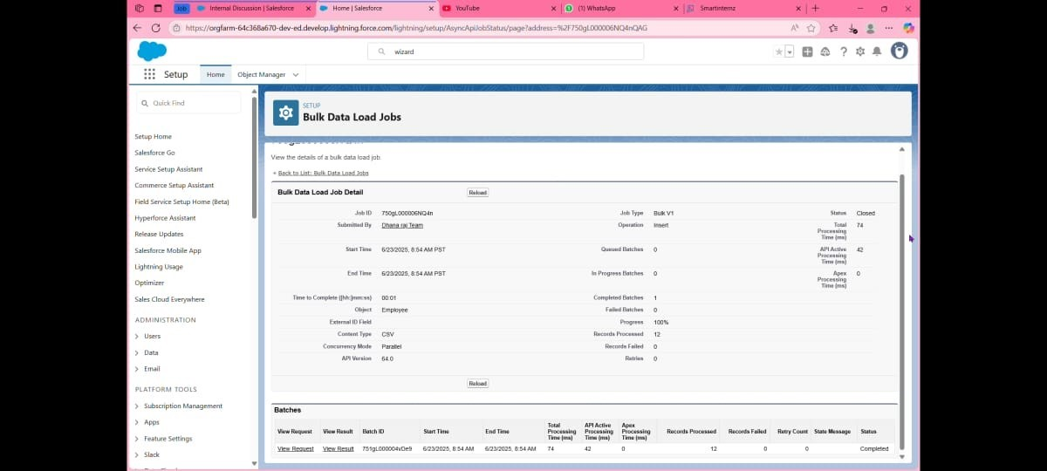

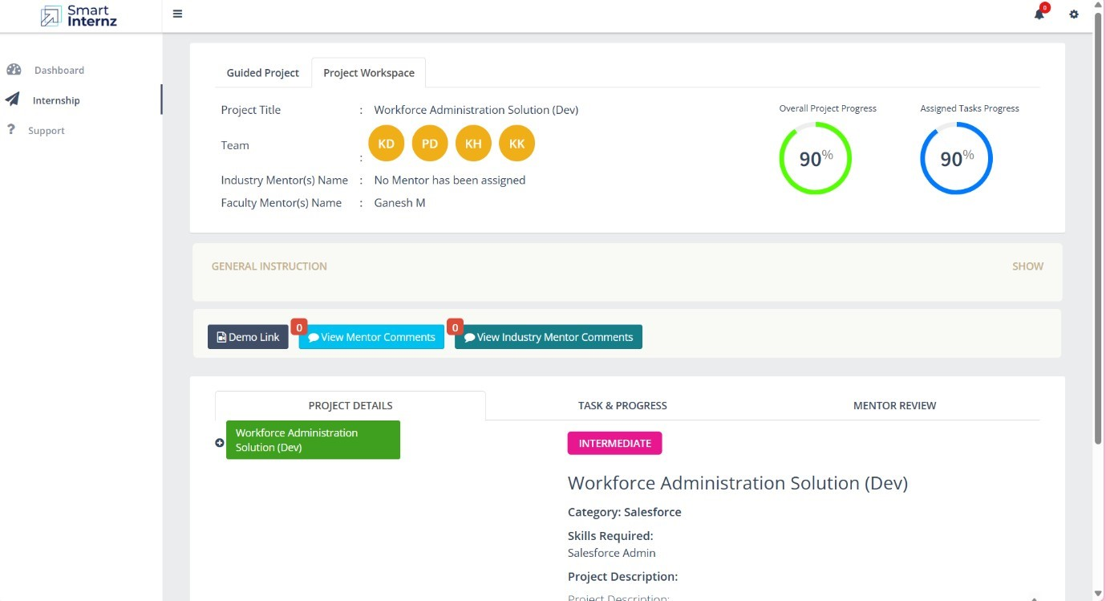

1. Known Issues

Leave approval email alert may not trigger if template is not set

Dashboard load time may vary for users with limited access rights

1. Future Enhancements

Slack/email notifications for approvals

Advanced filters in dashboards

Integration with external HR systems or APIs

## Project Design Phase Solution Architecture

|  |  |
| --- | --- |
| Date |  |
| Team ID | LTVIP2025TMID29792 |
| Project Name | Work force Administration (Dev) |
| Maximum Marks |  |

**Solution Architecture – Workforce Administration Solution**

Solution architecture in the Workforce Administration Solution project is a structured and strategic approach to transforming The Smart Bridge’s manual, fragmented workforce management into an integrated digital platform built on Salesforce.

Its goals are to:

Identify the best Salesforce-based configuration to streamline employee tracking, asset assignment, project participation, and leave approvals.

Describe the architecture and behaviour of the system—detailing how custom objects, data relationships, automation flows, and dashboards operate together to meet user needs.

Define core features, development phases, and workflow logic, such as Apex triggers, approval processes, role hierarchies, and Lightning App configurations.

Deliver a blueprint for how the solution is developed, managed, and deployed using Salesforce’s declarative tools and minimal custom code, while ensuring scalability and data security.

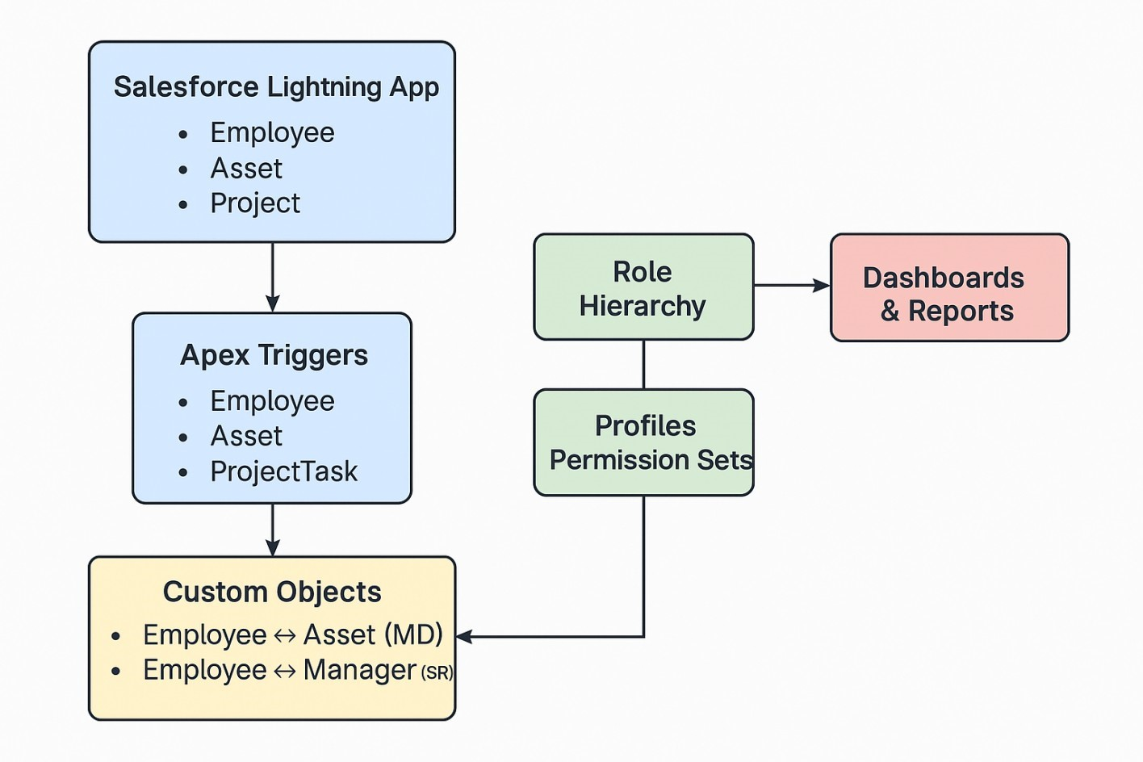

**Example - System Architecture & Data Flow for Workforce Administration Digram.**

**Project Planning Phase**

**Project Planning Template (Product Backlog, Sprint**

**Planning, Stories, Story points)**

**Product Backlog, Sprint Schedule, and Estimation (4 Marks)**

|  |  |  |  |  |
| --- | --- | --- | --- | --- |
| **Sprint** | **Functional**  **Requirement (Epic)** | **User Story Number** | **User Story / Task** | **Stor** |
| Sprint-1 | Employee object | USN-1 | As an HR admin, I can create an employee record with a reporting manager using a custom Employee object. |  |
| Sprint-1 | Asset mapping | USN-2 | As an admin, I can assign assets to employees using a master-detail relationship between Employee and Asset objects. |  |
| Sprint-2 | Leave Approval Automation | USN-3 | As an employee, I can request leave and trigger an approval process based on the number of leave days requested. |  |
| Sprint-2 | Duplicate Record Prevention | USN-4 | As a system, I should prevent the creation of duplicate employee names using an Apex trigger during record submission. |  |
| Sprint-2 | Security & Access control | USN-5 | As an admin, I can control user access through Profiles, Roles, and Permission Sets to ensure secure data visibility. |  |
| Sprint-2 | Project Assignment Dashboard | USN-6 | As a manager, I can view dashboards showing employee participation, project distribution, and asset usage metrics. |  |
| Sprint-3 | Lightning App Navigation | USN-7 | As a user, I can navigate all relevant tabs and features through a Lightning App designed for workforce administration. |  |
| Sprint-3 | Reporting &Analytics | USN-8 | As a team lead, I can access reports that summarize employee attendance, project assignments, and asset tracking trends. |  |

|  |  |
| --- | --- |
| Date |  |
| Team ID | LTVIP2025TMID29792 |
| Project Name | Workforce Administration |
| Maximum Marks |  |

|  |  |  |  |  |  |
| --- | --- | --- | --- | --- | --- |
| **Sprint** | **Total Story Points** | **Duration** | **Srint Start Date** | **Sprint End Date (Planned)** | **Story Point Completed** |

Use the below template to create product backlog and sprint schedule

**Project Tracker, Velocity & Burndown Chart: (4 Marks)**

**Velocity Calculation**

To estimate team productivity per iteration unit, the average velocity (AV) is calculated as: **AV = Total Story Points Completed ÷ Sprint Duration (in Days)** Given:

Total Story Points = 20

Sprint Duration = 10 Days

**Average Velocity = 20 ÷ 10 = 2 story points/day**

Thus, the team's **average velocity is 2 story points per day**

|  |  |  |  |  |  |
| --- | --- | --- | --- | --- | --- |
|  |  |  |  |  | **Planned En** |
| Sprint-1 | 20 | 2 Days | 20 Oct 2022 | 22 Oct 2022 | 20 |
| Sprint-2 | 20 | 2 Days | 23 Oct 2022 | 24 Nov 2022 |  |
| Sprint-3 | 20 | 2 Days | 25 Nov 2022 | 26 Nov 2022 |  |
| Sprint-4 | 20 | 2 Days | 27 Nov 2022 | 28 Nov 2022 |  |
|  |  |  |  |  |  |
|  |  |  |  |  |  |

📊 **Burndown Chart Data**

|  |  |  |
| --- | --- | --- |
| **Day** | **Planned Story Points Remaining** | **Actual Story Points Remaining** |
| Day 1 (20 Jun) | 30 | 30 |
| Day 2 (21 Jun) | 25 | 27 |
| Day 3 (22 Jun) | 20 | 22 |
| Day 4 (23 Jun) | 15 | 18 |
| Day 5 (24 Jun) | 10 | 12 |
| Day 6 (25 Jun) | 5 | 6 |
| Day 7 (26 Jun) | 0 | 3 |
| Day 8 (27 Jun) | — | 1 |
| Day 9 (28 Jun) | — | 0 |

Format the chart:

X-axis: Days

Y-axis: Story Points Remaining

Add a legend to distinguish **Planned** vs. **Actual** lines.

This will give you a clean visual showing how my team progressed across the sprint timeline.

## Project Design Phase Problem – Solution Fit Template

|  |  |
| --- | --- |
| Date |  |
| Team ID | LTVIP2025TMID29792 |
| Project Name | Work force Administration(dev) |
| Maximum Marks |  |

**Problem – Solution Fit Template:**

**Problem :**

The Smart Bridge faces difficulty in managing employees across multiple projects and tracking the status of their assets. Current workflows rely on manual record-keeping, resulting in inefficiencies, inconsistent reporting, and limited visibility for HR and project managers.

**Solution :**

A Salesforce-based Workforce Administration Solution that centralizes employee data, automates asset assignment, and provides real-time dashboards for team performance and project tracking**.**

**Purpose:**

Solve the complex challenge of distributed employee tracking and resource oversight.

Accelerate process adoption using familiar cloud-based tools and web interfaces.

Increase communication clarity with role-based dashboards and automation flows.

Build trust and improve internal operations by offering transparency and centralized control.

Understand and elevate workforce performance through customized reports and visual KPIs.

**Template:**

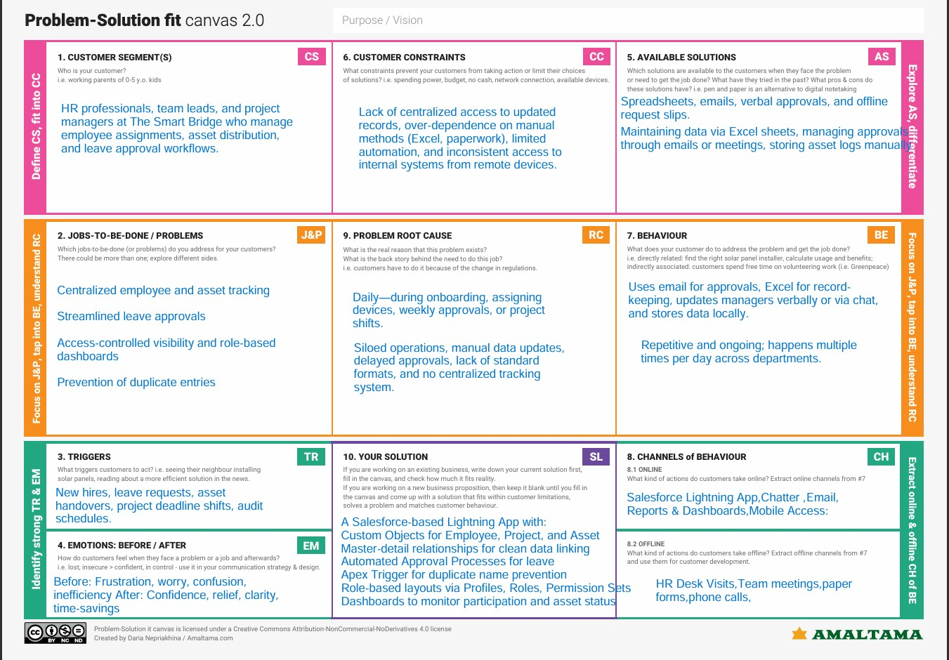

References:

https://www.ideahackers.network/problem-solution-fit-canvas/ https://medium.com/@epicantus/problem-solution-fit-canvas-aa3dd59cb4fe

# User Acceptance Testing (UAT) Template

|  |  |
| --- | --- |
| Date | 28-06-2025 |
| Team ID | LTVIP2025TMID29792 |
| Project Name | Workforce Administration (DEV) |
| Maximum Marks |  |

**Project Overview:**

Project Name: [Workforce Administration]

Project Description: [A centralized Salesforce-based application to manage employee records, project participation, asset tracking, and leave approval workflows for The SmartBridge.]

Project Version: [V1.0]

Testing Period: [25 June 2025] to [ 28 June 2025]

**Testing Scope:**

**Features to Be Tested:**

Employee object creation with reporting structure

Asset assignment via master-detail relationships

Leave approval automation

Apex trigger for duplicate prevention

Profiles, roles, and permission control

Dashboards and reports

**User Stories/Requirements Covered:** USN-1 to USN-8 – covering all epics related to HR automation, project mapping, and reporting.

**Testing Environment:**

URL/Location: [https://developer.salesforce.com/]

Credentials (if required): [Username : rejectedpeace814319@agentforce.com

Password : 236K1A044]

**Test Cases:**

|  |  |  |  |  |
| --- | --- | --- | --- | --- |
| **Test**  **Scenario** | **Test Steps** | **Expected Result** | **Actual Result** | **Pass/Fail** |
| Tc -001 | Employee creation and  hierarchy assignment | 1Navigate to  Employee tab  2Create new record  3Assign manager | Employee record was successfully created with  assigned reporting manage | **[**✔**]** |
| Tc -002 | Asset assignment | Navigate to  Employee tab →  Create new record  → Assign manager | Asset was properly linked and displayed under the corresponding employee Record | **[**✔**]** |
| Tc -003 | Leave approval process | Submit leave request →  Approver receives it → Approver responds | Leave request triggered approval workflow and status updated in approval history | **[**✔**]** |
| Tc -004 | Duplicate entry prevention | Attempt to create employee with existing name →  Save | system prevented duplicate entry with appropriate vadilation error message | **[**✔**]** |
| Tc -005 | Dashboard  visibility based on roles | Login as manager → Open Dashboard tab | *Dashboard displayed only relevant data according to the user's role.* | **[**✔**]** |
|  |  |  |  |  |

**Bug Tracking:**

|  |  |  |  |  |  |
| --- | --- | --- | --- | --- | --- |
| **Bug**  **ID** | **Bug Description** | **Steps to reproduce** | **Severity** | **Status** | **Additional feedback** |
| BG-  001 | Leave request approval email not triggered | Submit leave request → Wait for approver email | Medium | In  Progress | Review Process Builder and email alert configurations. |
| BG-  002 | Assigned asset not showing under employee record | Assign asset → Refresh employee record | High | Open | Check master-detail relationship and object visibility settings. |
|  |  |  |  |  |  |

**Sign-off:**

Tester Name: [ALL TEAM MEMBERS]

Date: [28-6-2025]

Step1: first we created account in salesforce development (Developer Edition with Agentforce and Data Cloud - Salesforce.com)

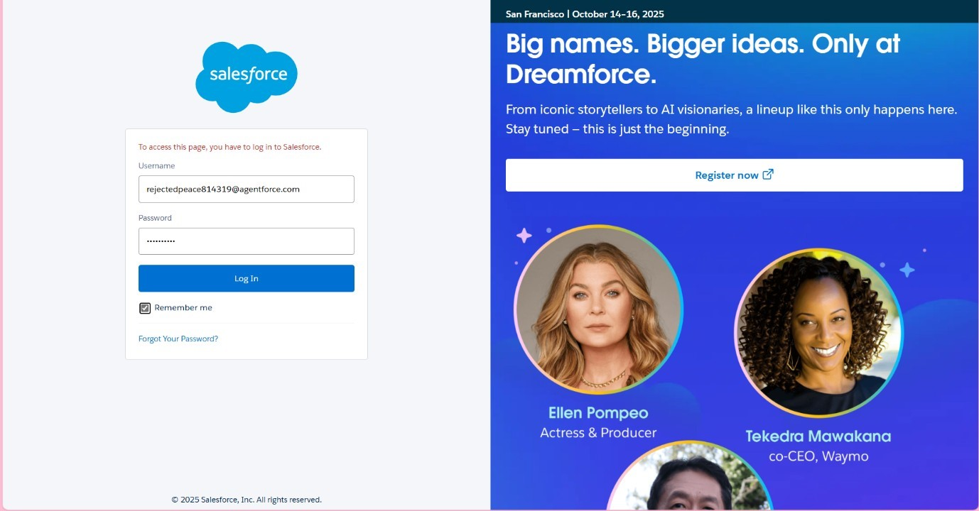

Step 2: Activated the account

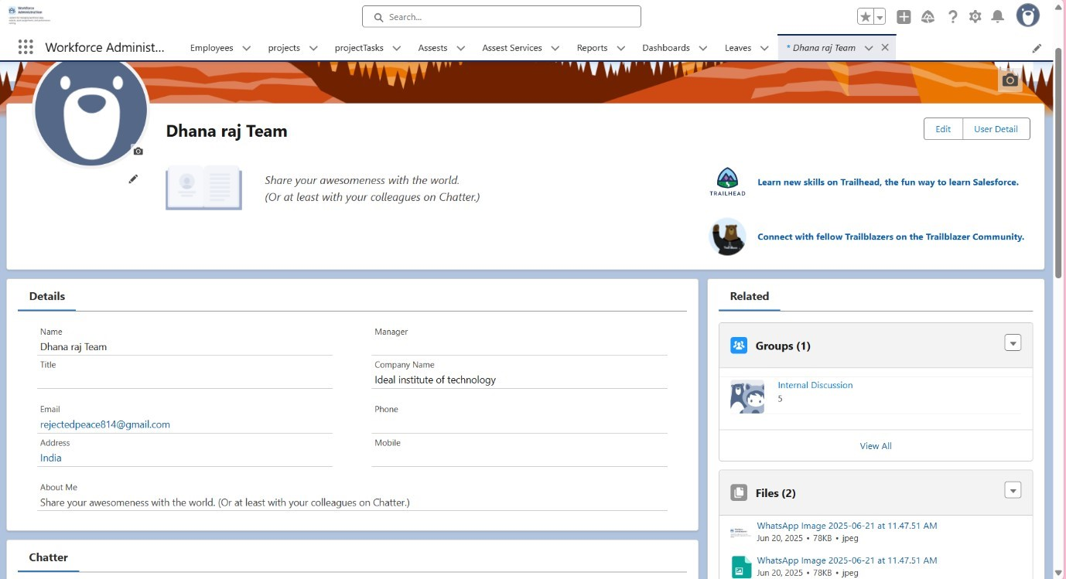

Step 3: next created Employee object

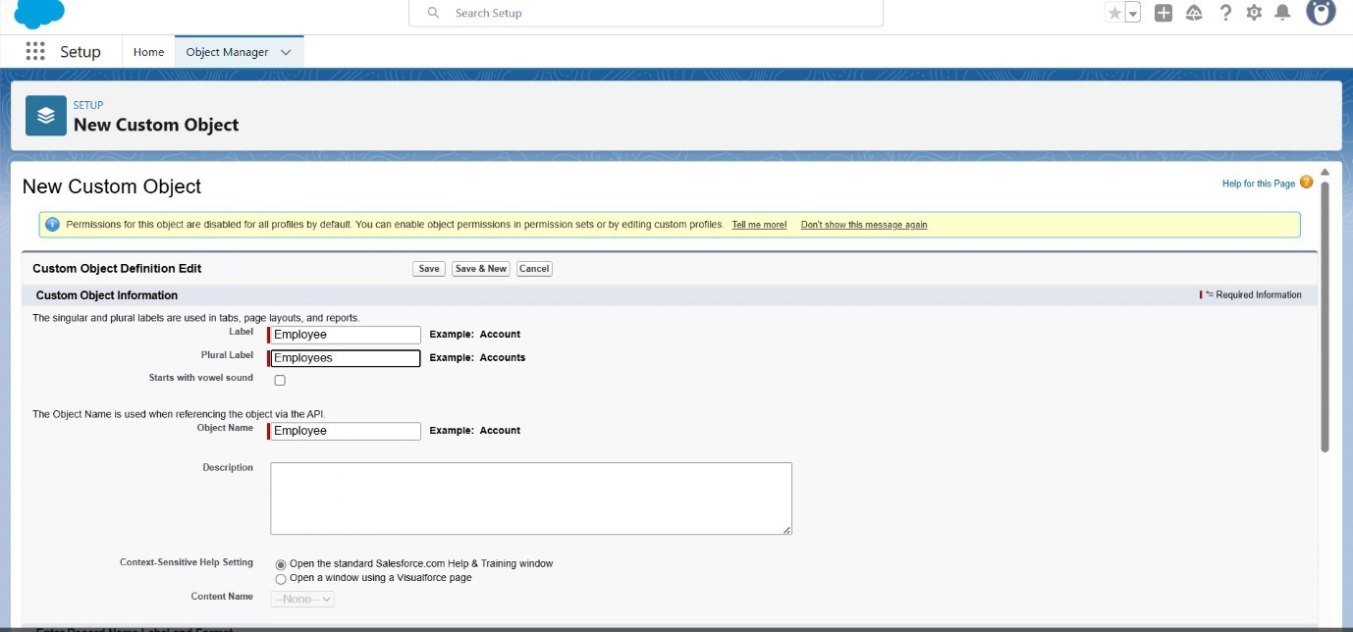

Step 4: next created custom object

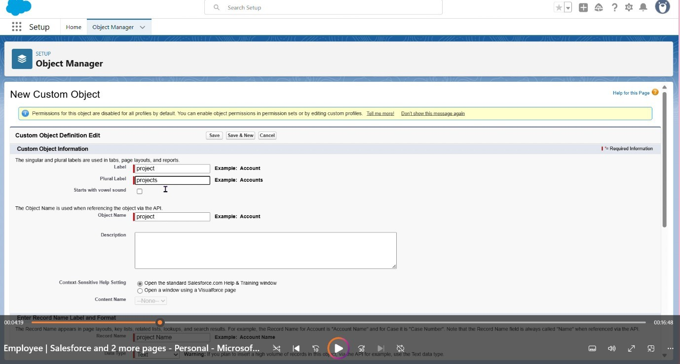

Step 5:

Created objects with names As projectTask , Assest, Assest Service

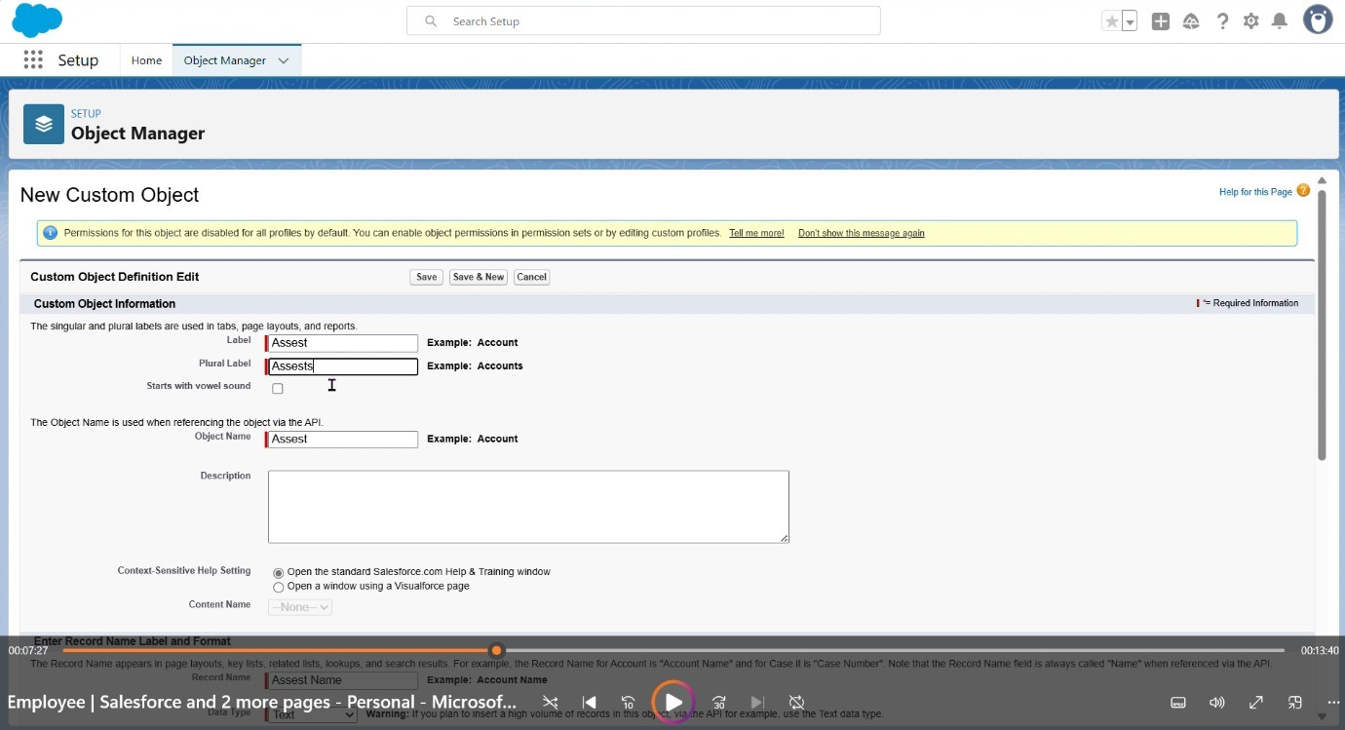

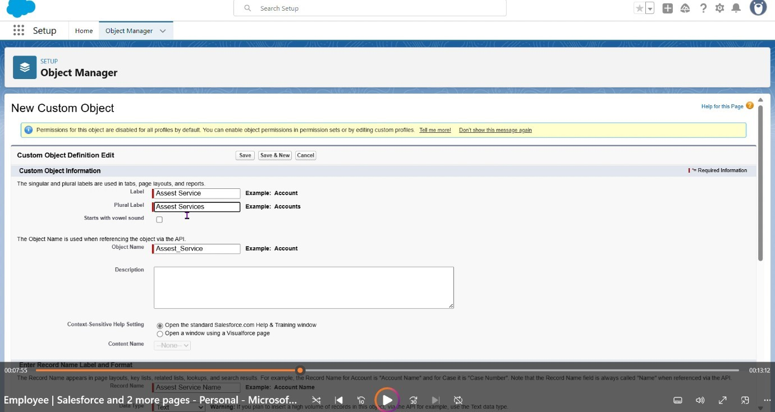

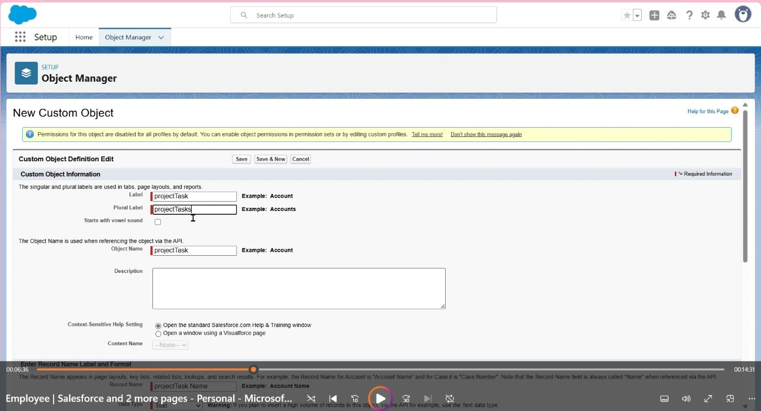

Step 6: Creating a custom tab employee

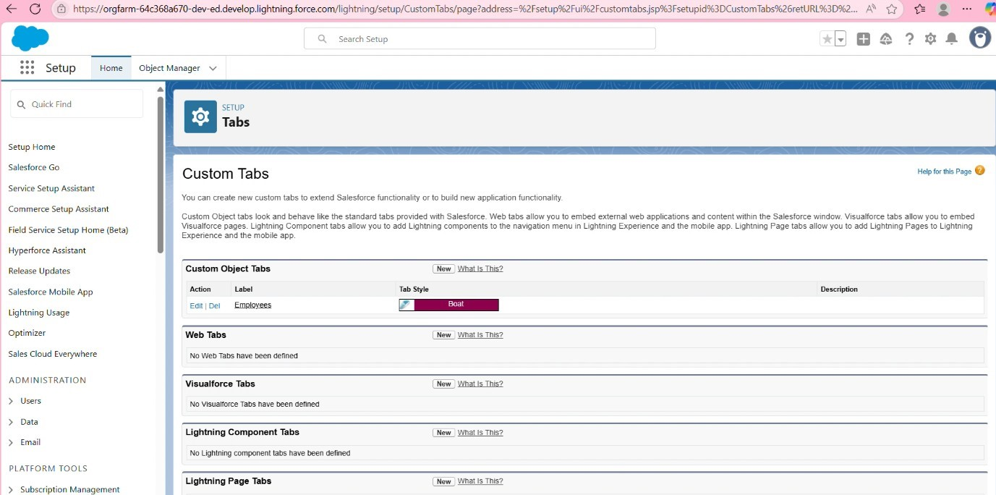

Step 7:

Creating tabs for remaining objects also

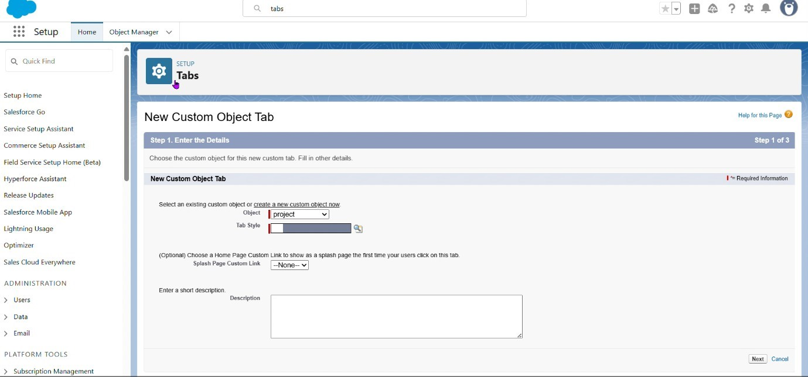

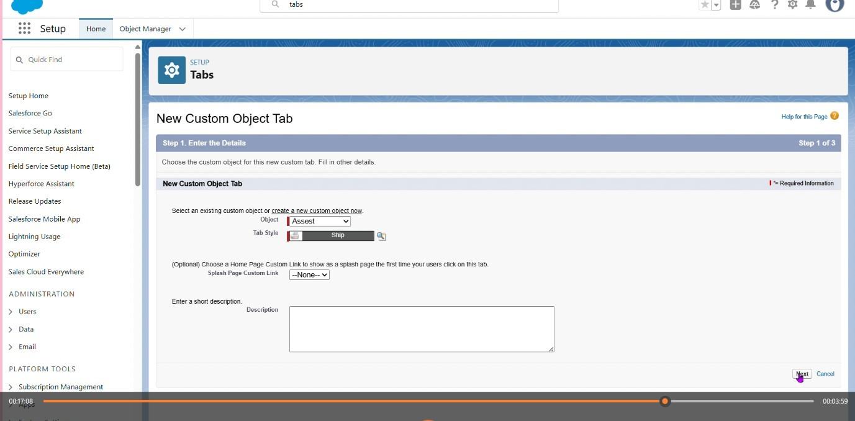

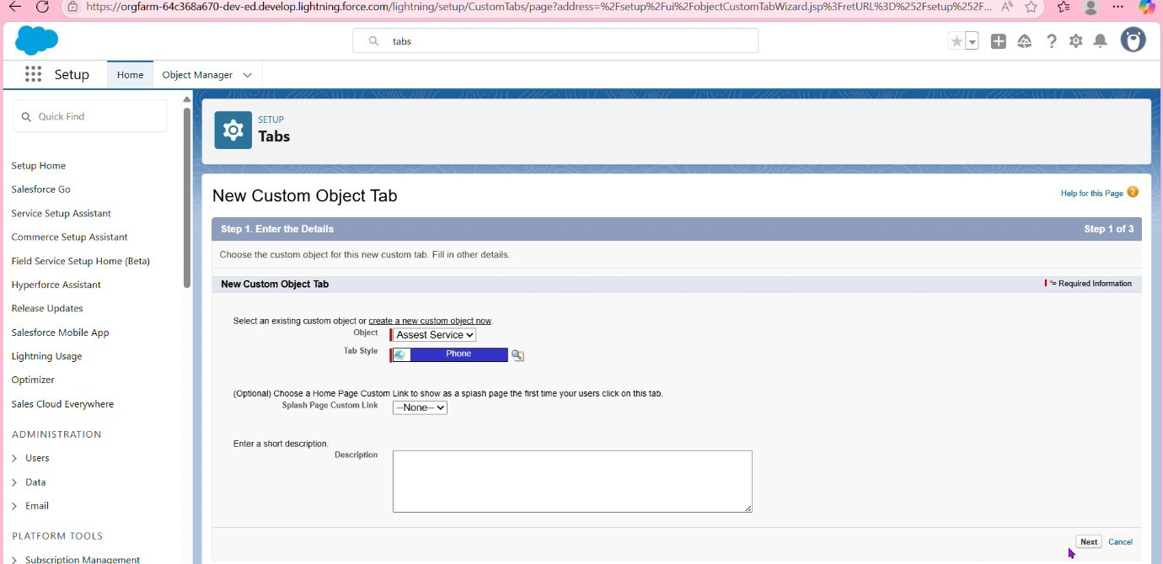

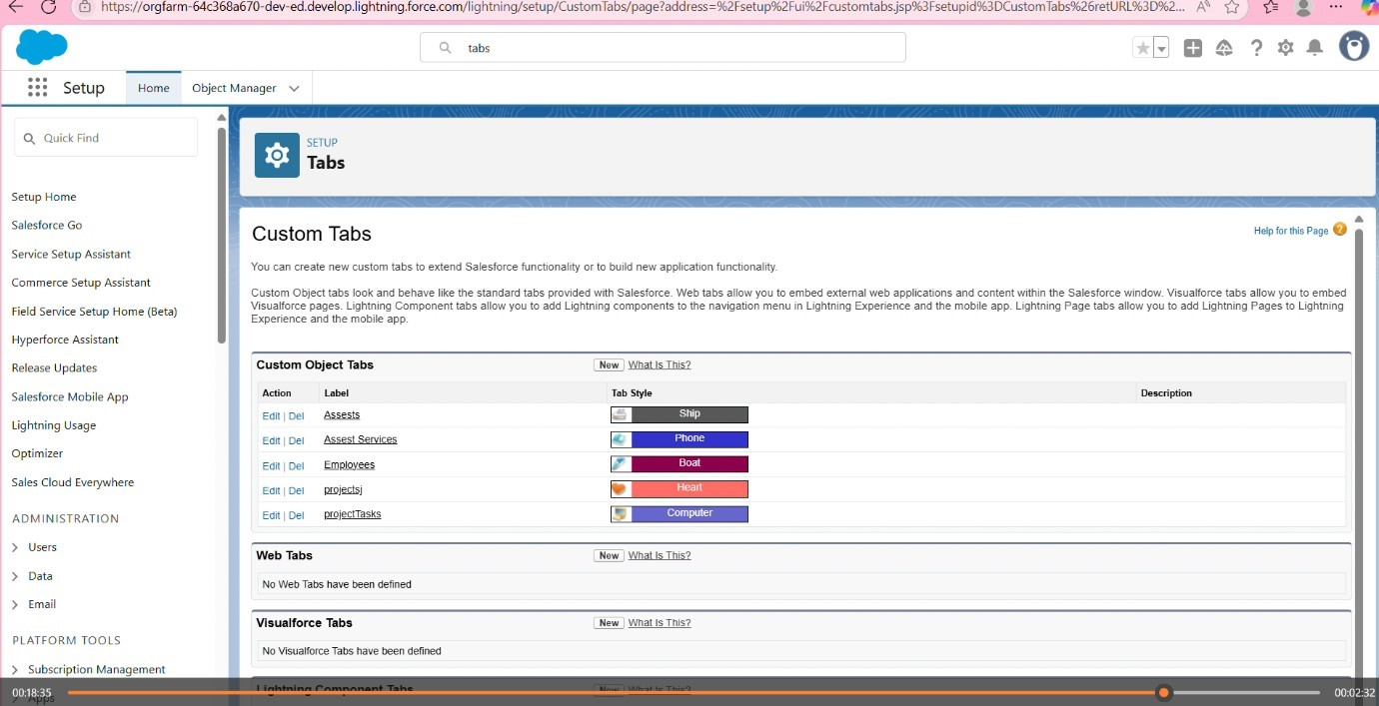

Step 8:

Creating lightening app

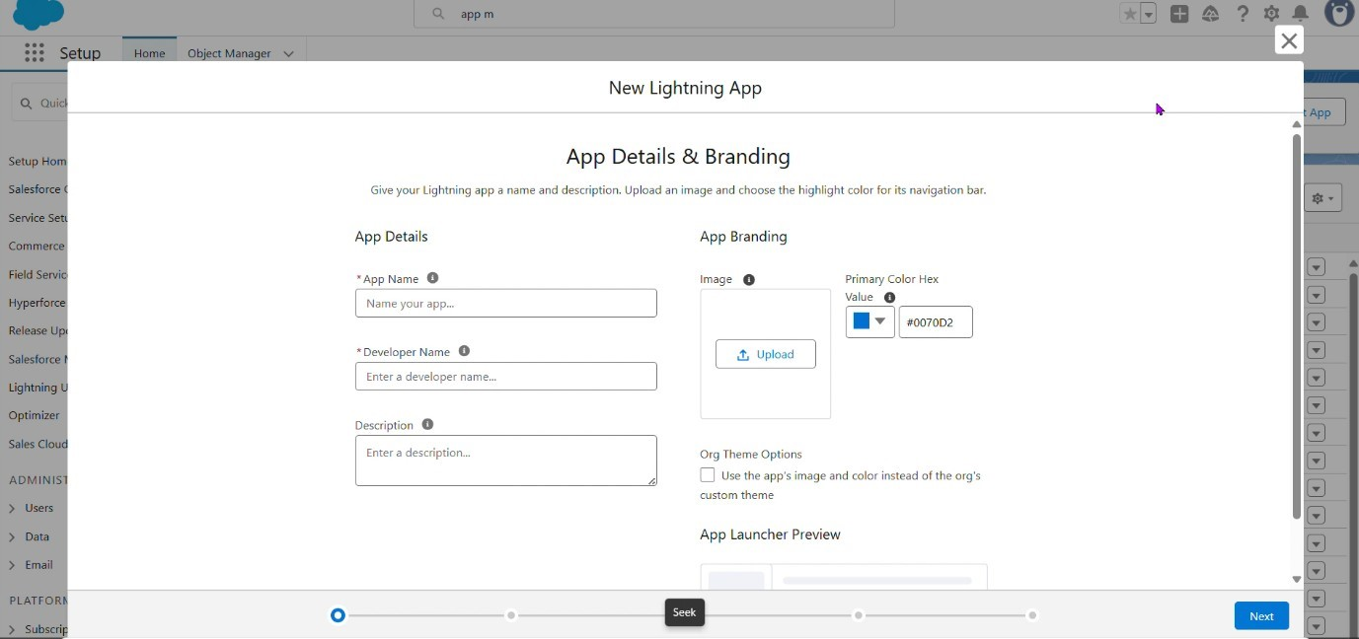

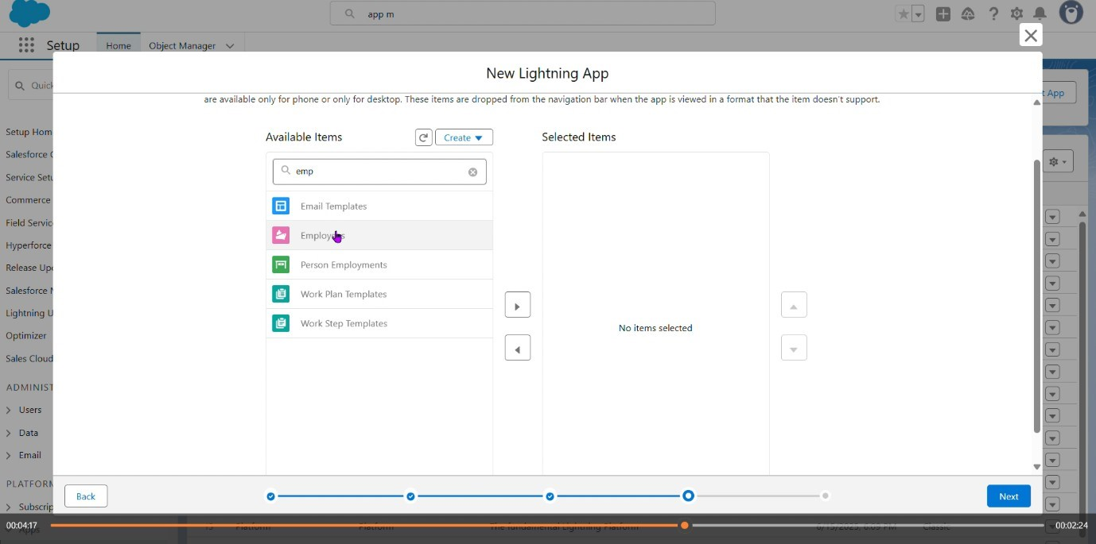

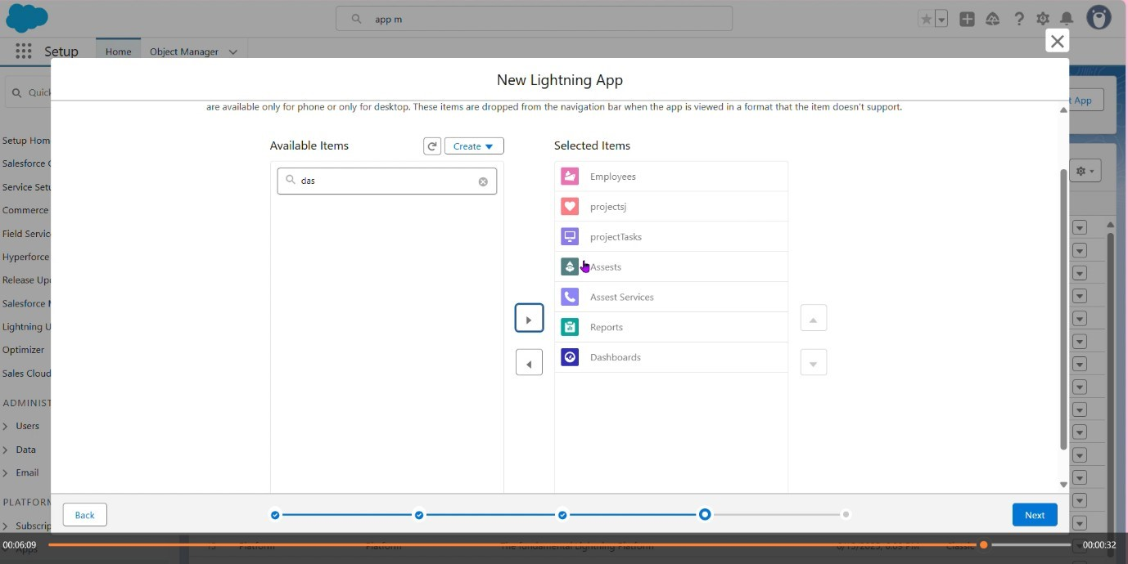

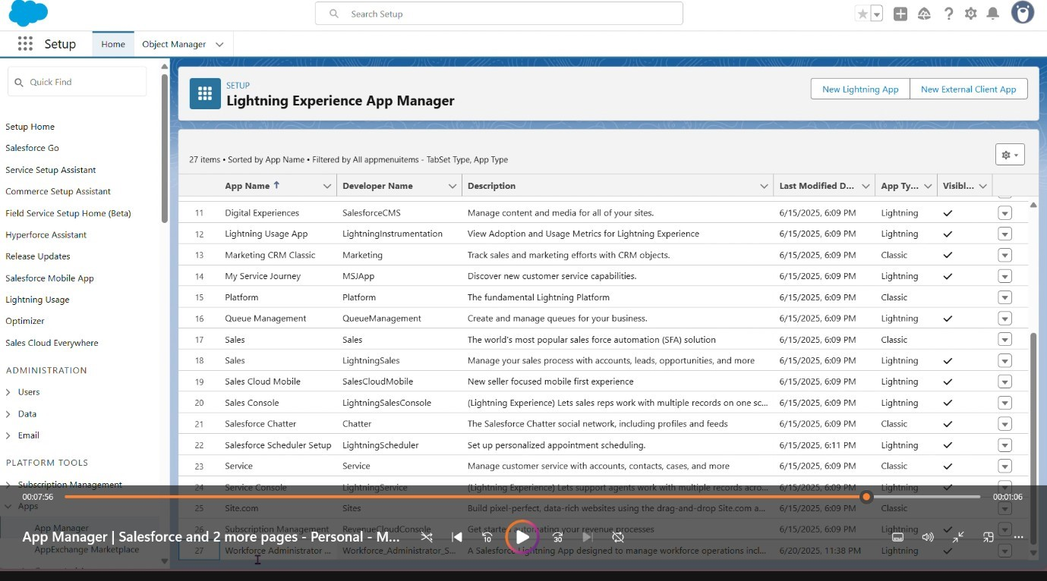

Step 9:

Creating fields and relationship

Setting owd

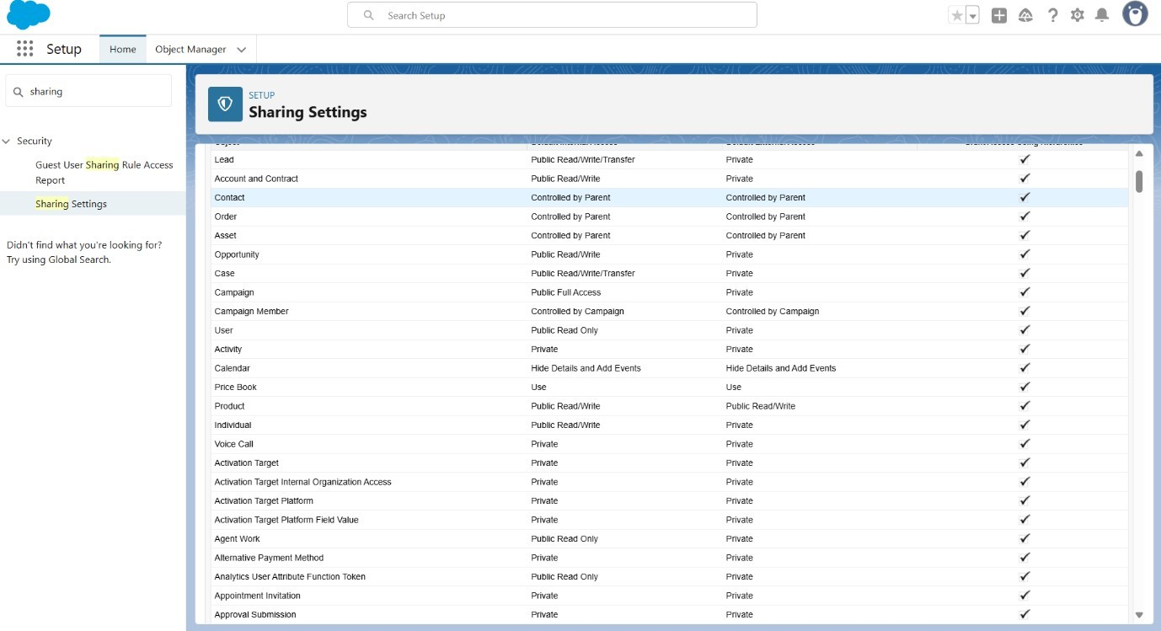

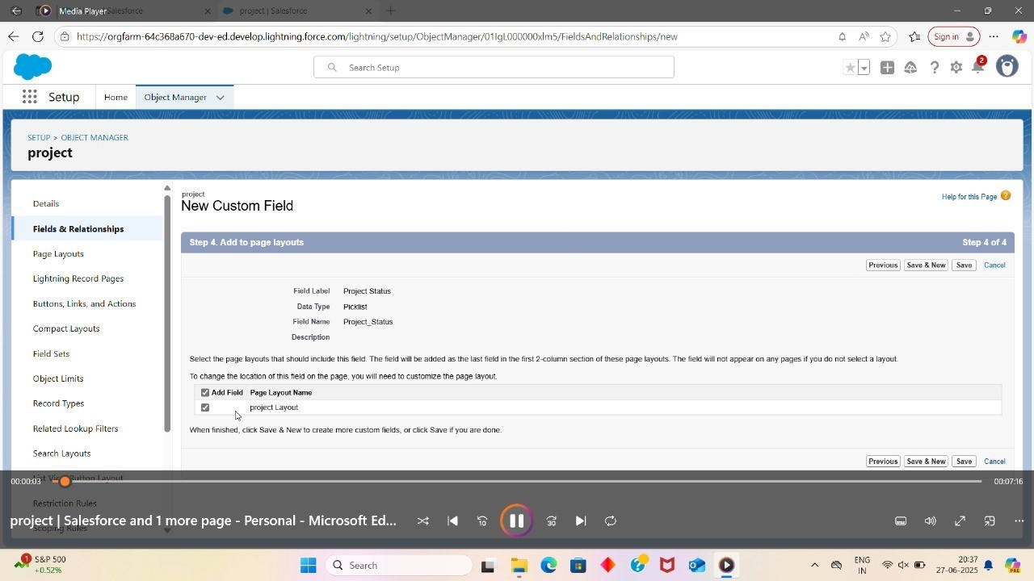

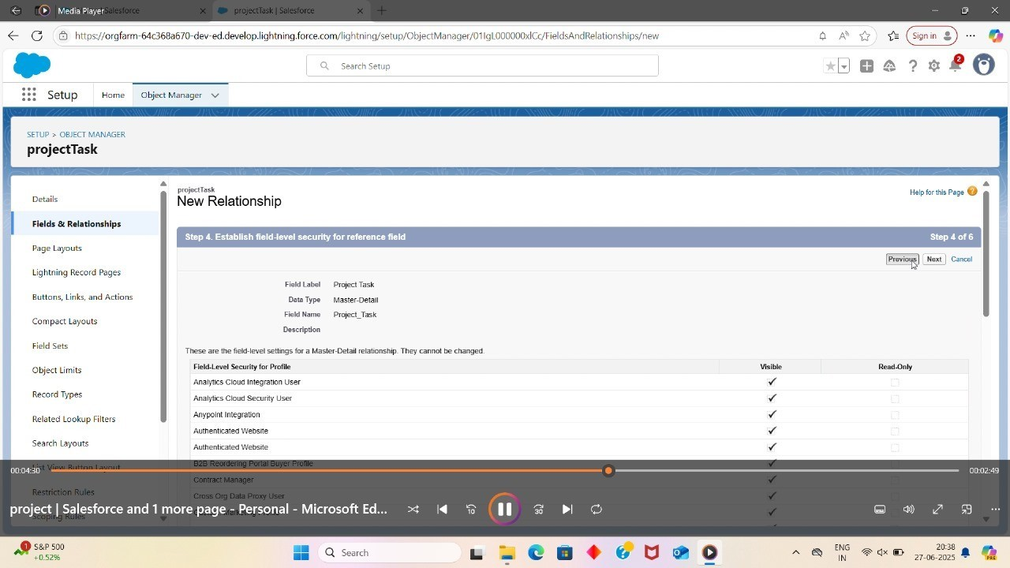

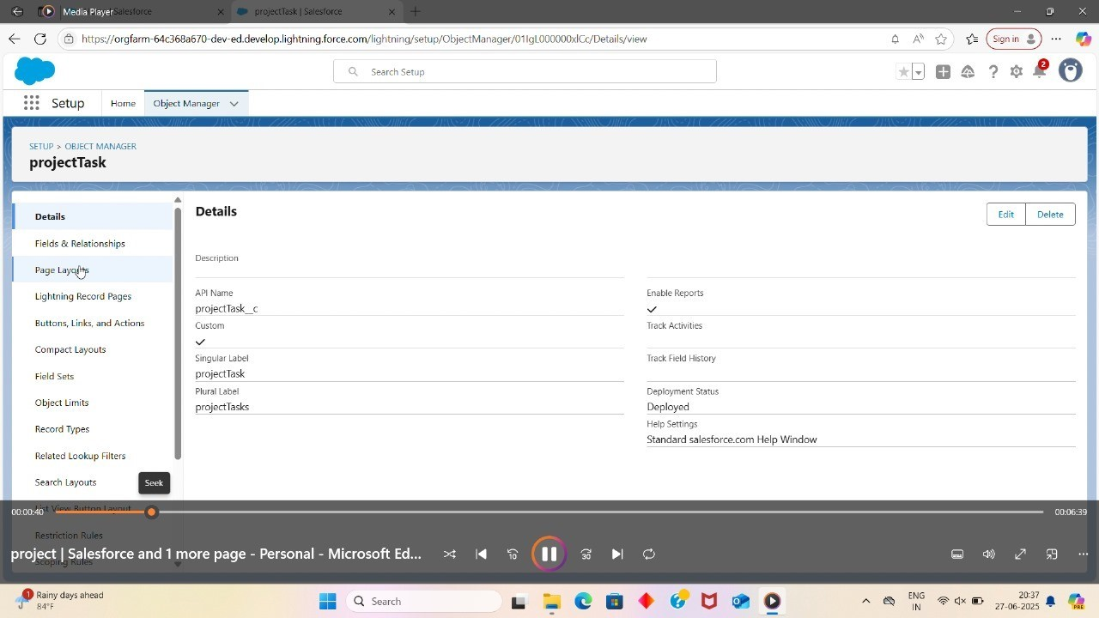

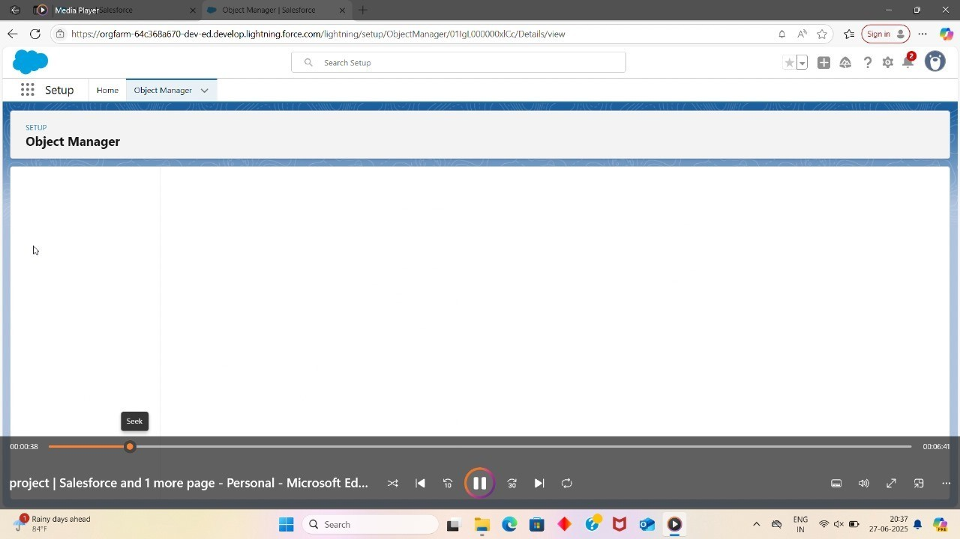

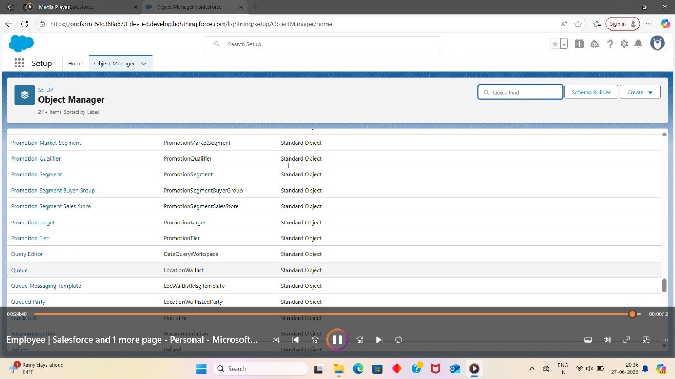

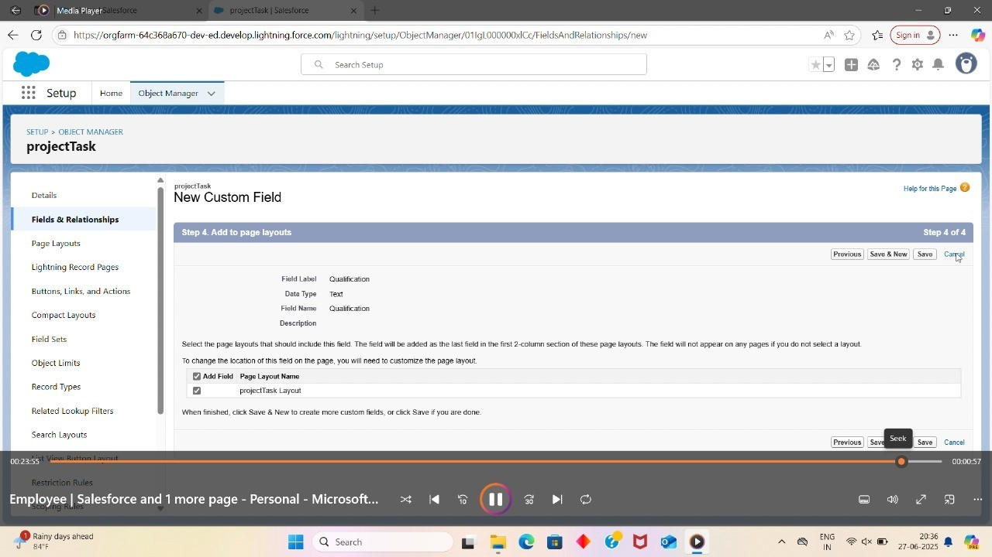

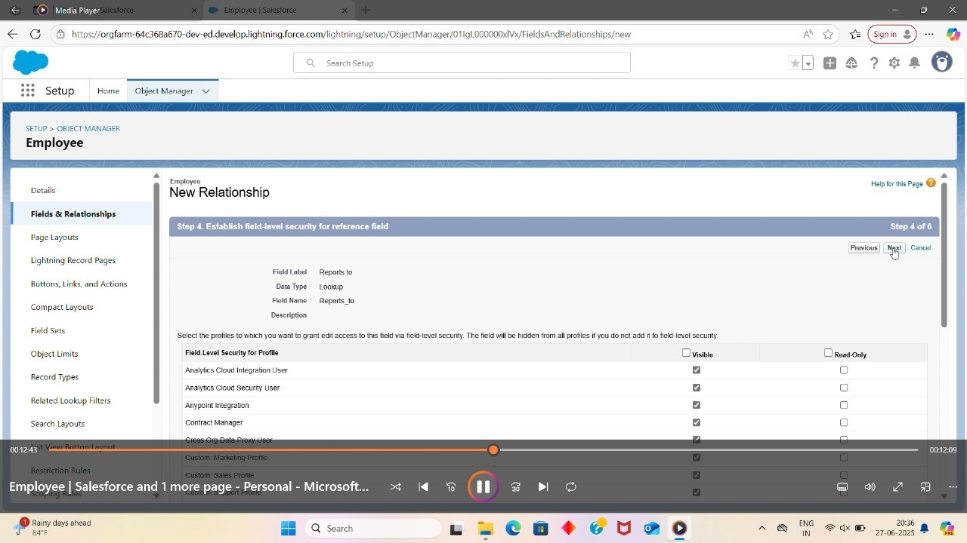

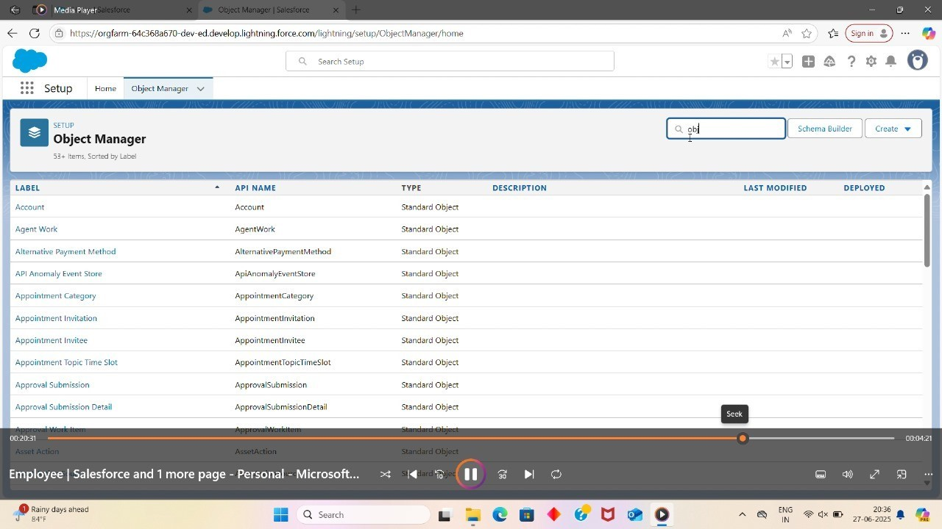

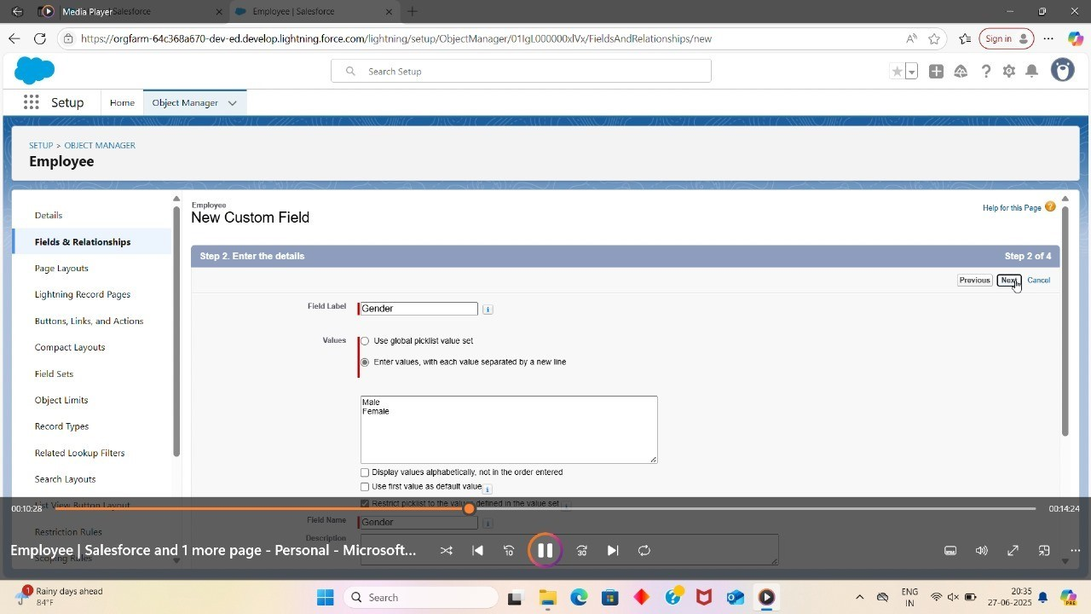

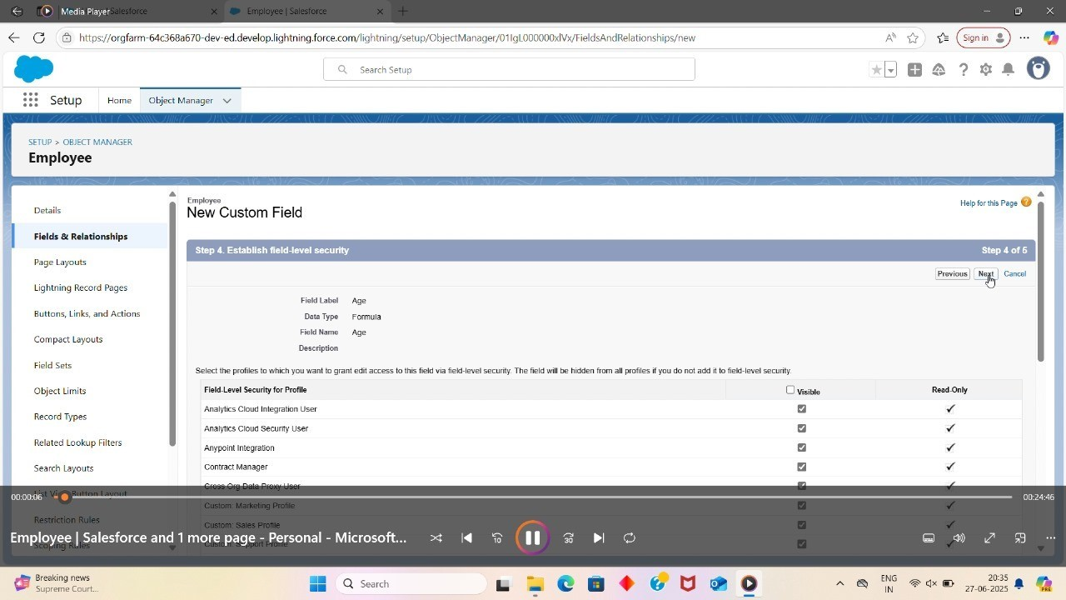

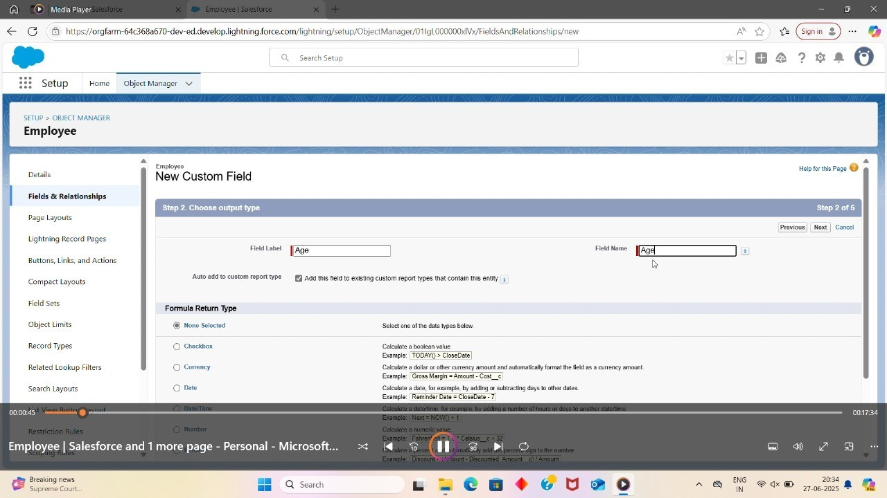

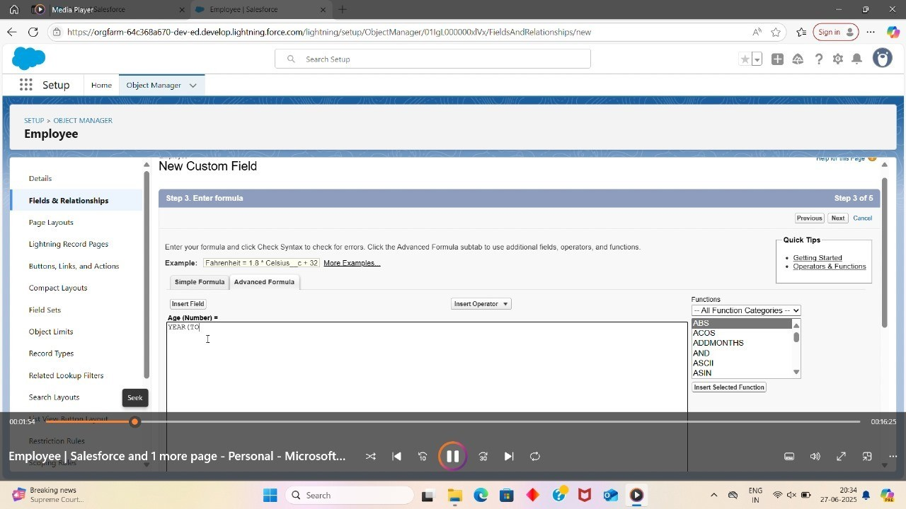

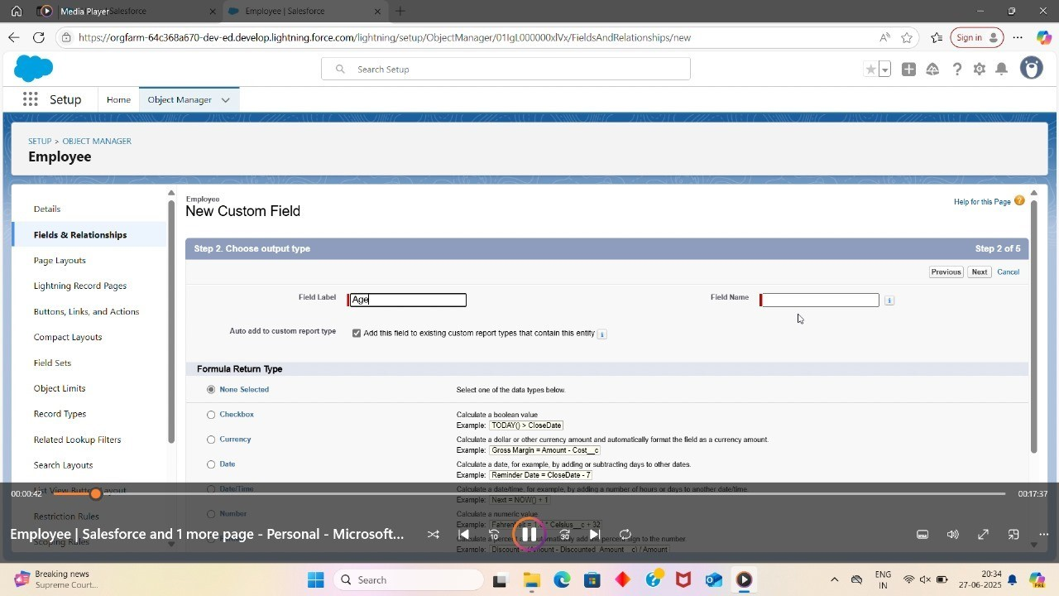

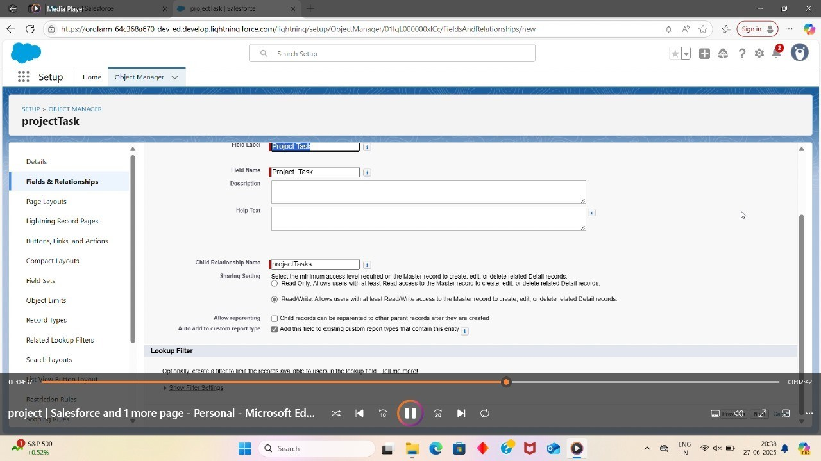

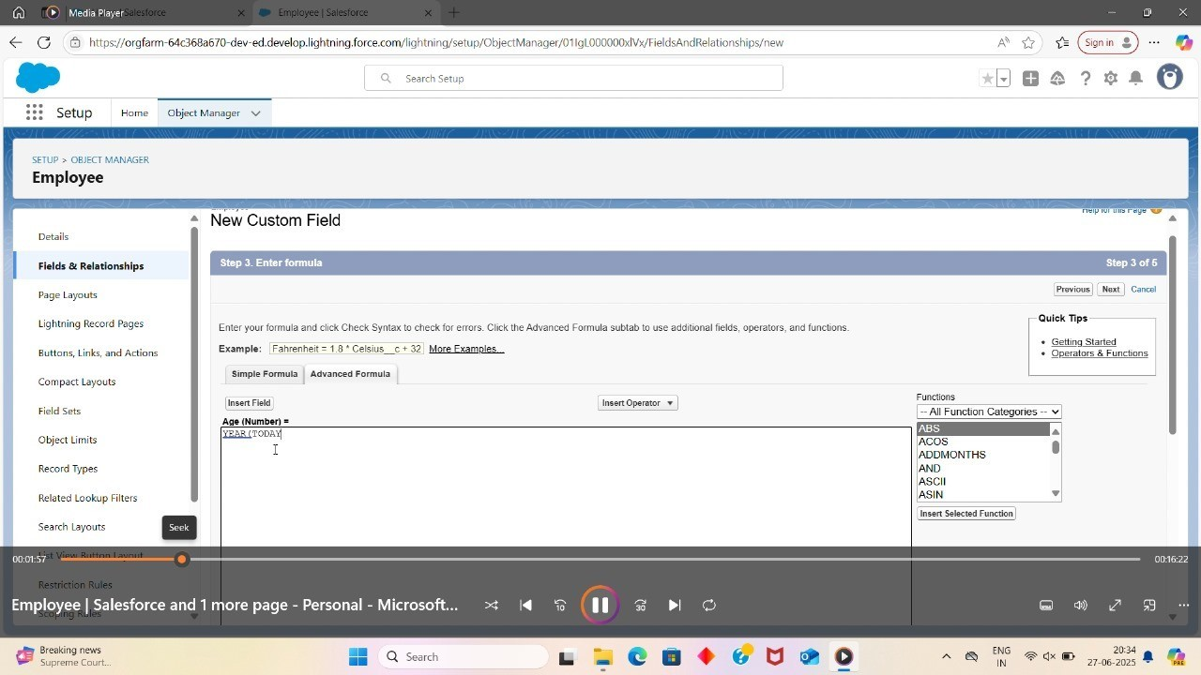

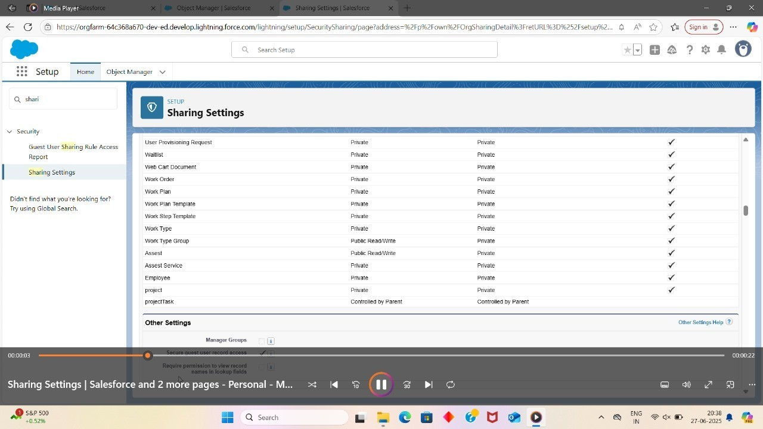

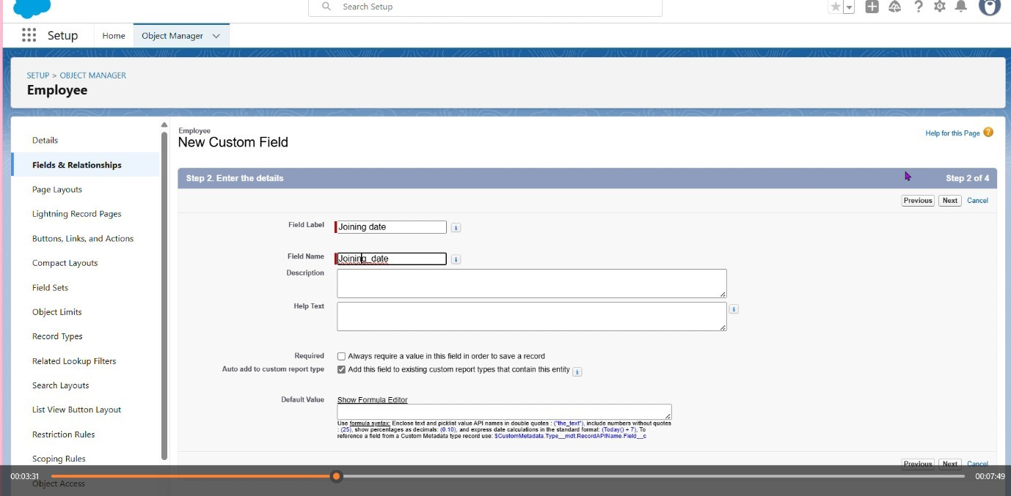

Step :

Import data Wizard

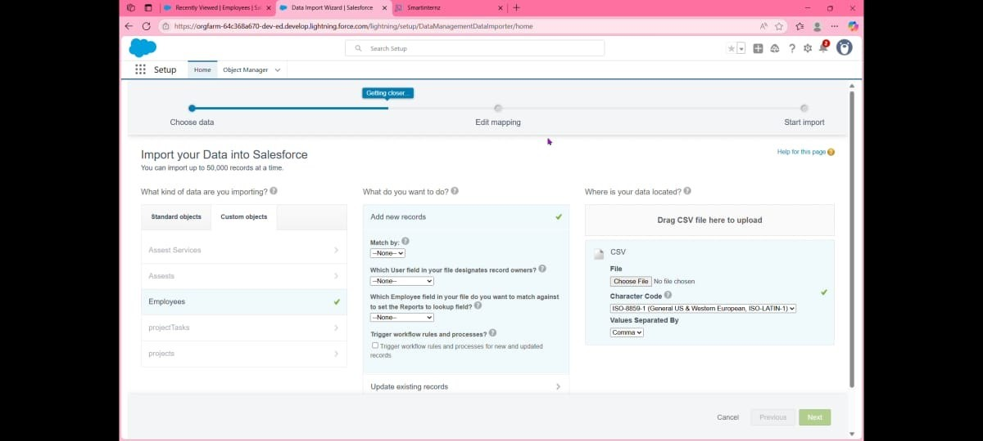



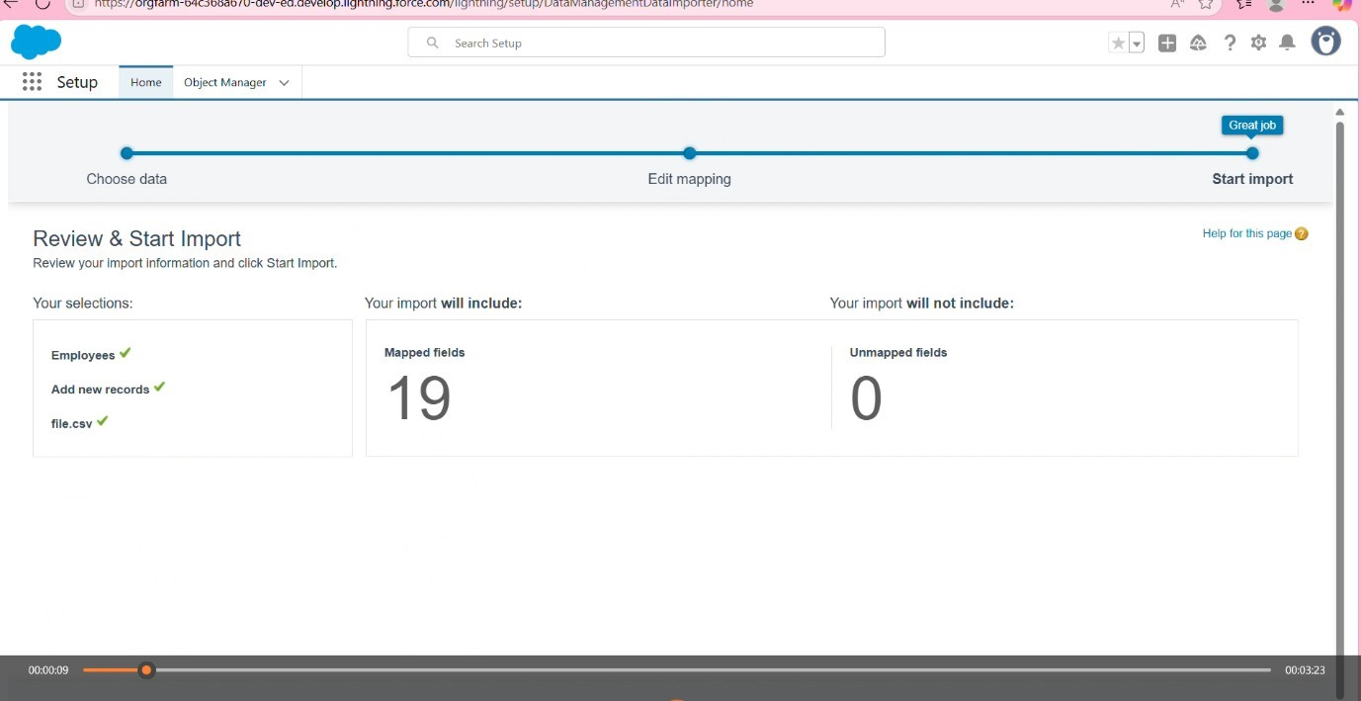

Selected the file in the csv format



sucessally imported data without any errors step : profiles

(HR profile ,manag profile,Employee profile)

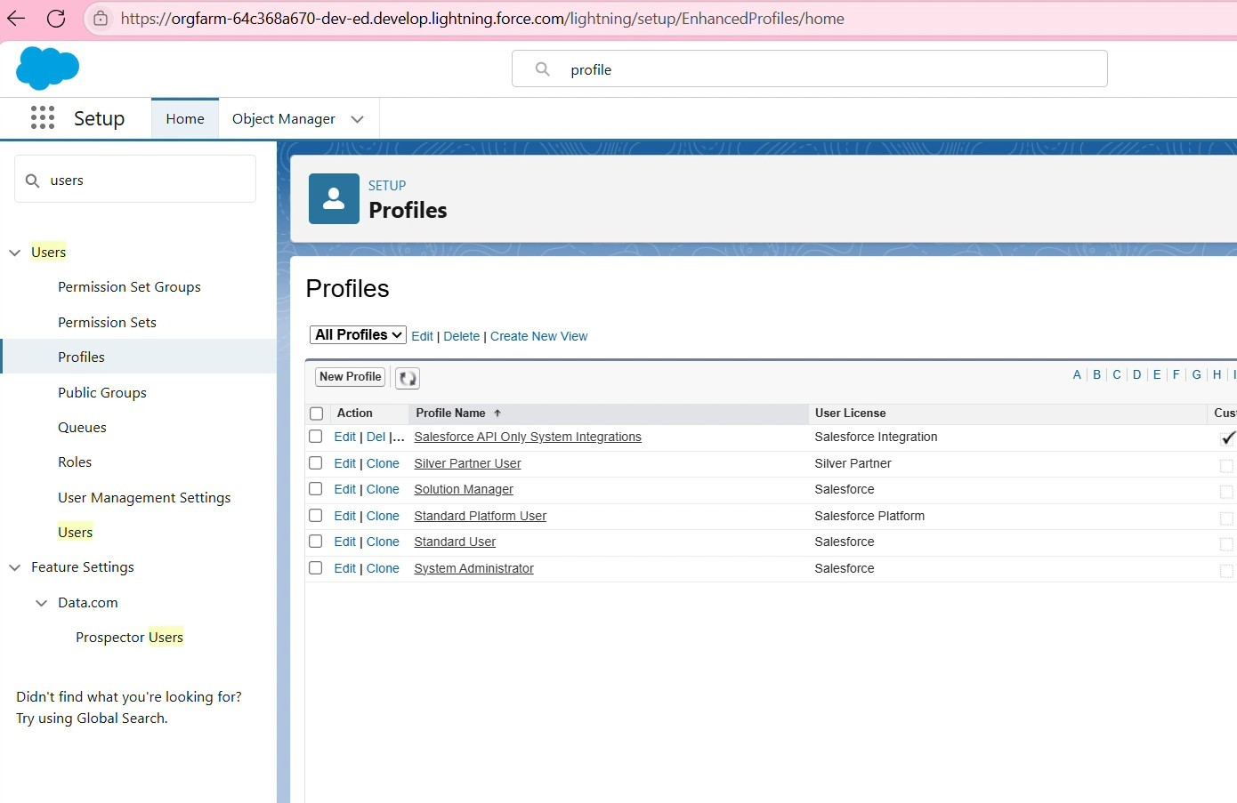

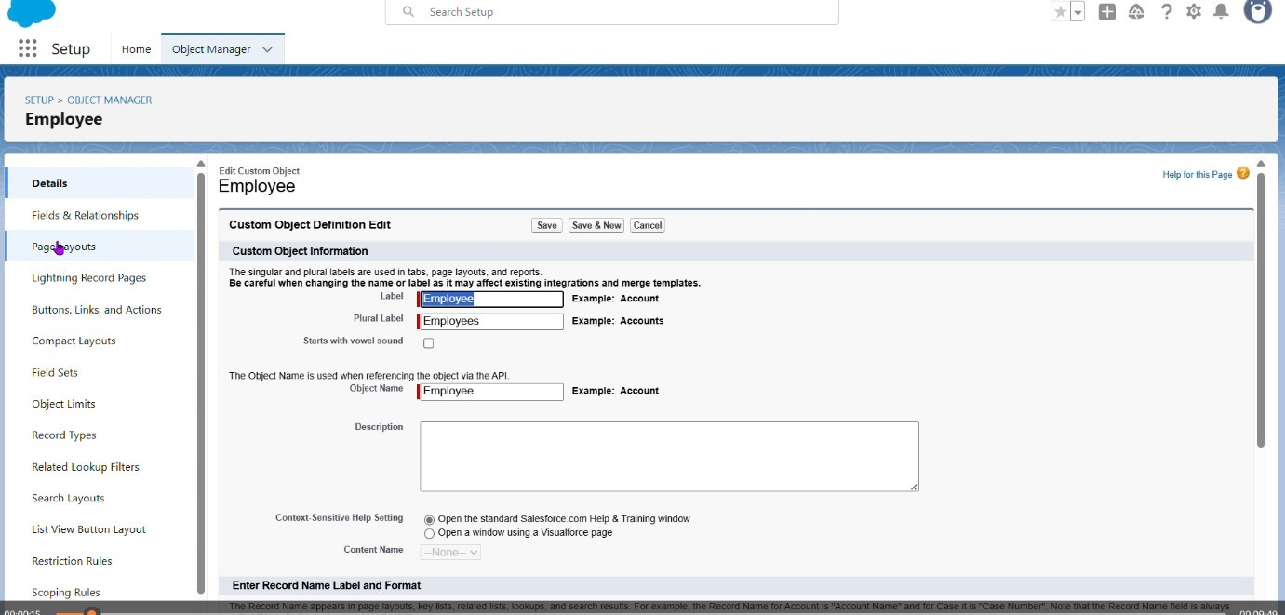

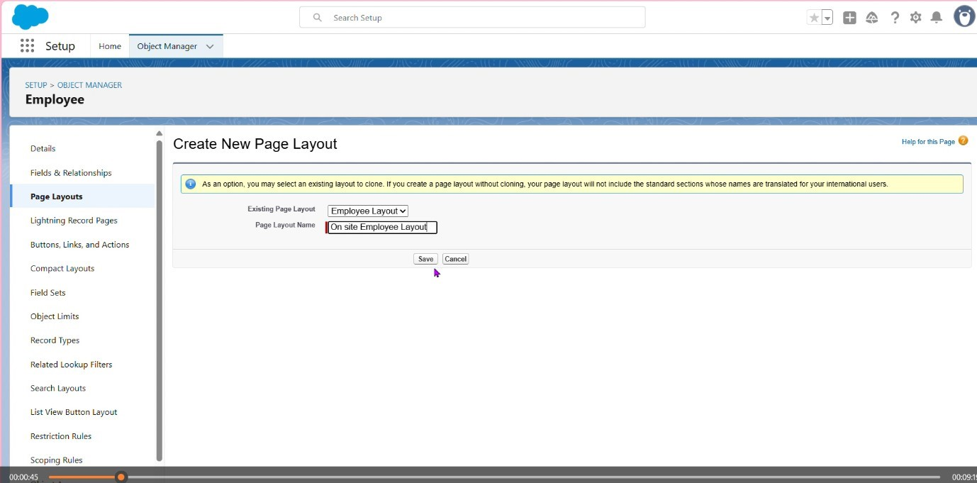

Created Employment layout

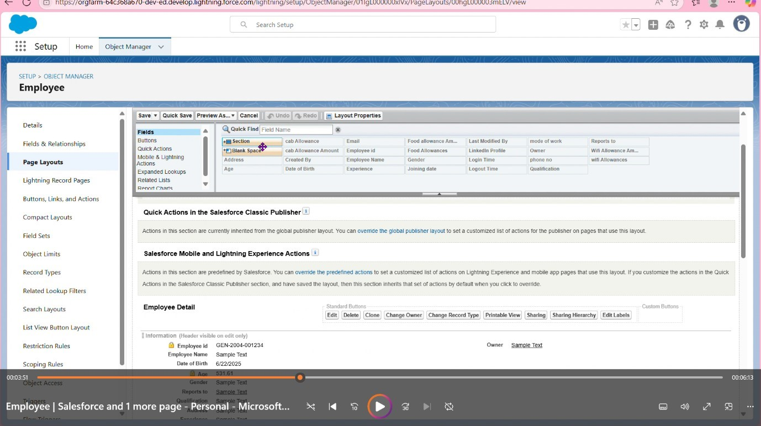

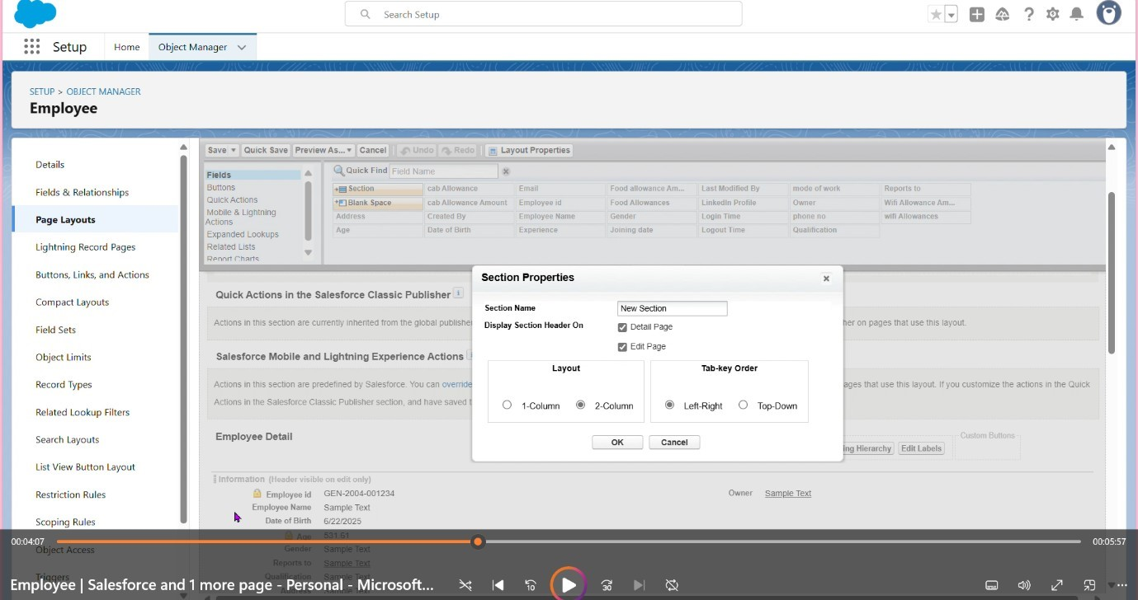

Again created new section

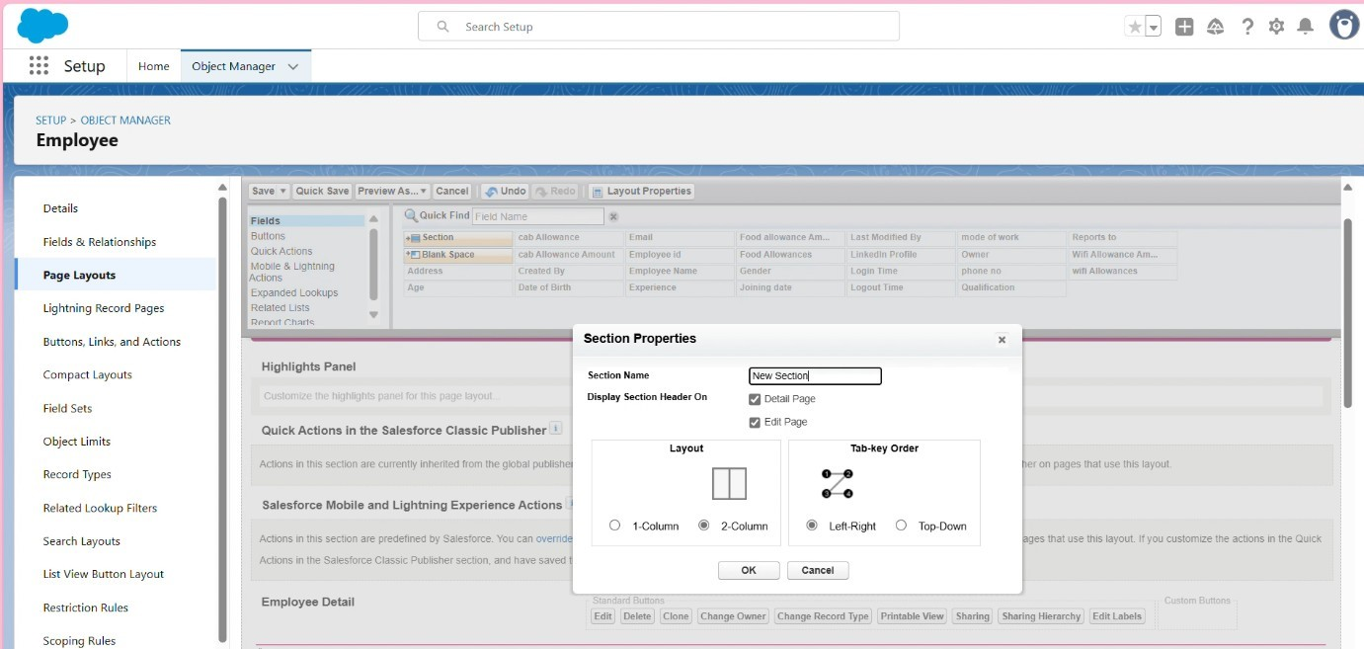

Added allowance

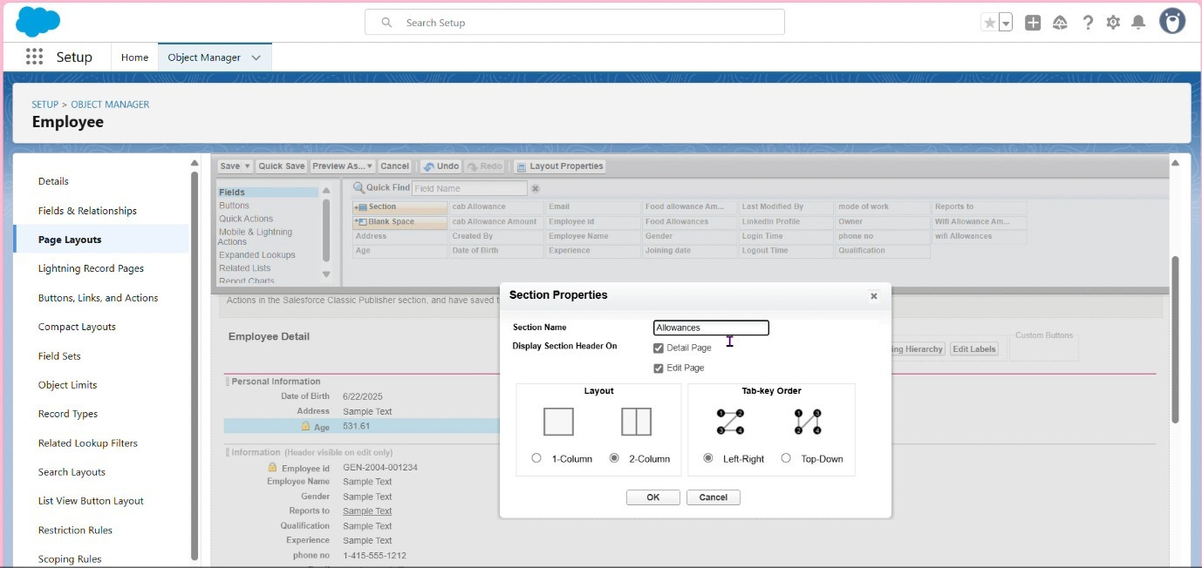

Created all fields

Created employee layout and on _site layout

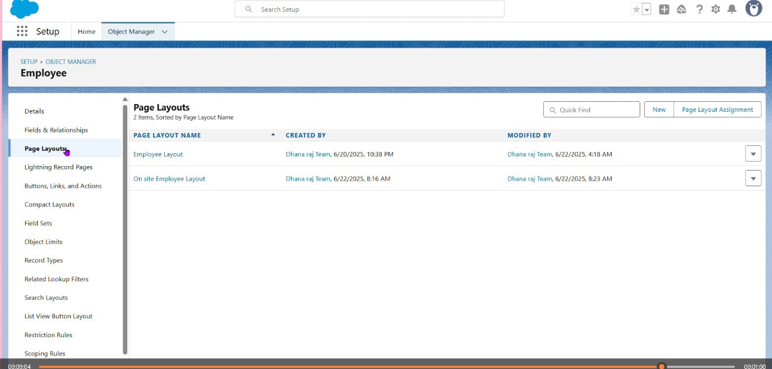

Page layouts:

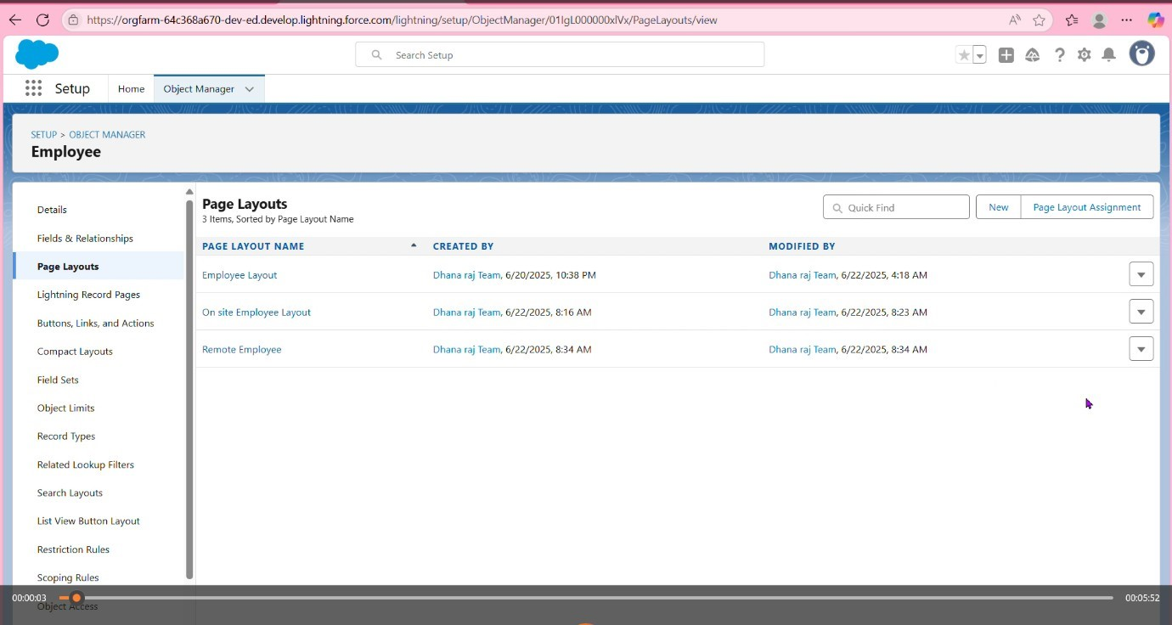

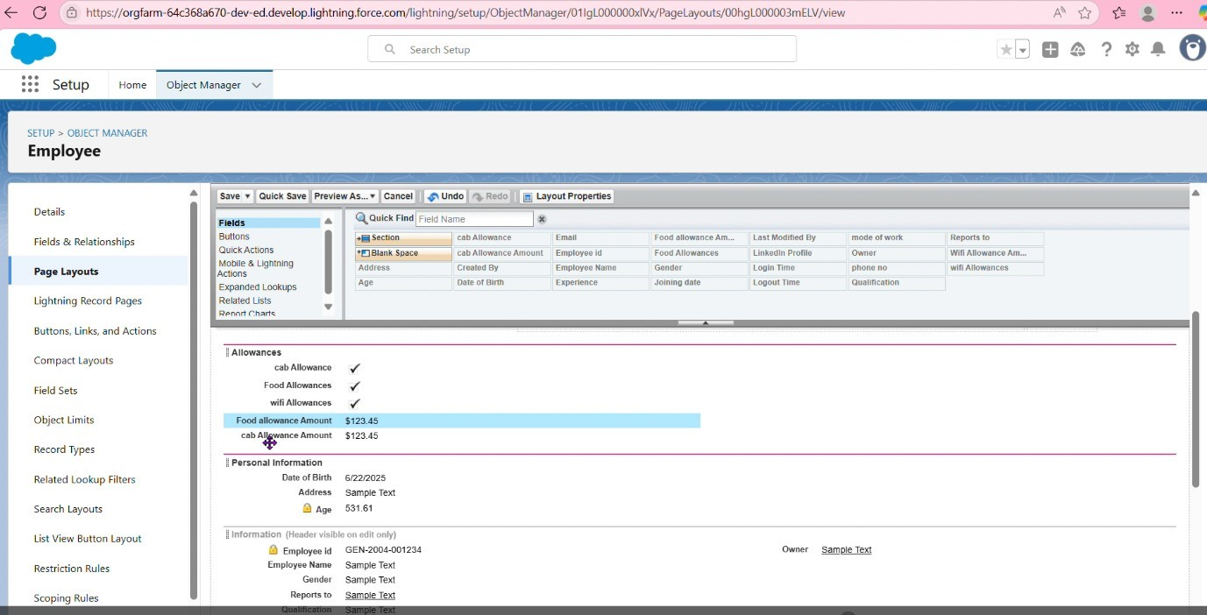

Chatter Group:

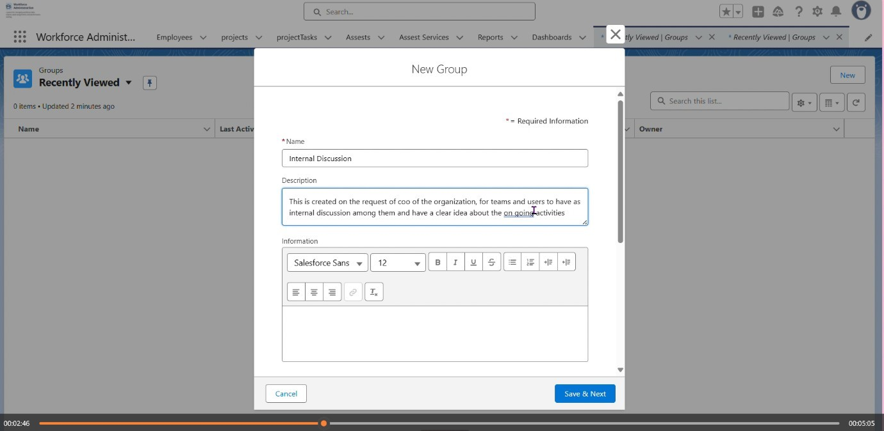

f

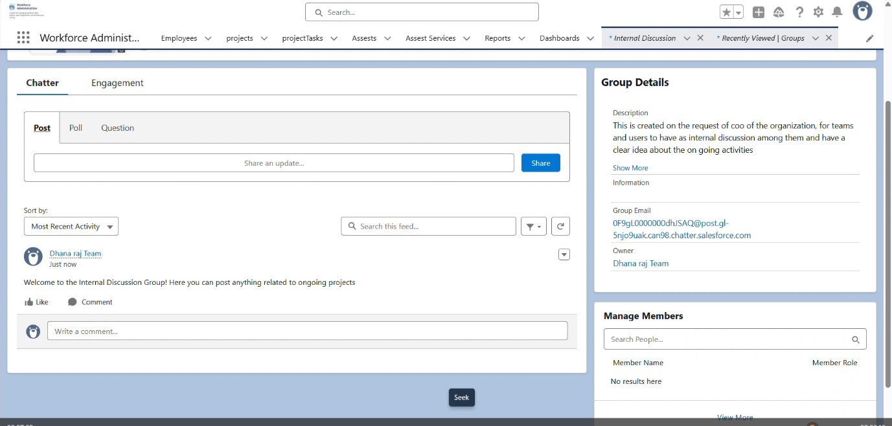

finally created Chatter group

**6.14 Record Types:**

Creating On Site Employee Record Type To Create a Record Type:

Go to Setup

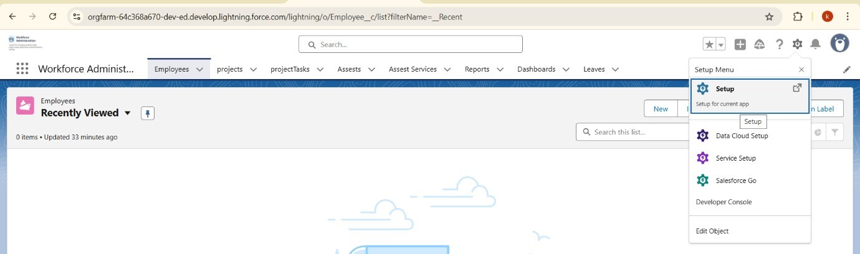

Click on Object Manager and Search for Object Employee then click on edit from drop down

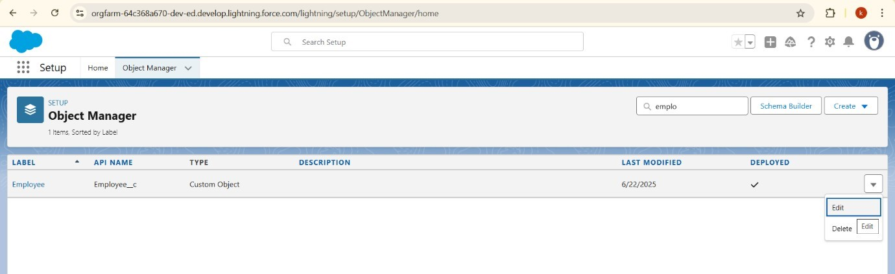

From the panel click Record Types then Select New and Give Record Type Label as “On Site Employee” and make it active

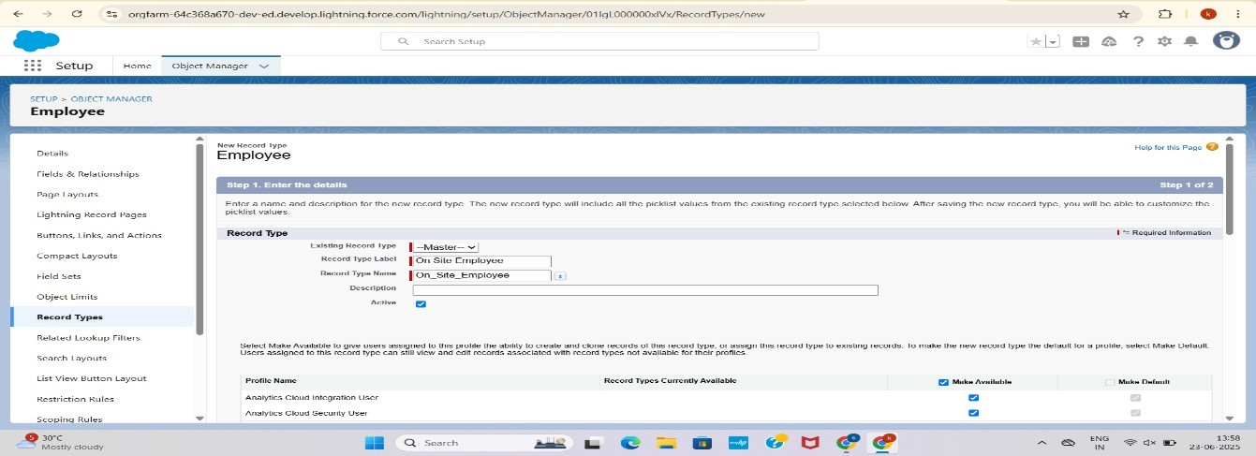

Uncheck for “Make Available”.

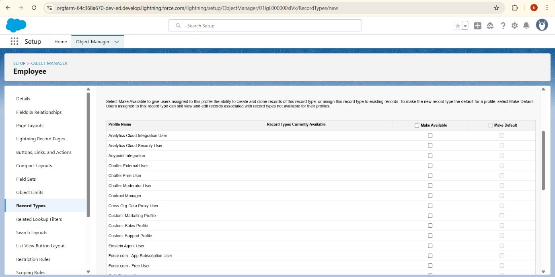

Scroll down and check for the Manager & System Administrator profile and click on Next.

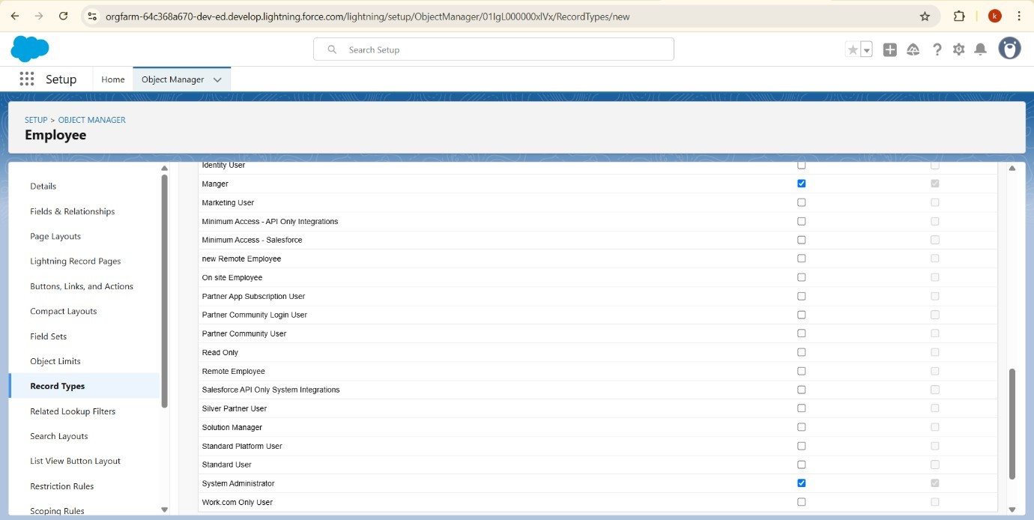

Select “Apply a different layout for each profile”, and change page layout to On Site Employee Layout for manager profile and System Administrator.

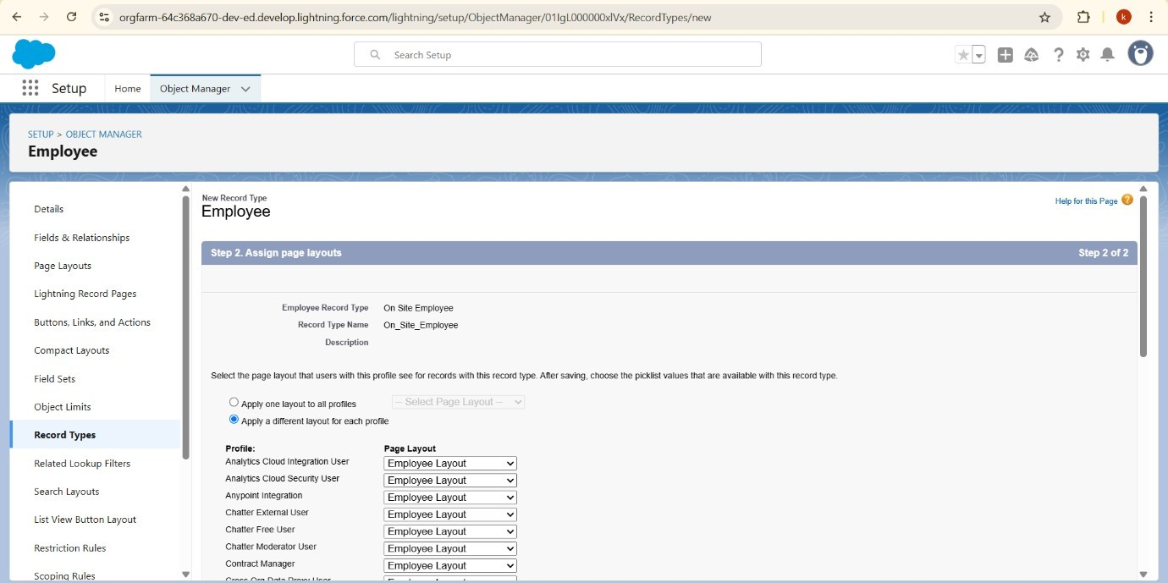

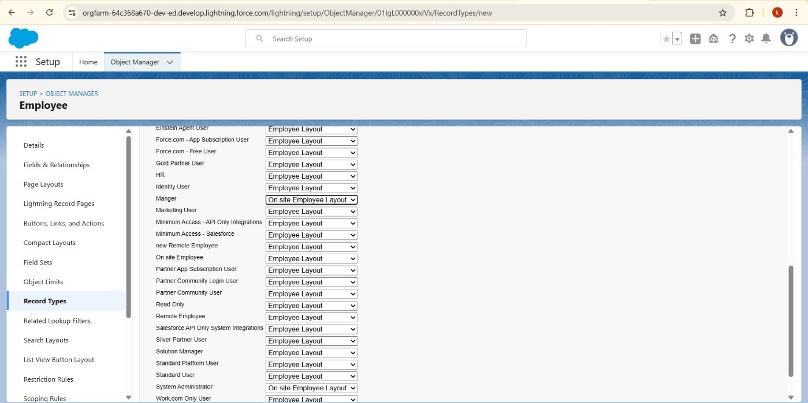

Save

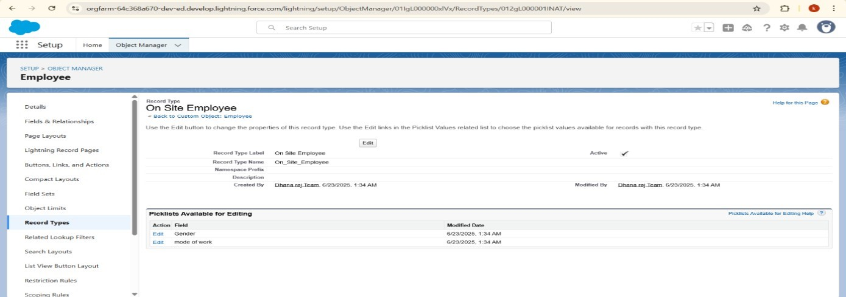

Creating Remote Employee Record Type

To create a Record Type

Go to setup and Click on Object Manager and Search for Object Employee then click on edit from drop down ,From the panel click Record Types then Select New and Give Record Type Label as “Remote Employee” and make it active.

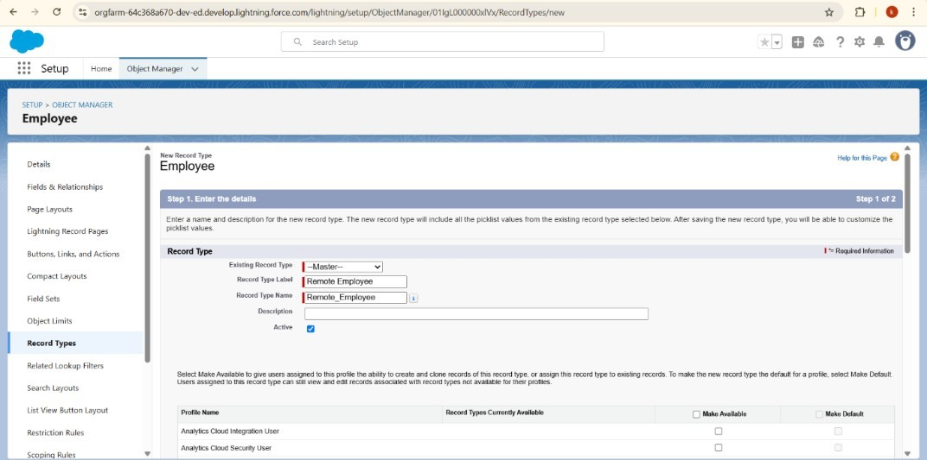

Scroll down and check for the Manager & System Administrator profile and click on Next.

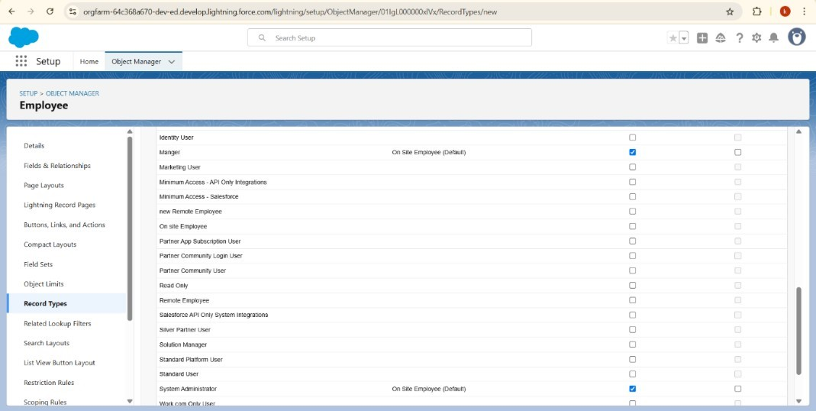

Select “Apply a different layout for each profile”, and change page layout to Remote Employee Layout for manager profile and System Administrator.

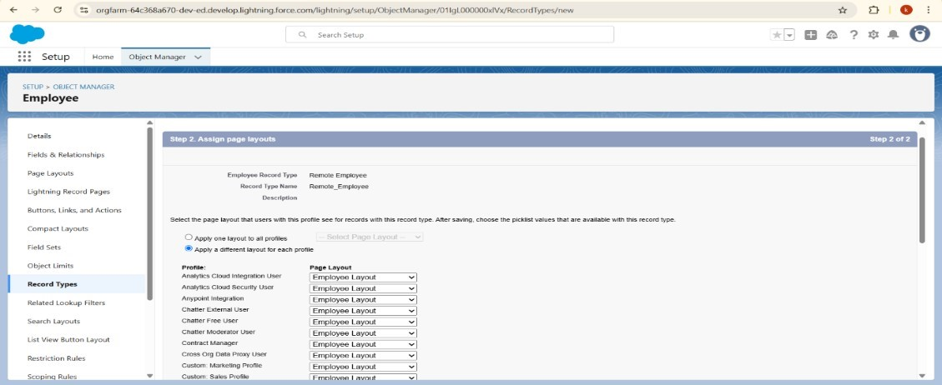

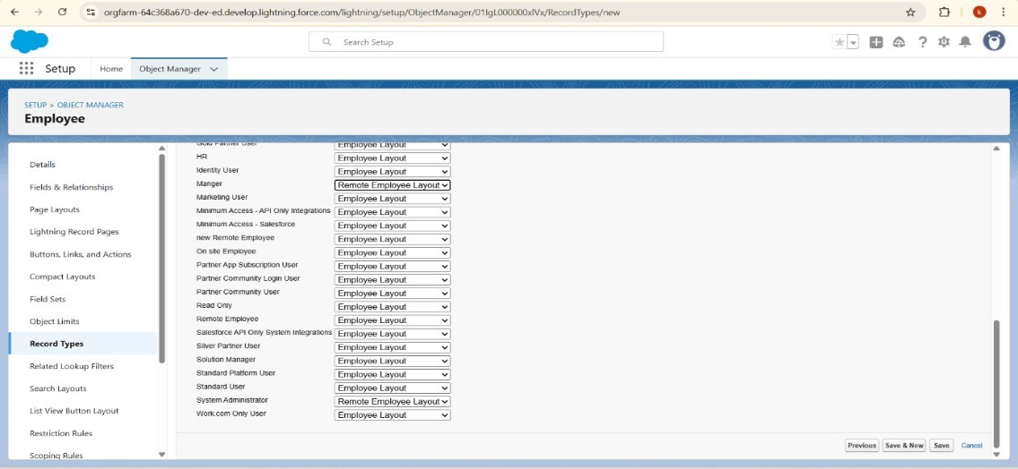

Click on Save

# 6.15 Permission Sets

To create a report with Report Type Employee

Go to the app , click on the reports tab and Click New Report Select report type from category or from report type panel or from search panel --> click on start report.

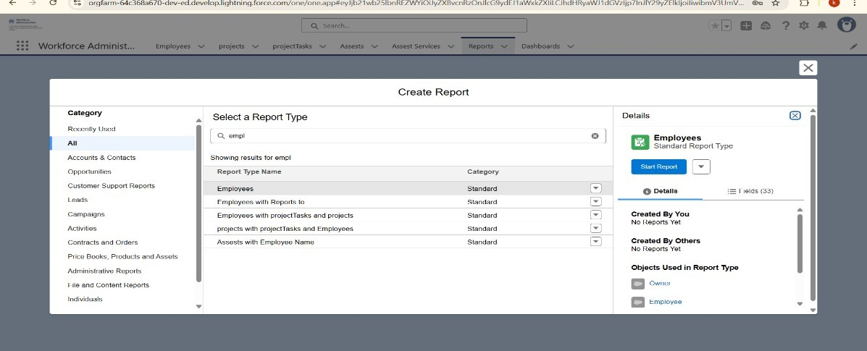

Add fields from left pane

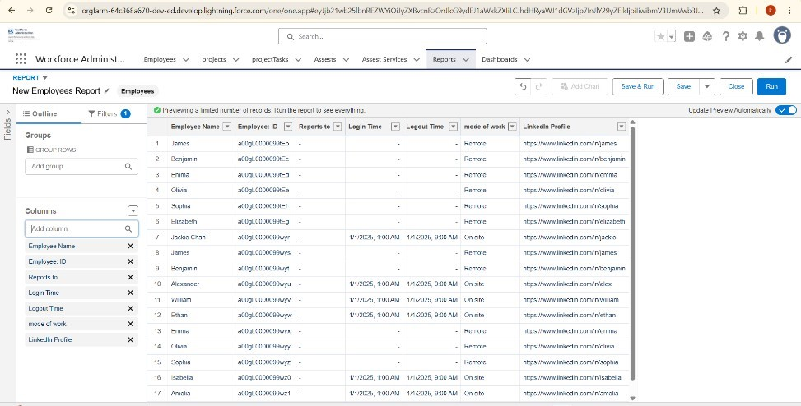

Save or run it

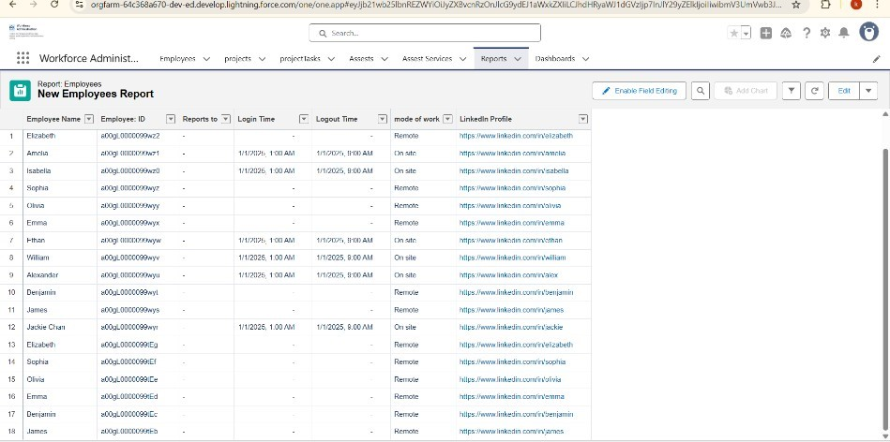

To create a report with Report Type Employees with Project Tasks and Projects Go to the app , click on the reports tab and Click New Report Select report type from category or from report type panel or from search panel --> click on start report.

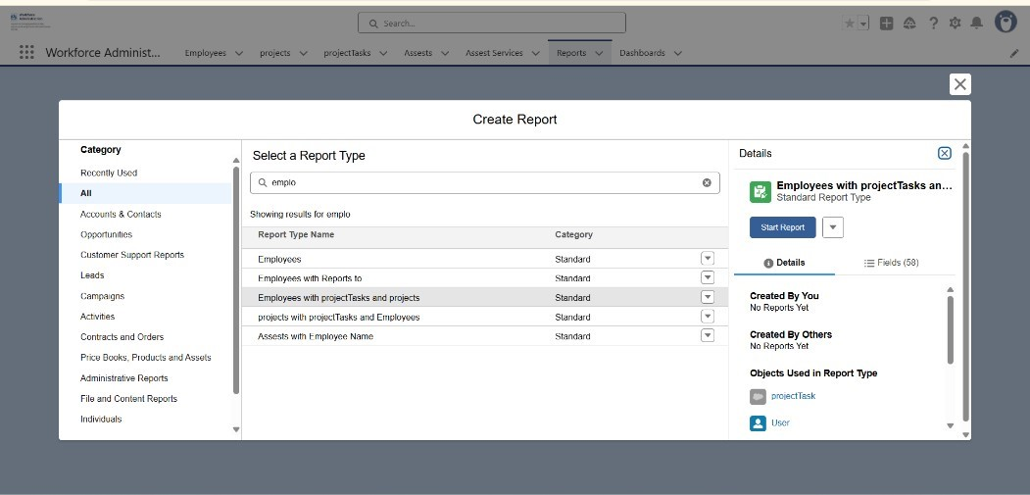

Add fields from left pane.

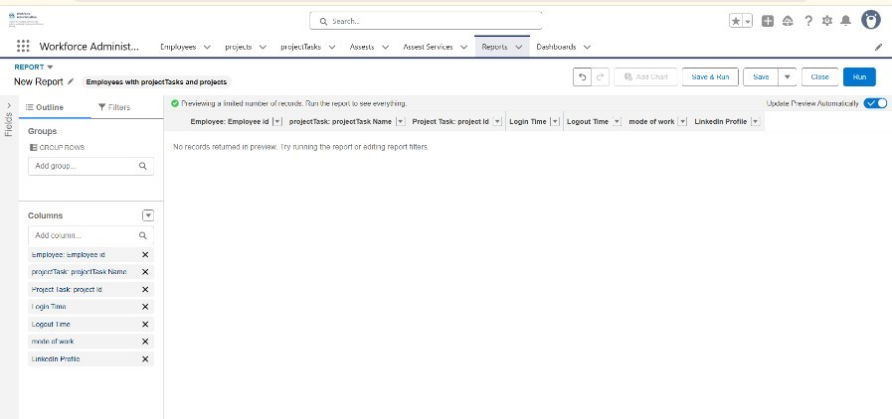

Save or run it.

To create a report with Report Type Employees with Assets.

Go to the app , click on the reports tab and Click New Report Select report type from category or from report type panel or from search panel --> click on start report.

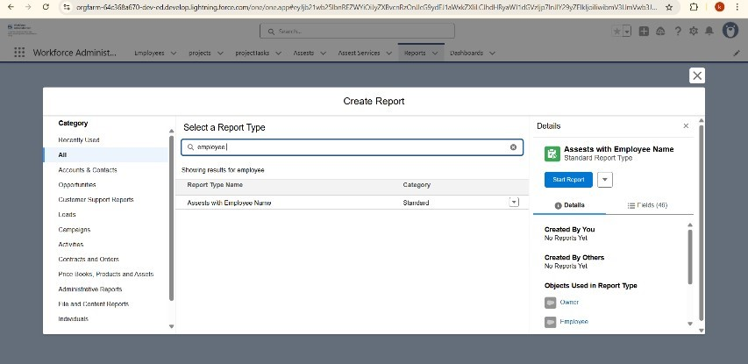

Add fields from left pane.

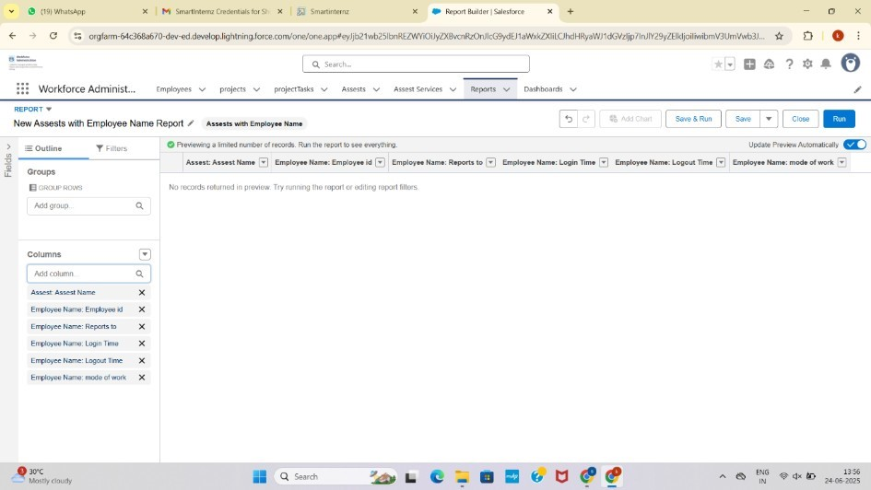

Save or Run it

# 6.16 Dashboards

Create a Dashboard. click on the Dashboards tabs and click on New Dashboard. Give a Name and click on Create.

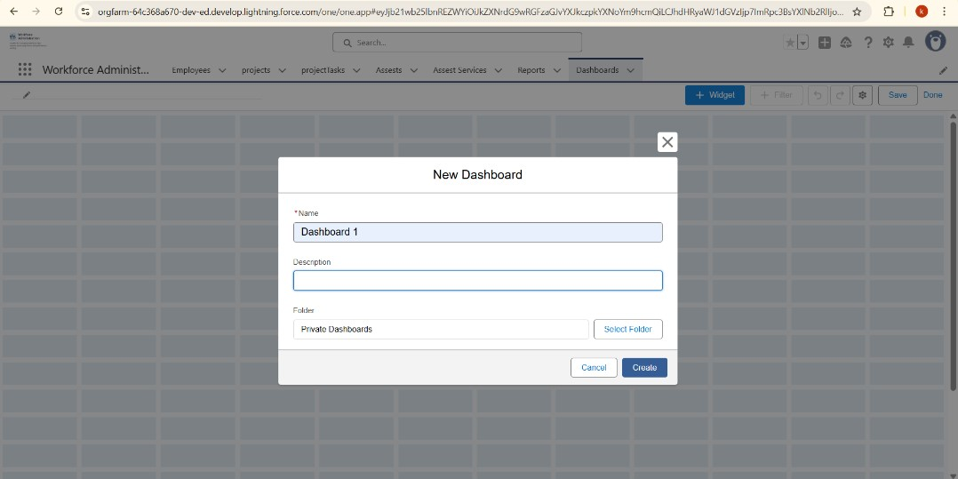

Select add Widget and Select a Report and click on select.

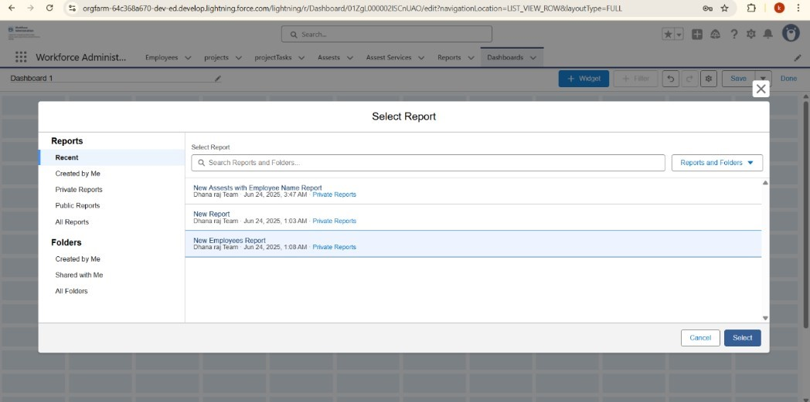

Click Add then click on Save and then click on Done.

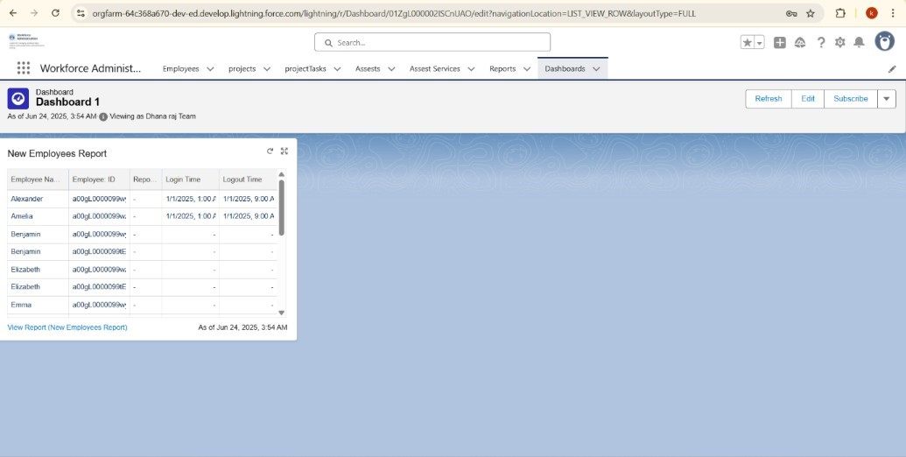

Create another Dashboard click on the Dashboards tabs and click on New Dashboard. Give a Name and click on Create.

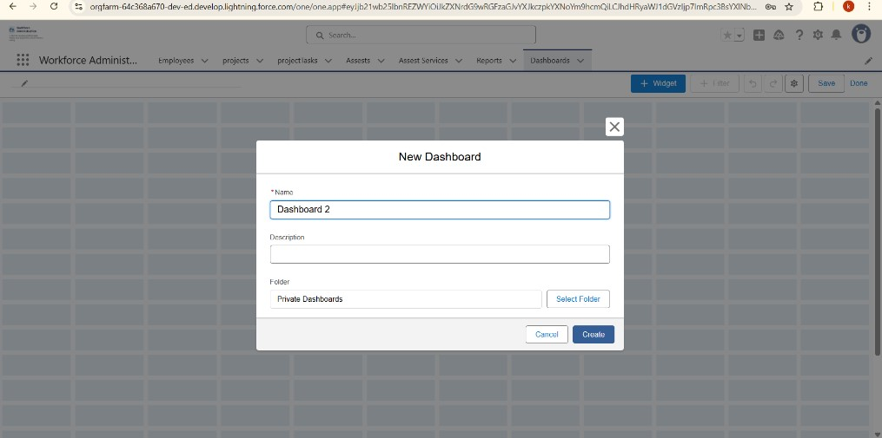

Select add Widget and Select a Report and click on select.

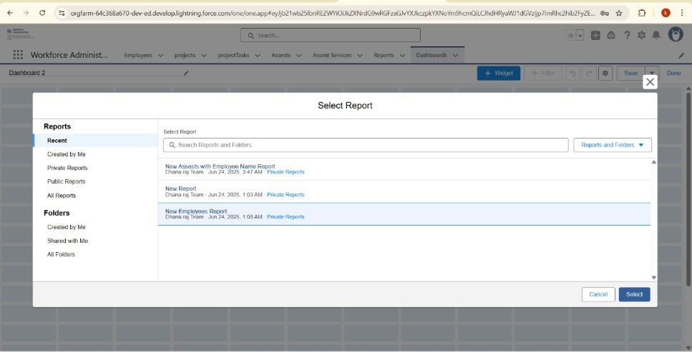

Click Add then click on Save and then click on Done.

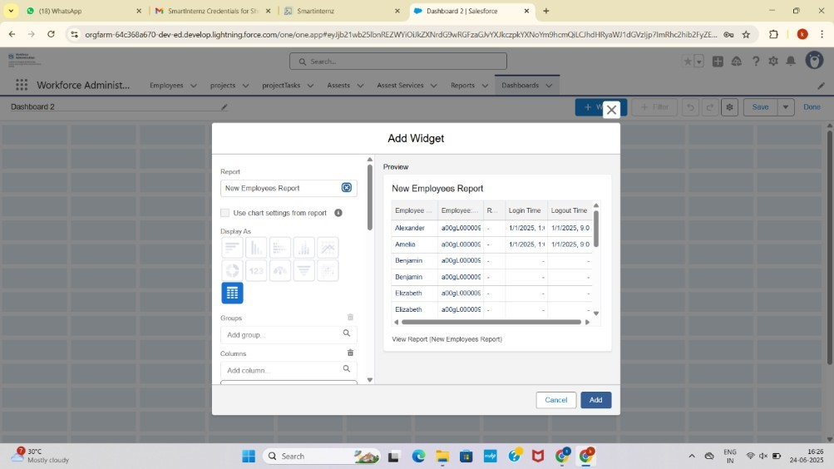

# Approval Process

Create a leave Object.

Go to Setup and click on object Manager then select custom Object.

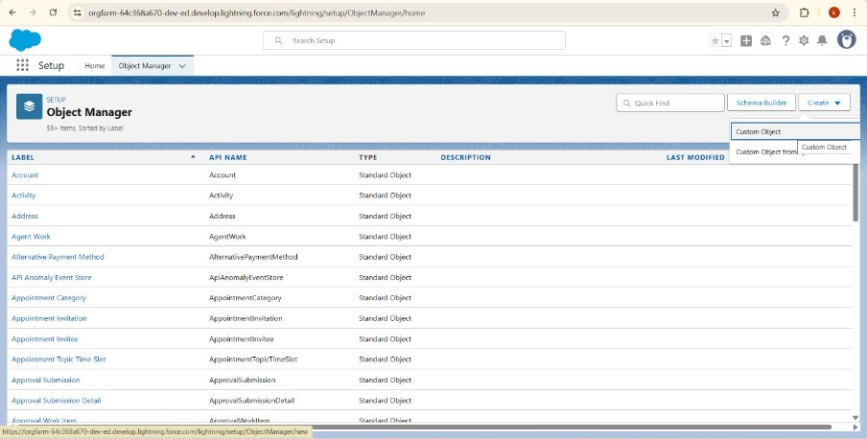

Give the label name as leave.

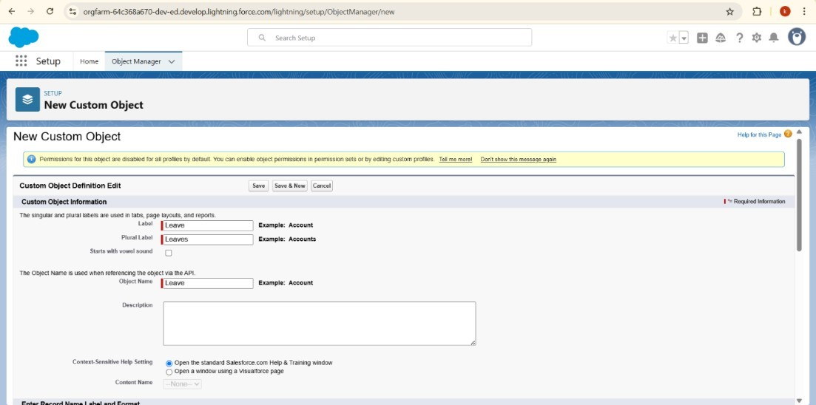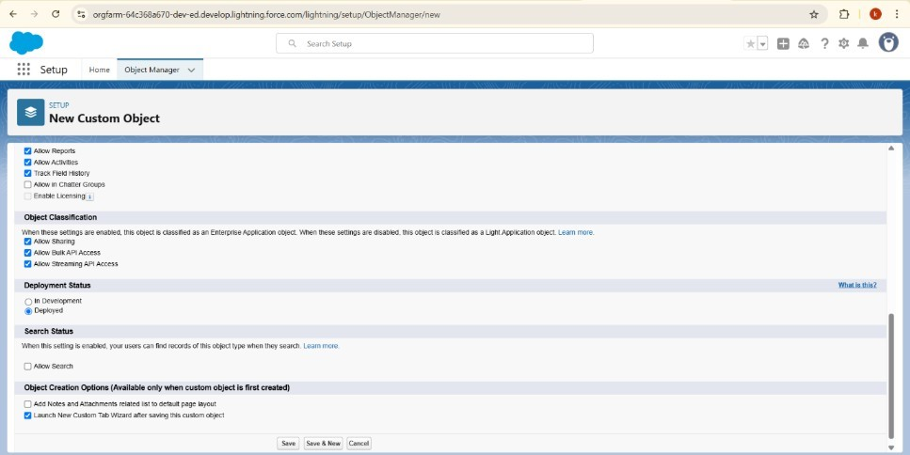

Click on save.

Create a field in leave object and click on new.

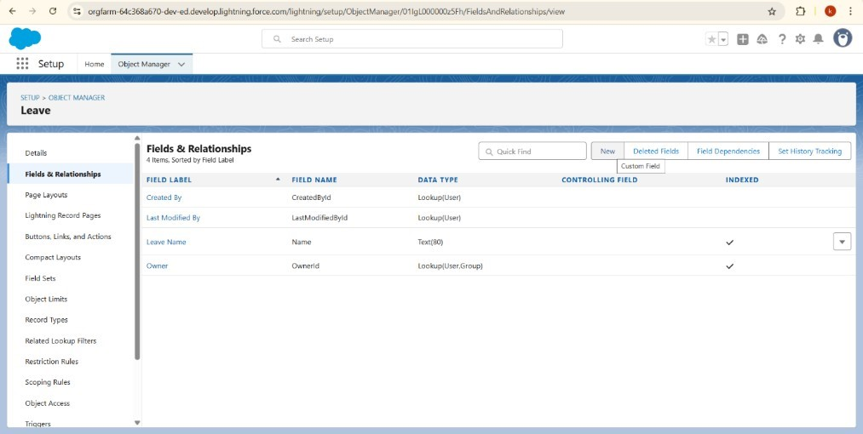

Choose the field type as lookup relationship and object is employee and then field label

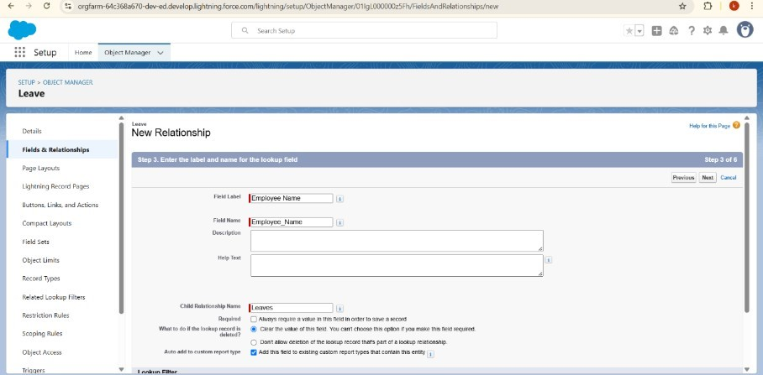

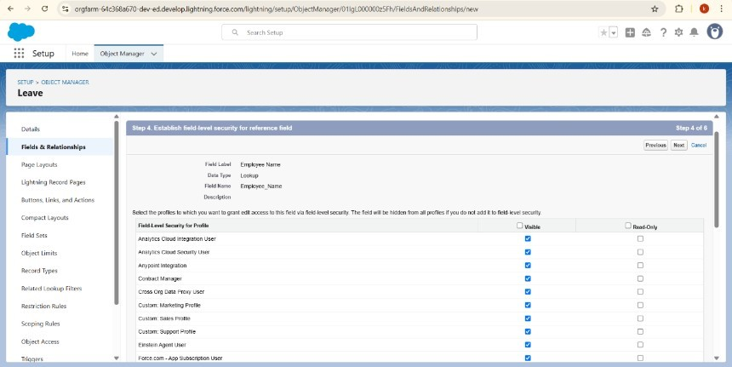

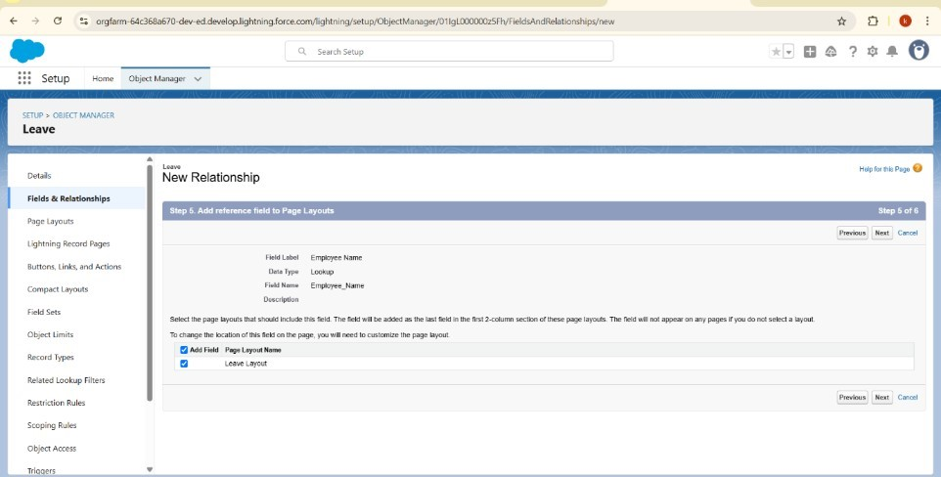

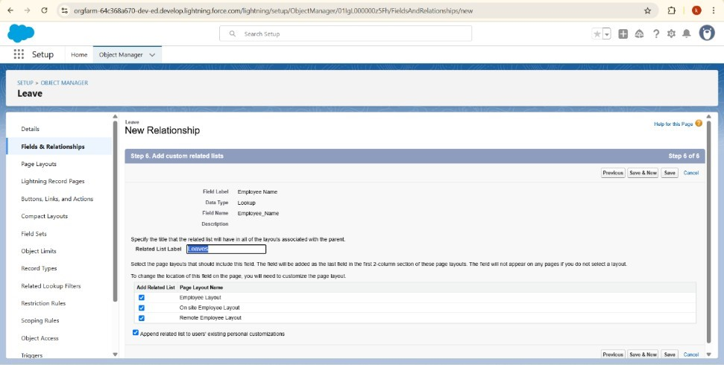

Click on save.

Choose the field type as Number and field is No. of Days next step as

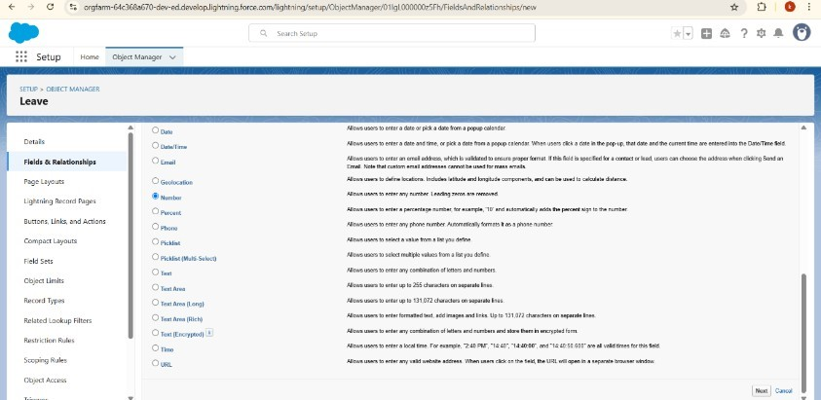

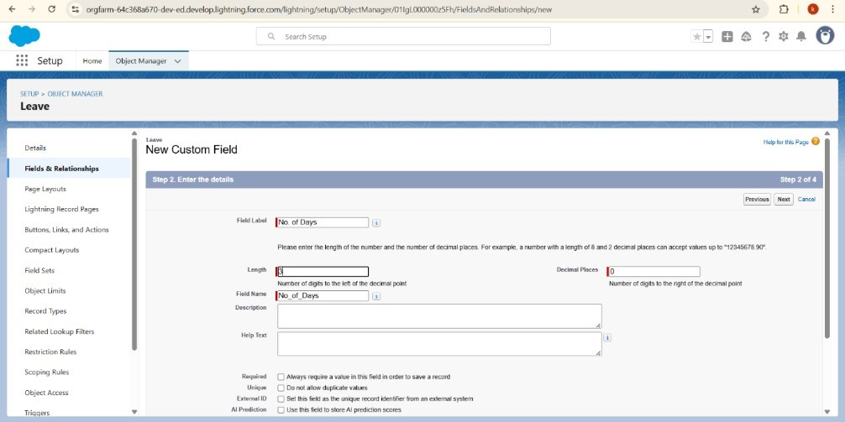

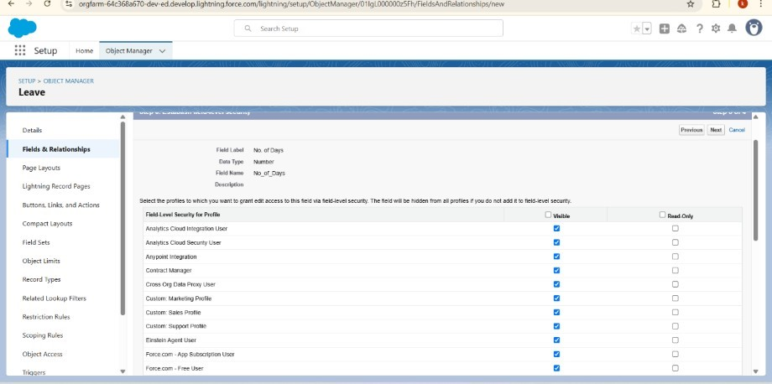

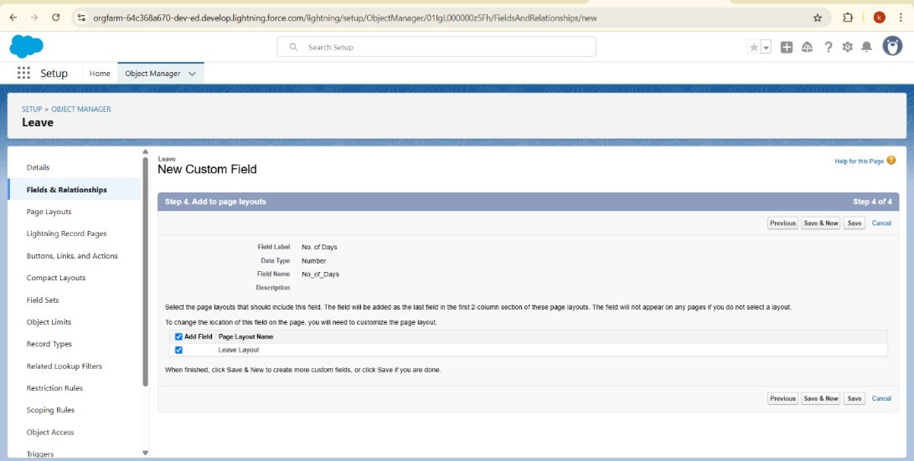

Choose the field type as text and field is Subject next step as

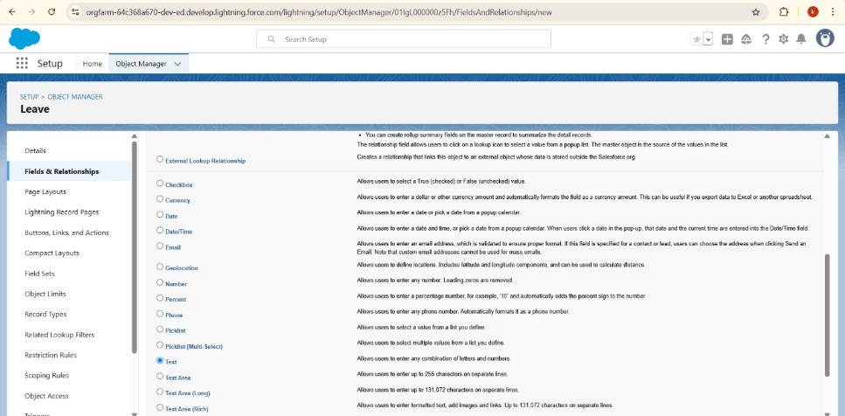

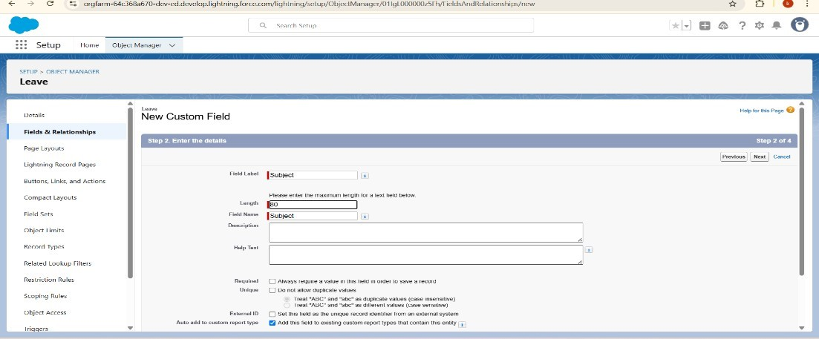

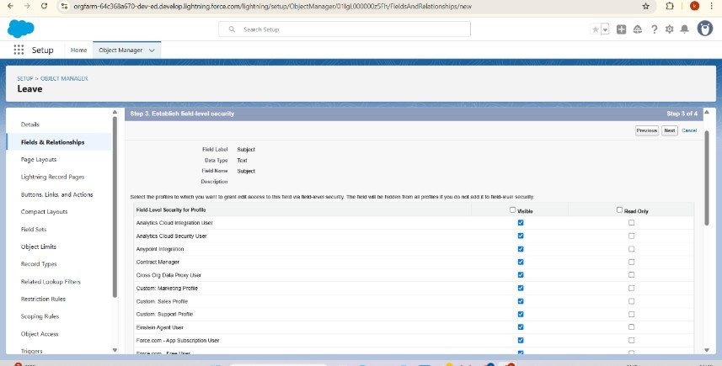

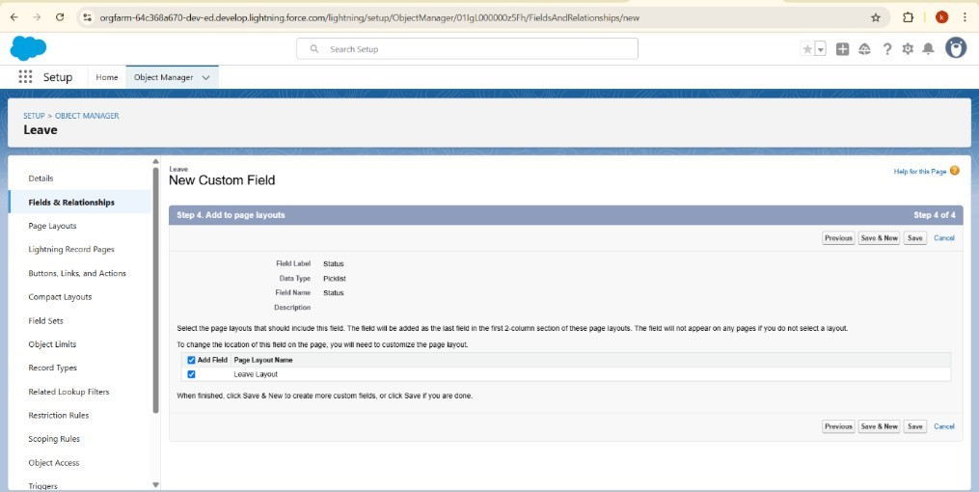

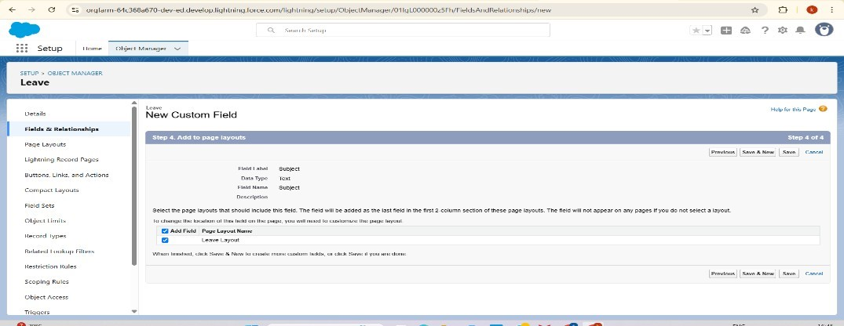

Choose the field type as Text Area (Rich) and field is Description next step as

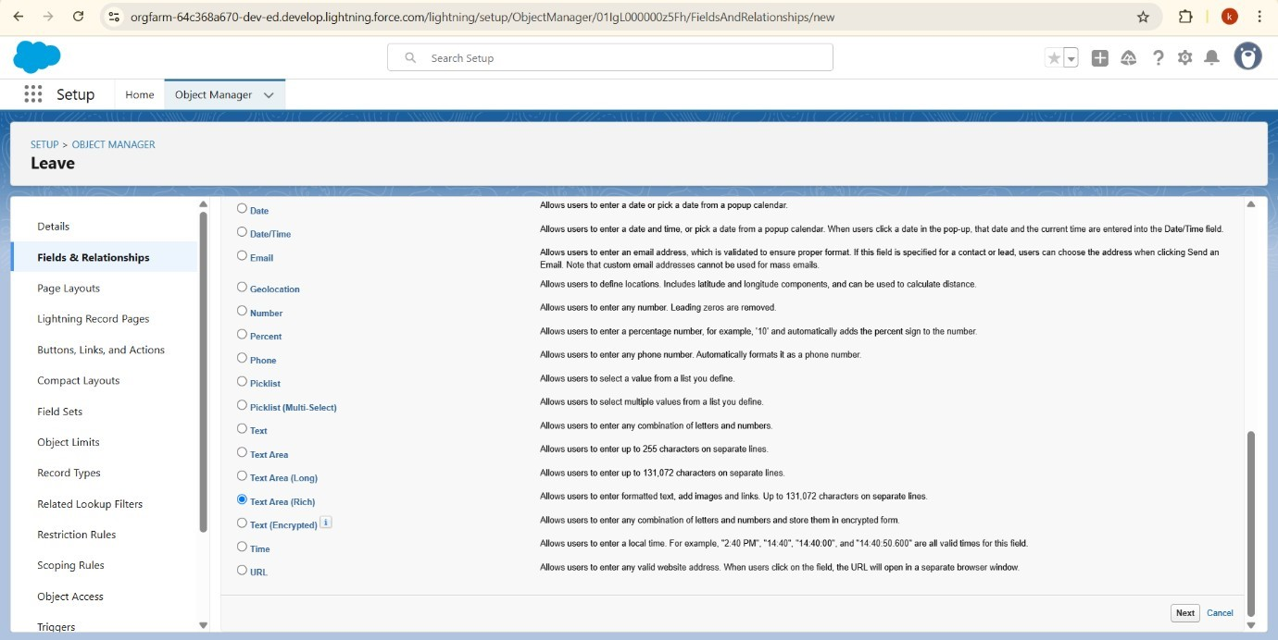

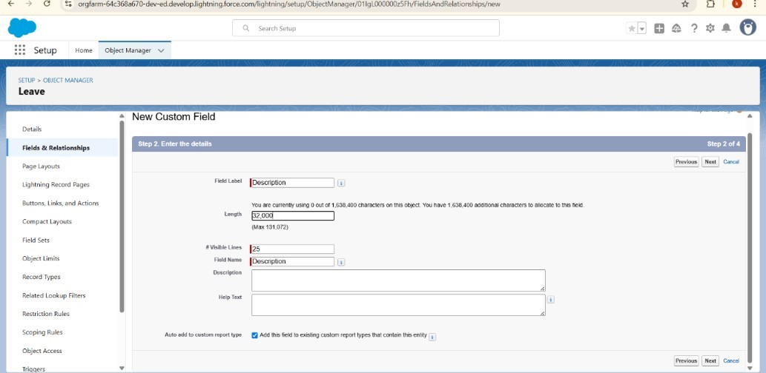

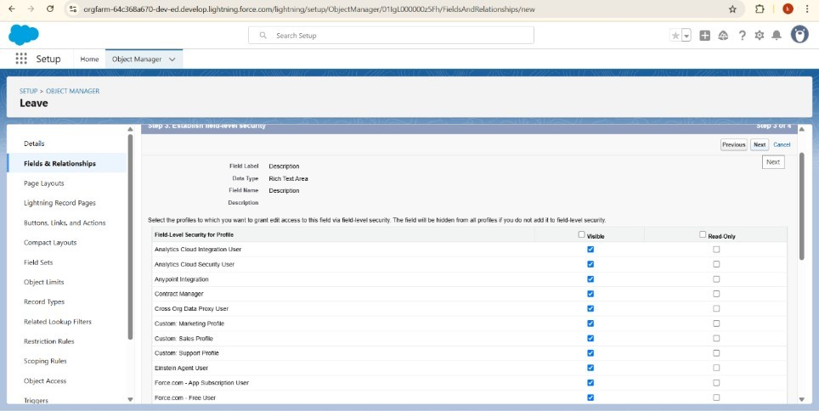

Choose the field type as Picklist and field is Status next step as

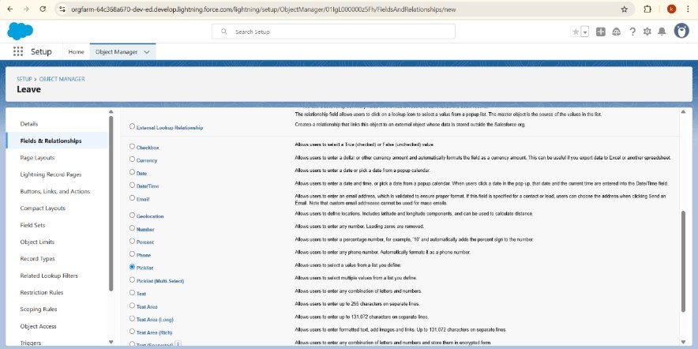

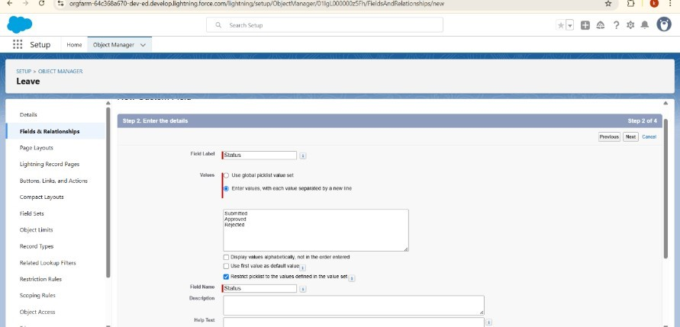

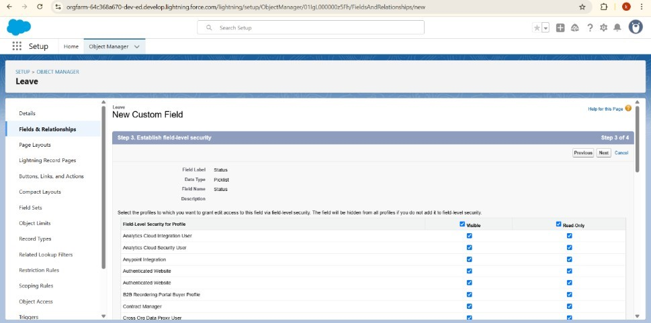

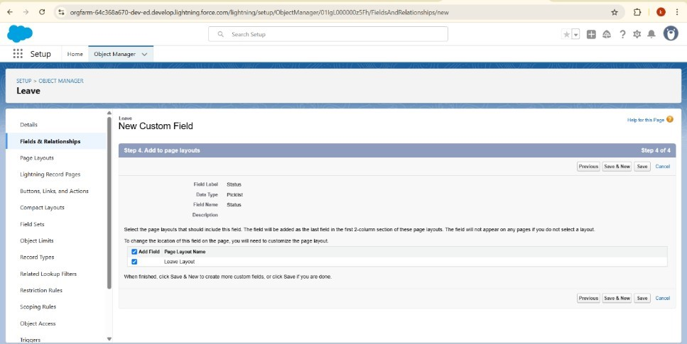

Create an Approval Process for Leave object.

In the Manage Approval Processes For list, select Leave. Click Create New Approval Process and select Use Jump Start Wizard.

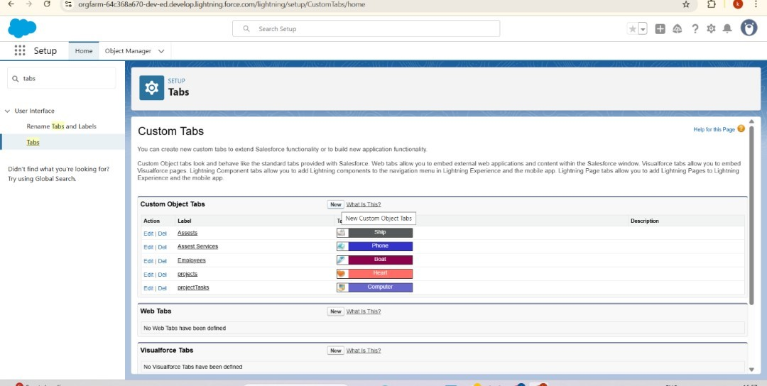

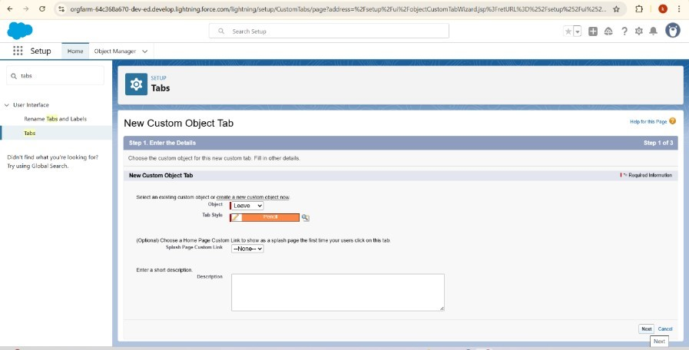

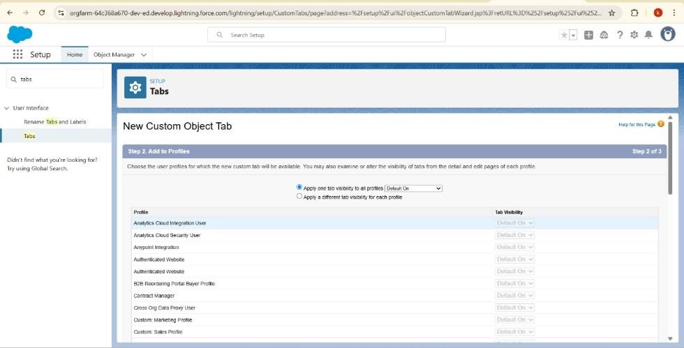

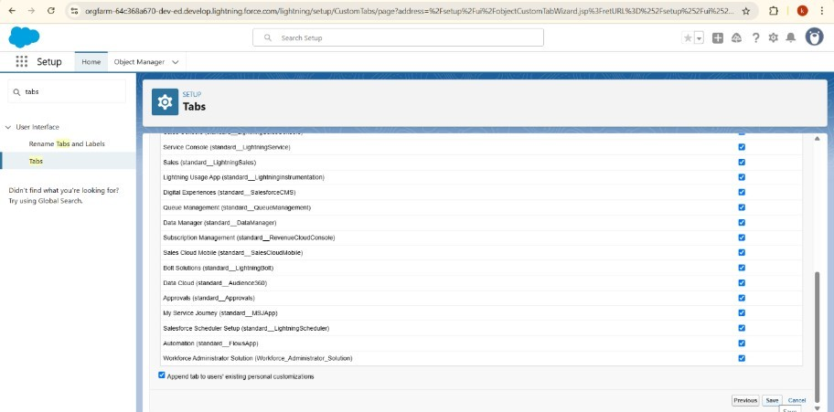

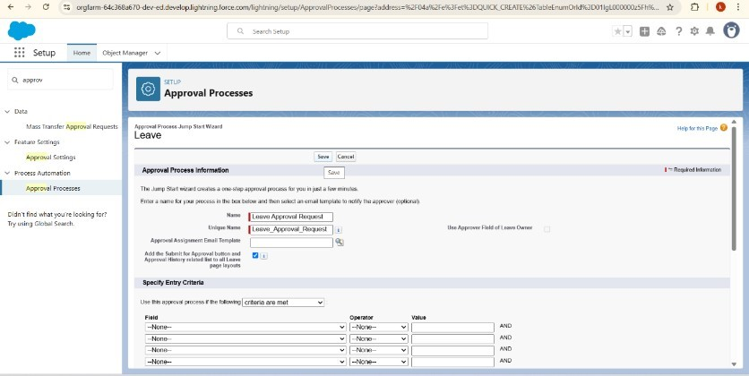

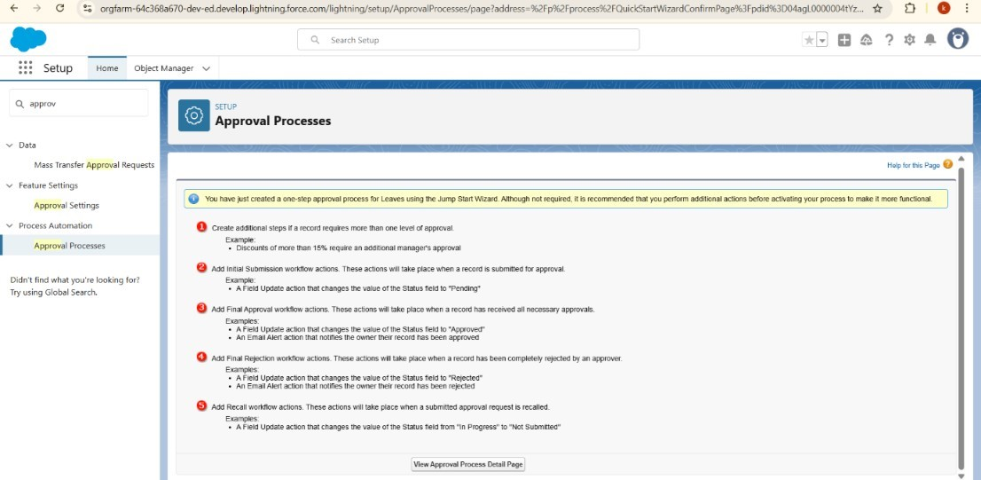

Initial Submission Action.

Under initial submission action click on add new and select field update.

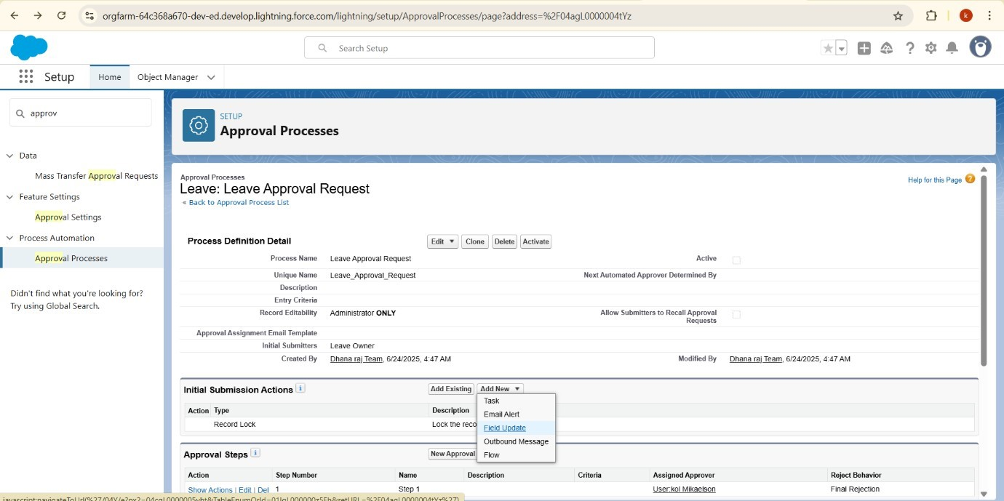

Give field name as Approval status to submit

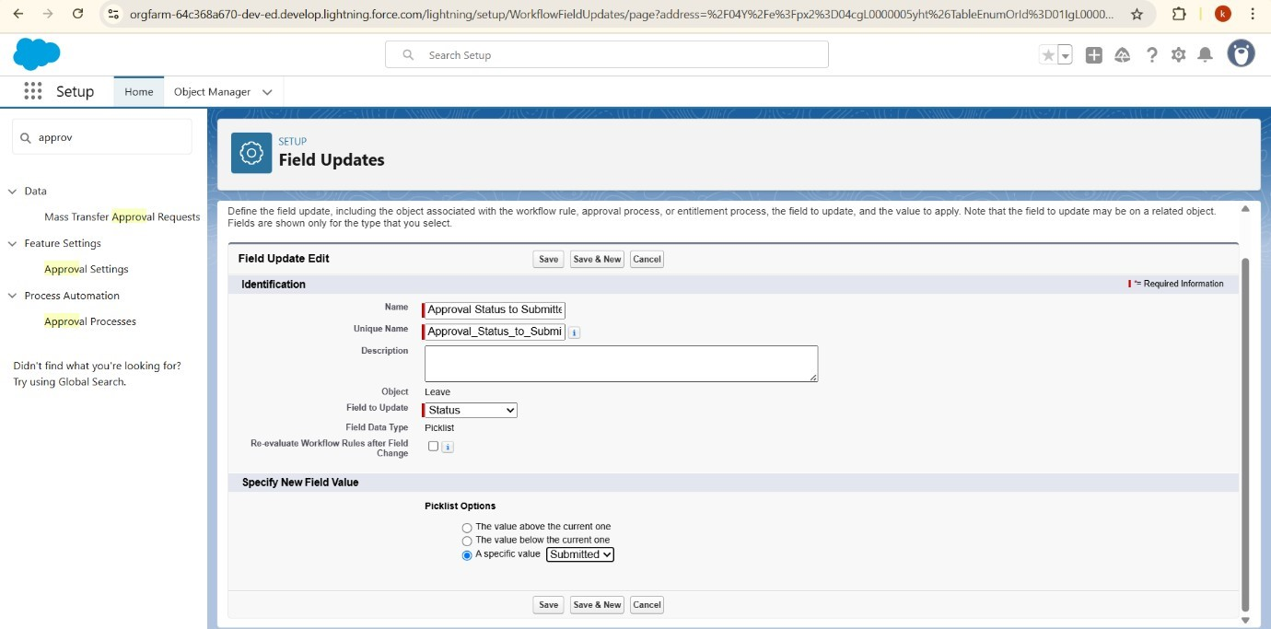

Approval Steps

Give the name as “Approval from HR” and click on next.

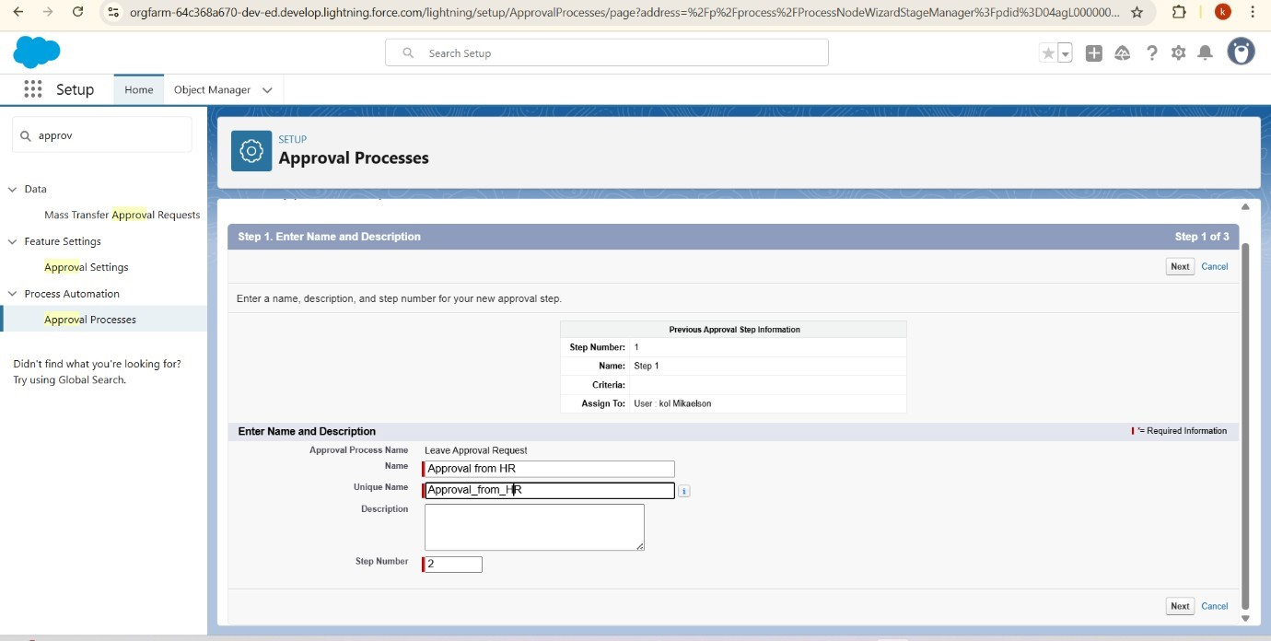

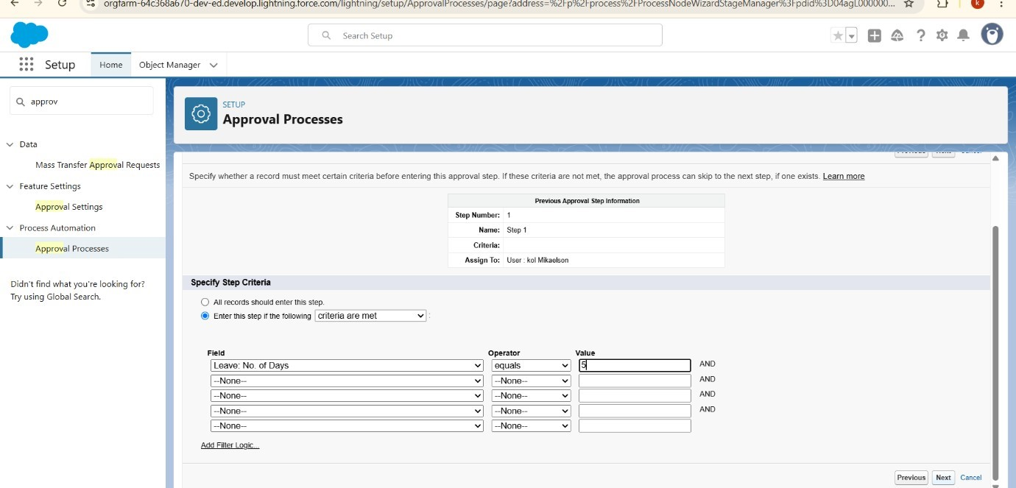

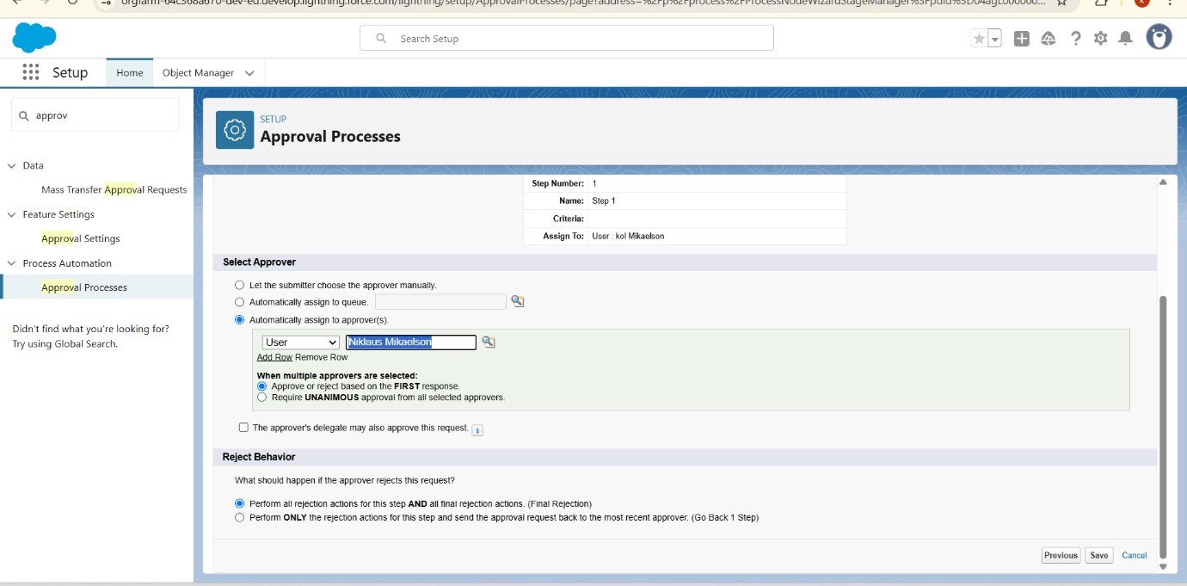

Select No I will do later

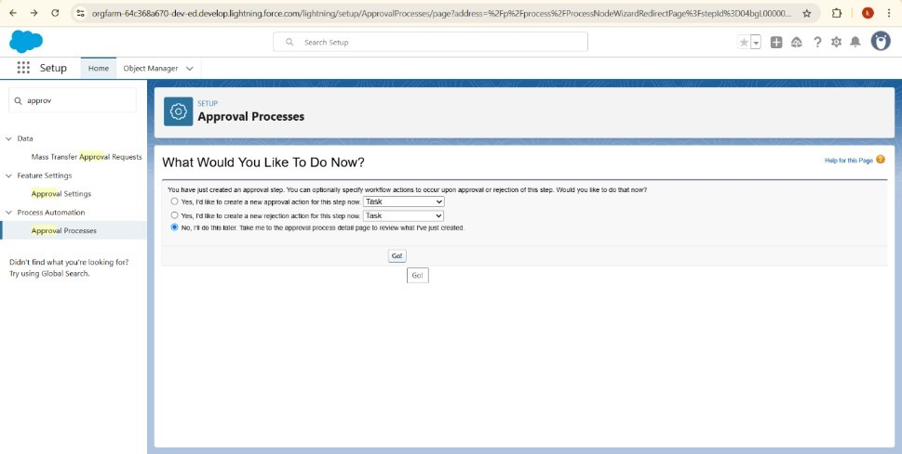

Final Approval Action.

Under initial submission action click on add new and then select field update.

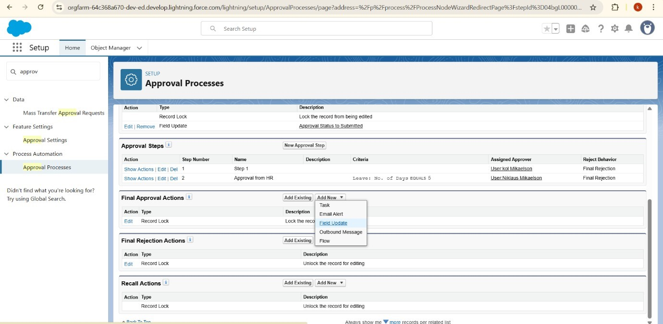

Give name as “Approval Status to Approved”. Under specify new field value select “A specific value” and select Approved and click Save.

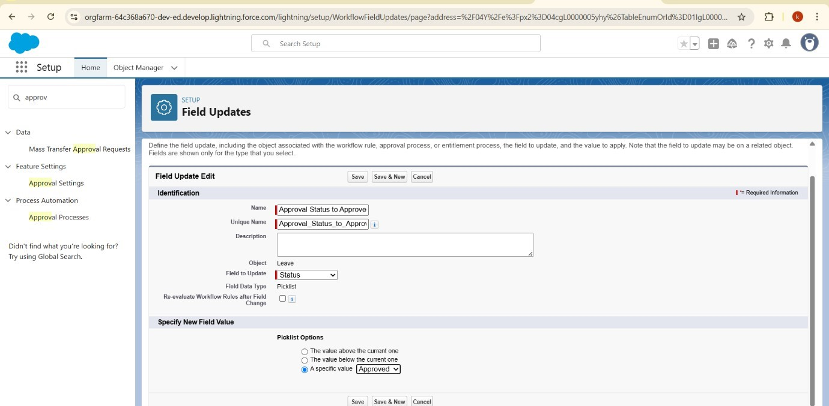

Final Rejection Action.

Under initial submission action click on add new and then select field update.

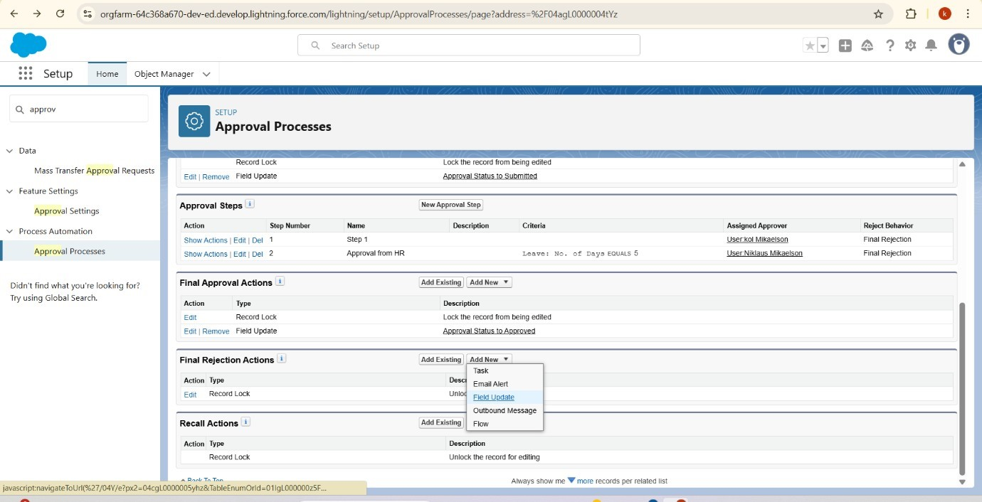

Given name as “Approval Status to Rejected”

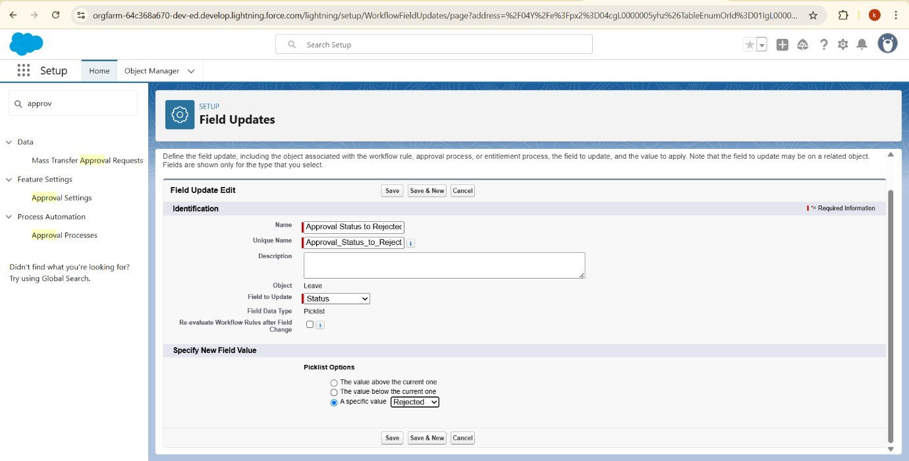

# 6.18 Apex Trigger

**Creating an apex trigger**

**Click on new file and select apex class**

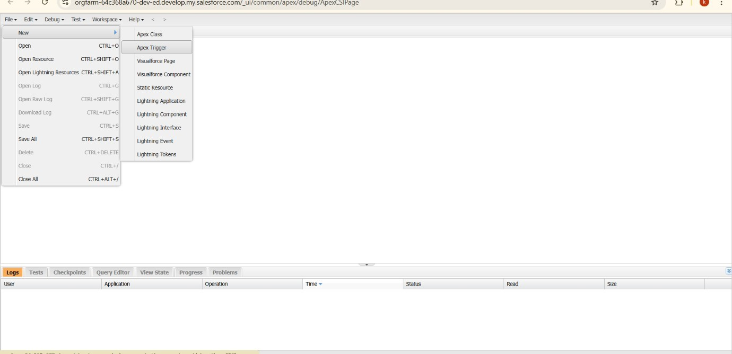

Name is EmpInsert and object is Employee__c.

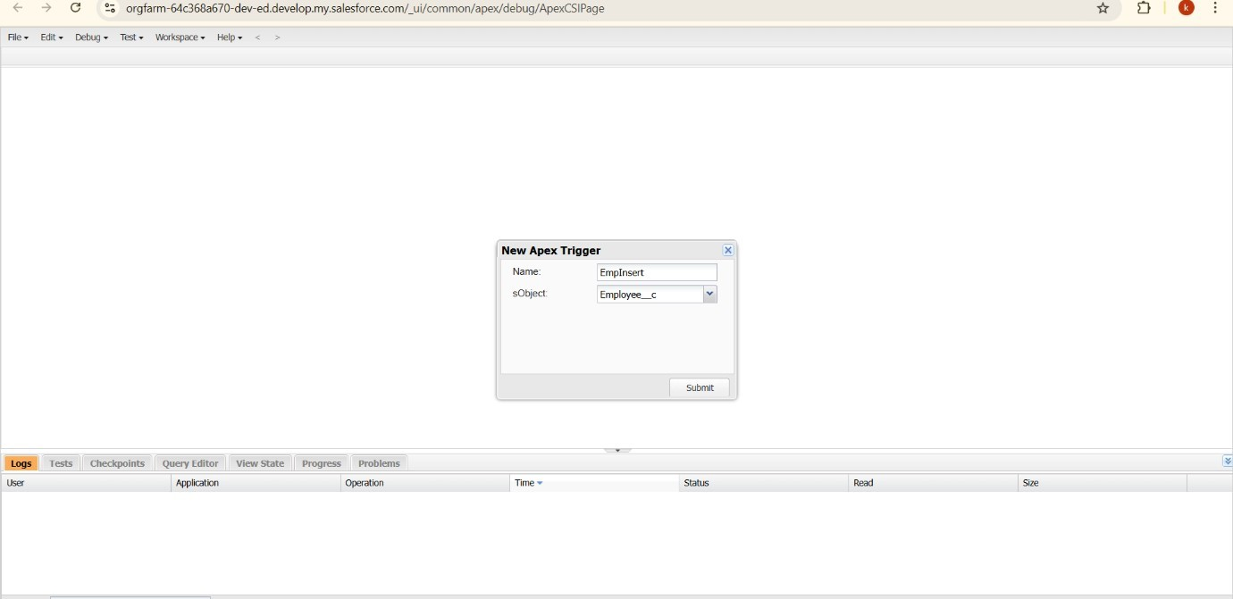

Click on save

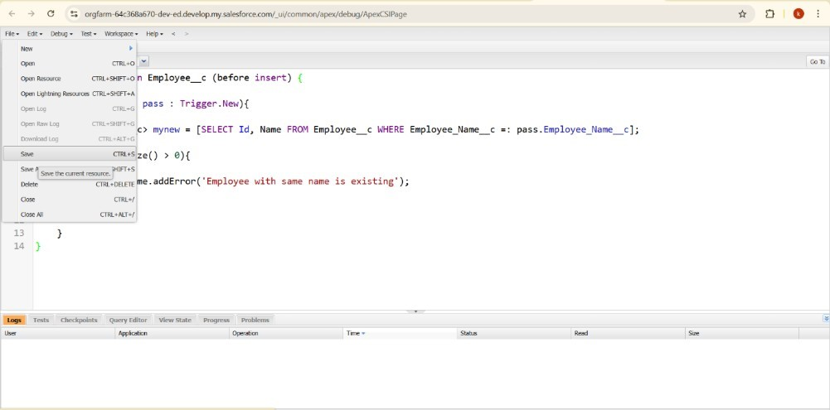

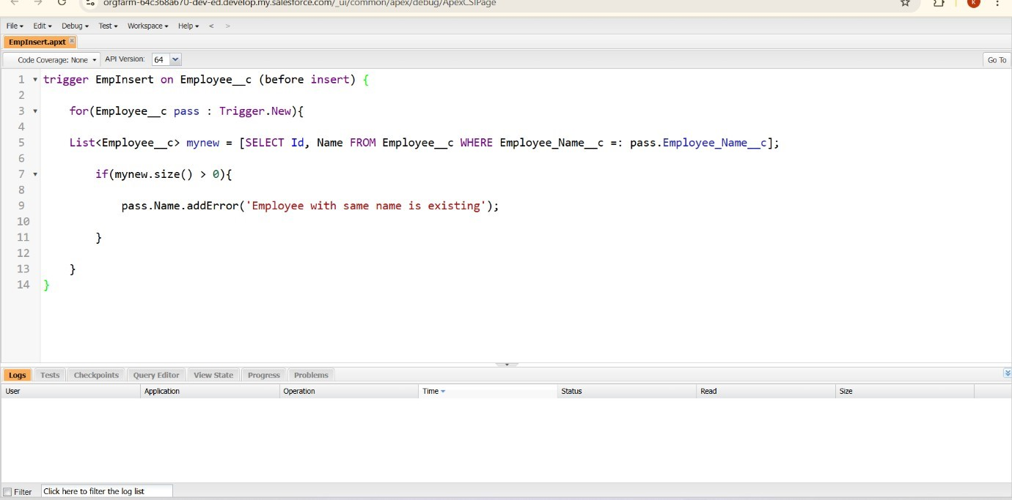

Testing the trigger

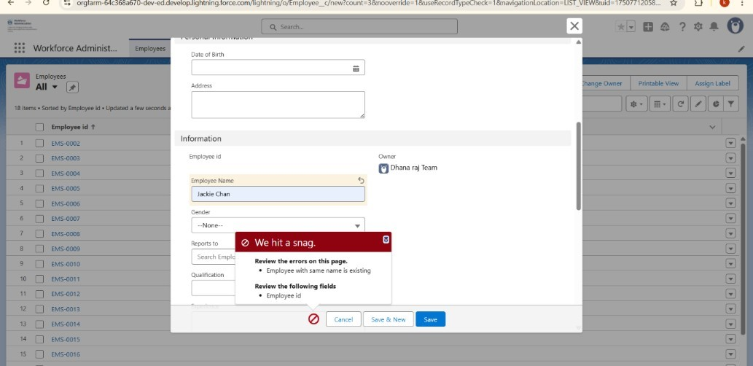

**Sprint Summary & Velocity Calculation – Workforce Administration Solution**

A **Sprint** is a fixed-duration development cycle during which the team completes a planned set of tasks. An **Epic** represents a larger objective, which is divided into smaller, manageable **User Stories**. Each story is assigned **Story Points** based on its complexity using a standard estimation technique (typically inspired by the Fibonacci series).

**Sprint 1: (3 Days)**

**Employee & Asset Management Epic**

Create Custom Employee Object – 4 Points

Configure Master-Detail Relationship with Assets – 2 Points

Build Apex Trigger for Duplicate Prevention – 2 Points

Set Up Lightning App Tabs – 2 Point

**Total Story Points (Sprint 1):** 10

**Sprint 2: (2 Days)**

**Leave & Access Control Epic**

Automate Leave Approval Process – 4Points

Implement Profile & Role-based Security – 4 Points

Build Dashboard for Project Participation – 2 Points

**Total Story Points (Sprint 2):** 10

**Sprint 3: (2 Days)**

**Reporting & Navigation Epic**

Configure Reports for Asset & Leave Status – 5 Points

Optimize Tab Navigation & UI Layout – 5 Points

**Total Story Points (Sprint 3):** 10

**Velocity Calculation**

**Total Story Points Completed:** 10(Sprint 1) + 10 (Sprint 2) + 10 (Sprint 3) = **30** **Number of Sprints:** 3

**Velocity = Total Story Points ÷ Number of Sprints** **Velocity = 30÷ 3 ≈ 10.0 Story Points per Sprint**

Your team’s **average velocity is approximately 10.0 story points per sprint**, based on the completed development cycles in the Workforce Administration Solution project.